This job aid describes information regarding account set up for sponsored projects. This document can be referenced to understand workflow and where to access information in COEUS and SAP to ensure successful account set up.

New Award Notification
Award Notification Information Request | Sponsored Programs will send an award notification information request to the business office of the responsible cost center for the grant which looks similar to the email below.  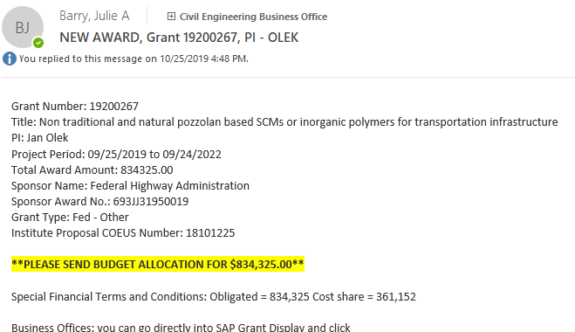
Finance Launch Pad
SAP Fiori—Grant Verification | Log into SAP Fiori through https://one.purdue.edu/
GMGRANTD | Enter the transaction code GMGRANTD
Responsible Cost Center Verification | To verify the responsible cost center (RCC):  - Enter the grant number in the search box and enter.  - Verify grant is established under the correct Responsible Cost Center under the General Data Tab  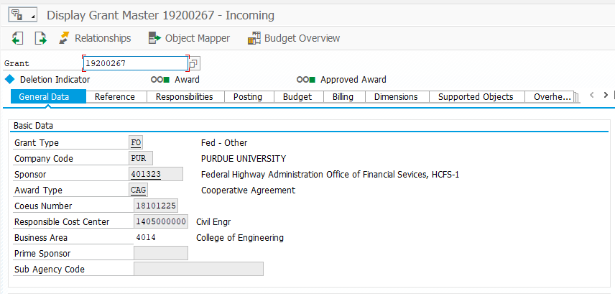
Building Your Grant File
COEUS  Dev # Example: 00078031—will always have three leading zeros.  IP # Example: 18101225 | A complete training on COEUS can be accessed here: https://www.purdue.edu/business/sps/videos/coeus/  To access COEUS visit: https://www.purdue.edu/business/coeus/  Use COEUS Premium--Login with your Career Account and Password  Note: COEUS Definitions  IP = Institute Proposal – this is the record of when a proposal leaves the university and is sent to a sponsor (contract negotiations, etc). It houses all correspondence with sponsor upon its award or rejection. It may be linked to multiple development records.  Dev = Proposal Development Record – Number will start with three leading zeros. Ex. 00078031.This is the record for when a proposal is developed (narrative, budget, budget justification). Sometimes proposals are developed with multiple versions, so there may be several development records for one proposal sent to a sponsor. Likewise, there may be development records that were never sent to a sponsor at all (so they will not be linked to an IP number)  Medusa – The link that connects a proposal development record to an institute proposal record.
COEUS
Accessing an Institute Proposal | Choose Maintain and Institute Proposal  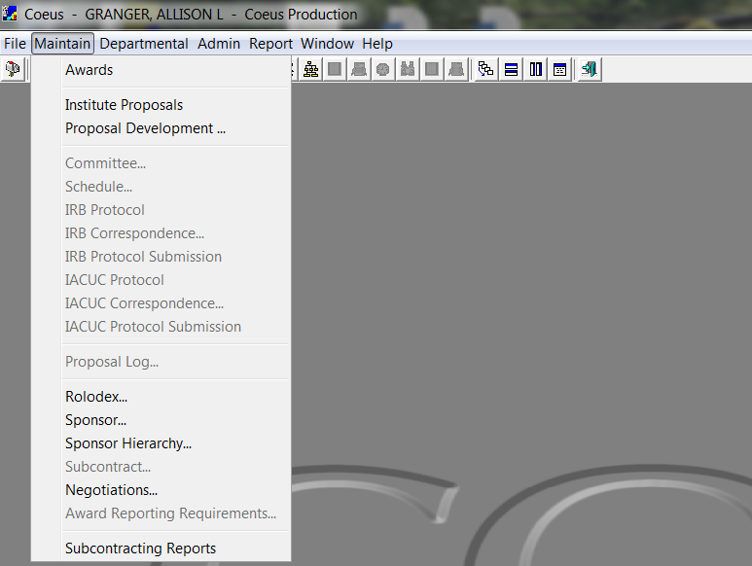  A search box will open where you can enter the Proposal Number (listed on the Notification Email) or search by Investigator Name with an asterisk (*wildcard search) 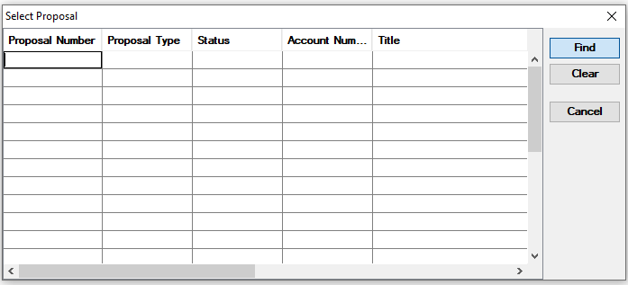  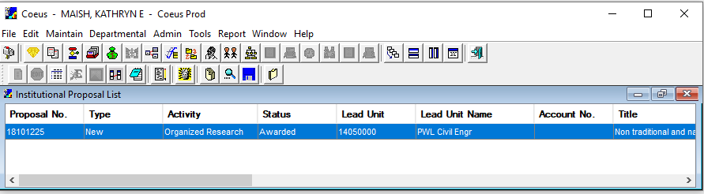  Validate the correct proposal appears by checking the title, RCC, and Investigator Name. Double click on the award to open the record.
COEUS Navigation
COEUS Navigation  Credit Split  Proposal Documents  Fully Executed Agreements  Budget Summary  Note: This information will be needed when completing the Budget Template on page 12 of QRG. | 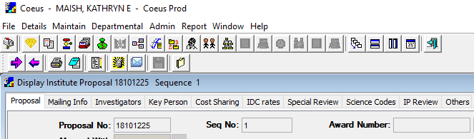  Check Credit Split—Click on the Investigators tab  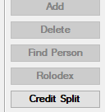  Next click on Credit Split on the right side of the page.  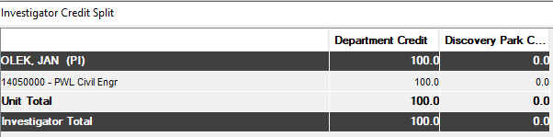  Credit Split is displayed for the department (AY) and Discovery Park (DP).  Viewing Proposal Documents-- click on the medusa head icon located on the bottom line.  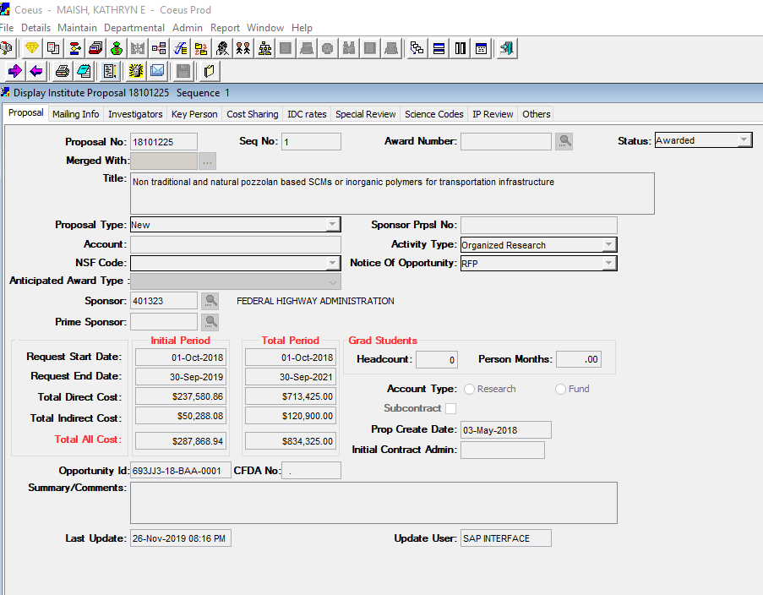  Highlight the Development Record number you that you need information on. Choose the record with the largest number if multiple appear. These are listed under the IP record.  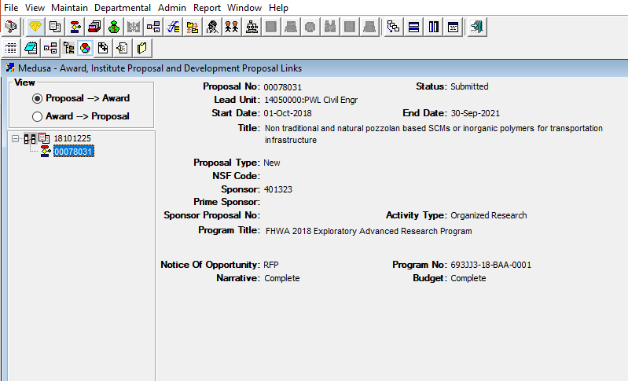  IP#  Dev #  Once you highlight the correct development record, click on View on the tool bar and choose Display.  Click on the Proposal Narrative icon.  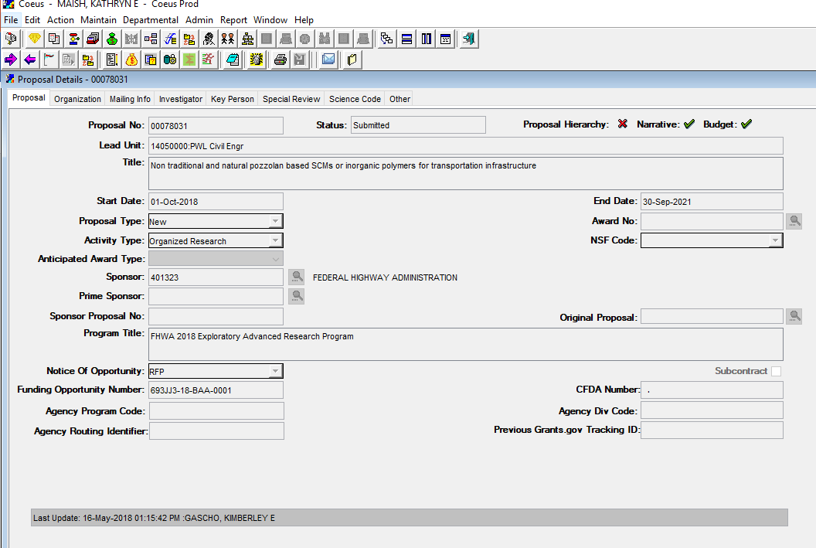  A new window will open where you can access documents such as the Budget Justification, Narrative, Summary, Form 32’s (Cost Share) or Proposal Worksheet. You can double click on the icon next to each file and download a copy to save to your grant file on your shared drive.  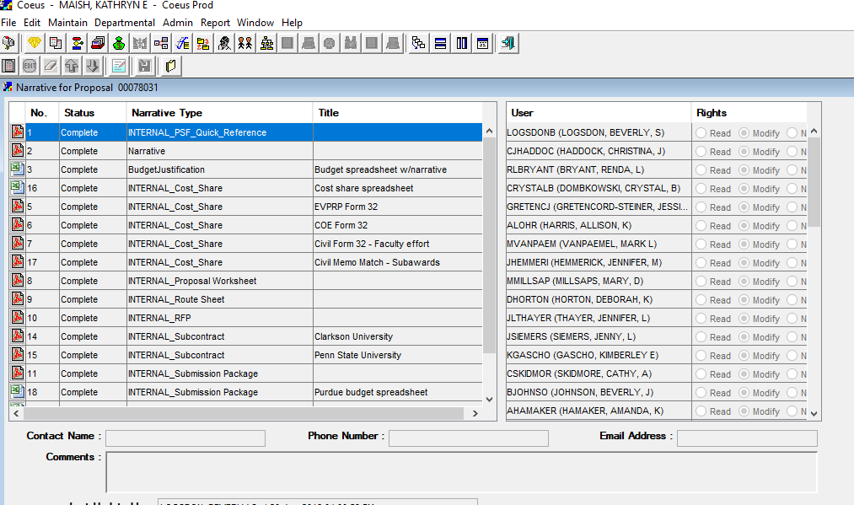  Reminder: Save a Copy See page 11 on How to Build your grant file and information you should save.  Close out of the Narrative section by clicking on the red X in the upper right corner. This will bring you back to the proposal details page.  Click on the Money Bag – Proposal Budget icon on the tool bar.  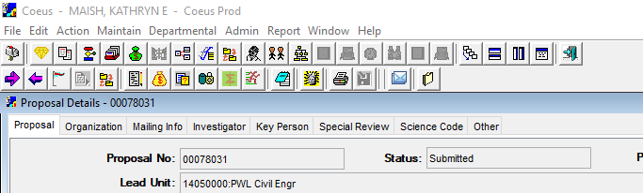  Click on Display—Make sure that you are on the record with the check box showing the final version of the budget.  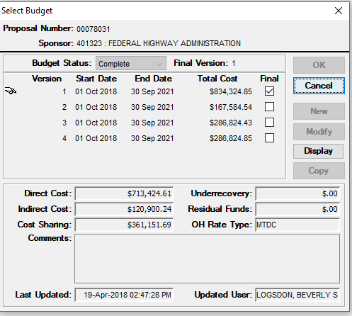  To view the budget summary, choose File from the toolbar and select Budget Summary.  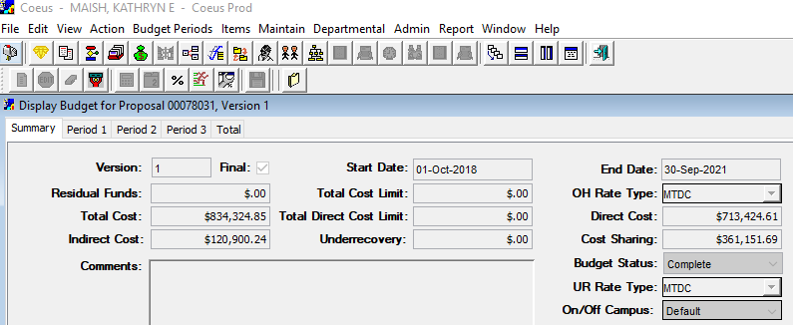  Reminder: Save a Copy See page 11 on How to Build your grant file and information you need to save.  This area contains reports on the Budget Summary by Period, Budget Summary of Cost Share, and the Budget Total. You will need to select the report you would like to view and the choose print. You can download a copy to save to your grant file.  Accessing the Fully Executed Agreement-- To access the Fully Executed Agreement you will need to close out of the Display Budget, Proposal Details, and Medusa screens. This will take you back to the Institute Proposal Display screen  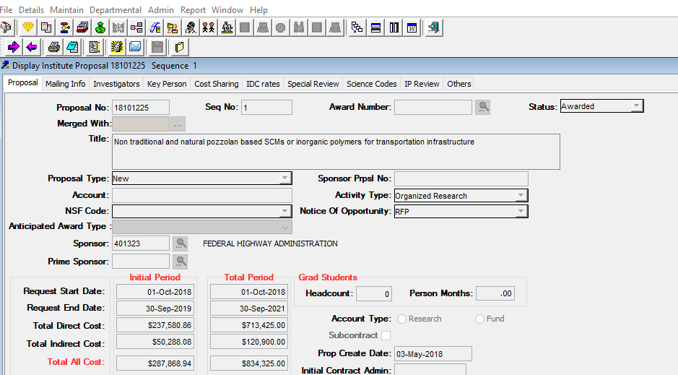  Once back to the Proposal Display screen. Choose Details, then Negotiations.  Click on the document icon next to the Activity Type that says Fully Executed Agreement.  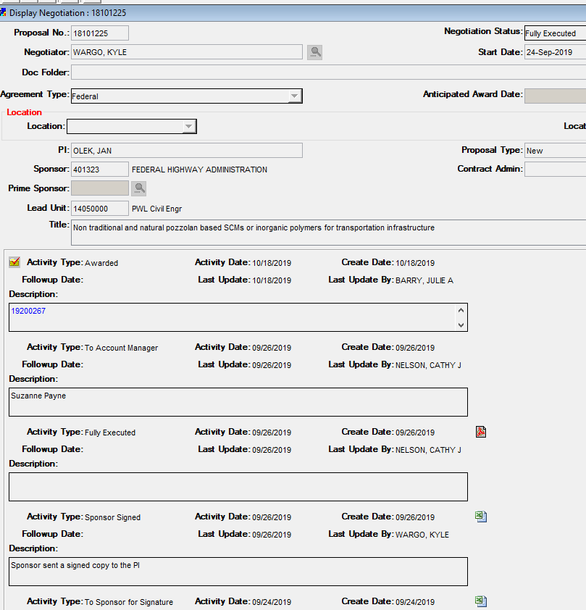  Reminder: Save a Copy See page 11 on How to Build your grant file and information you need to save.
Questions to Ask when Setting up a Budget
Questions to ask yourself and communication with the PI. | Questions to ask yourself as you navigate COEUS and begin the budget set up process:  - Does the budget on the notification email match the COEUS budget?  - How many PIs are on this project?  - Are their multiple business offices involved? Do I need to notify another account manager in another business office?  - Is there capital equipment?  - Will there be capital fabrication?  - What types of expenses do you expect on this award?  - Are students supported on this award? If so, how many and who?  - Will there be human subjects?  - Is there participant support?  - Will the PI attend conferences?  - Are their travel restrictions? Does travel require prior approval?  - Is there cost share? See Cost Share section of this QRG for more information.  - Are there subcontracts?  - Will the project be task based, where different accounts are needed?  Communicate with the PI to ensure proper set up when dealing with multiple PI’s on the grant, roll up budgets, lead times needed for ordering equipment, etc.  If you have questions about how to break out the budget between multiple PIs, please contact a business manager or research specialist for assistance.
Building your Grant File for Your Records
This step is required for Polytechnic and College of Engineering. | Although SPS uploads grant information to Perceptive Content you may choose to create your own grant file in your Business Office Shared Drive for quick reference. Your grant file might include the following:  - Award notification email (SPS)  - Notice of award email (SPS)  - Budget (COEUS)  - Budget summary by Period  - Cost Share budget summary by Period if applicable  - Budget total  - Budget justification (COEUS)  - Narrative (COEUS)  - Fully executed agreement (COEUS)  - Form 32’s if applicable (COEUS)  - Budget Template (YOU create this) See Creating Budget Template of this QRG.
Budget Template
Creating a Budget Template for Sponsor funds.  *Do Not use for cost share. See Cost Share section of this QRG for cost share templates. | Budget Templates can be found on the SPS website under the Post Award Tab/Business & Regional Offices:  https://dev.www.purdue.edu/business/sps/postaward/bs/sapbudgettemplates.html  Using information found previously in the award email and verified in COEUS and SAP, complete the template.  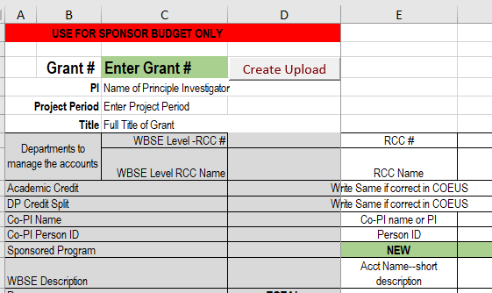  Blank Budget Template  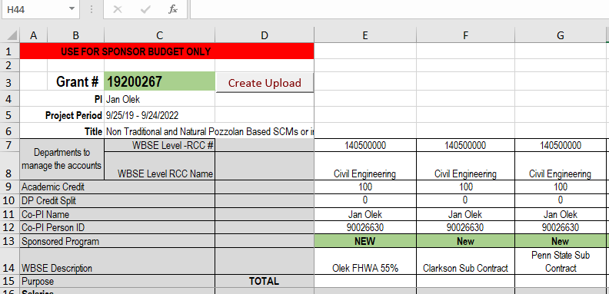  Sample of a completed Budget Template.  Note: Person ID can be found in SAP ECP using T-Code PA20.  Note: Depending on the grant you may be creating multiple accounts on a budget template. Use one column for each. Examples: Multiple PI’s, Subcontracts, Capital Equipment, Capital Fabrication, Participant Support, and items with different F&A  Using the COEUS Budget Total and Budget Summary by Period enter the $ amounts for each budget category on the template.  Enter F&A Rate as a %  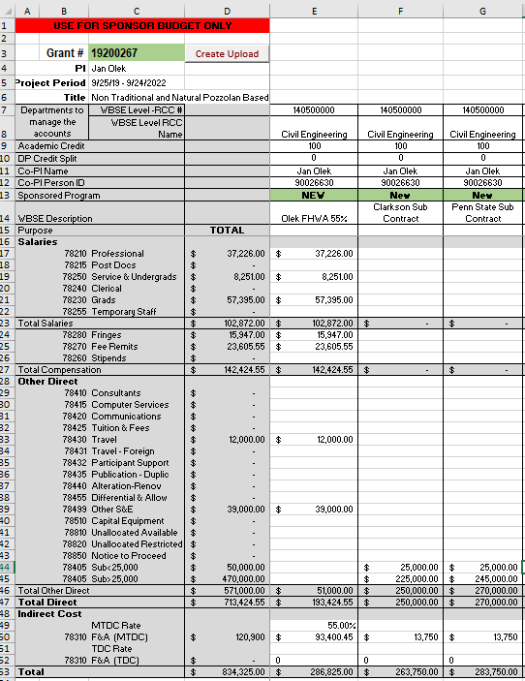  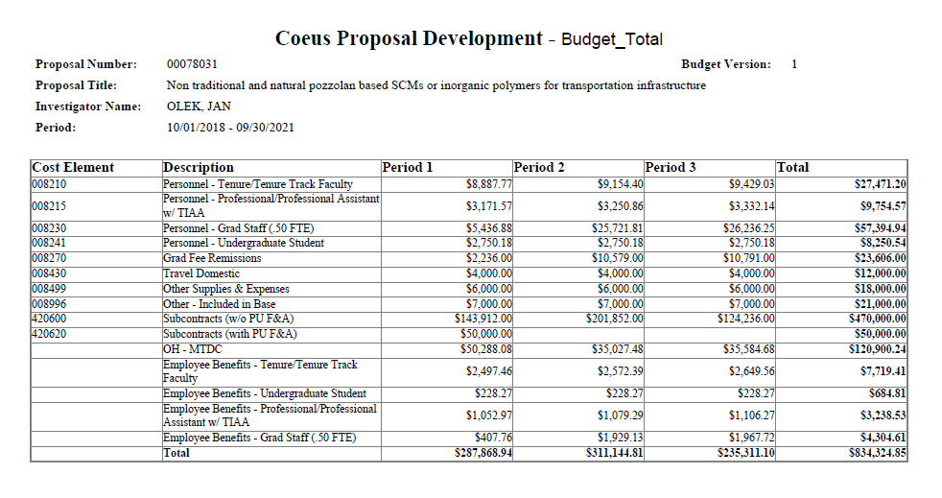  Example of a completed budget template.  Total here should match amount in award email.  - Save your template in your grant file.  - Review—Have a Business Manager or Research Account Specialist review template.  - Send—Email template back to the Post Award Specialist setting up your accounts for you.
Cost Share
Creating a Cost Share Template | CAUTION—Please see Business Manager or Specialist when completing.  TYPICAL SOURCES OF COST SHARE: (but not limited to):  Department committed cost share – usually for Academic year salary  College committed cost share – generally is for grad student support in the form of a PRF Fellowship or small amounts of cash committed  EVPRP committed cost share – generally for grad student support in the form of a PRF Fellowship, or capital equipment.  Memo Match – usually from an entity outside of Purdue committing their resources for the benefit of the project (sometimes in cash, sometimes in form of a discount of services, or a gift in-kind.)
Open your Form 32s found in the COEUS proposal narrative. See page 7 of this QRG on where and how to access.
- Identify the sources of cost share you have.
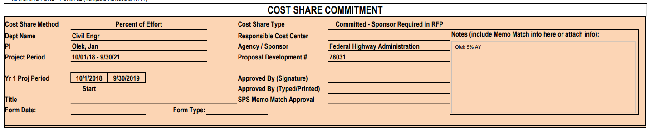

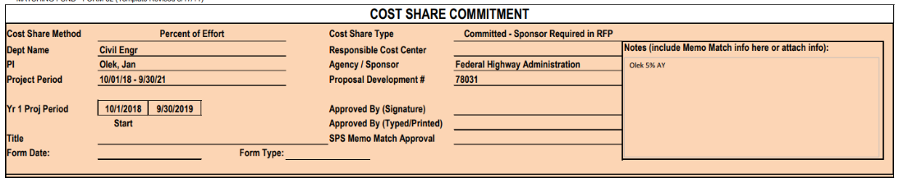
- Verify the form 32 has the correct development record number. See page 5 of this QRG on how to find the development record.

- Identify what the cost share is committing – usually there are notes which describe it.

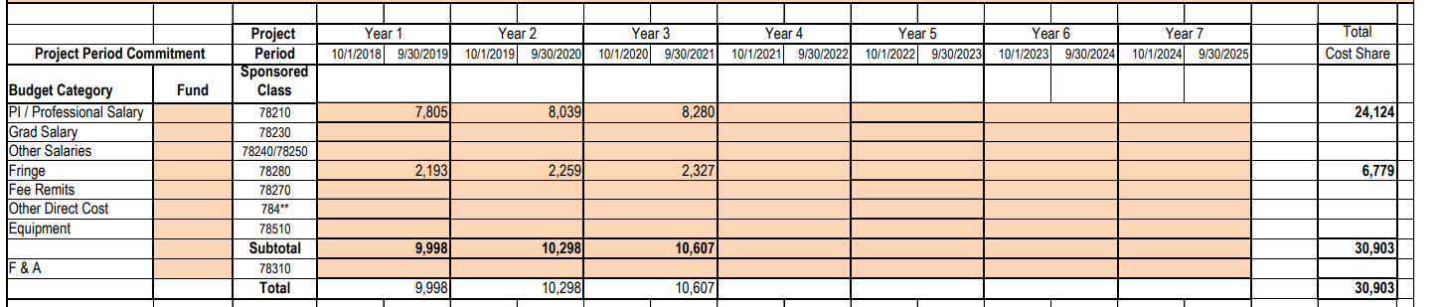
- The budget information below can also identify what is being committed. In this case, the commitment is for professional salary and the associated fringes.

- Validate your Form 32 matches the Cost Share budget summary by Period (instructions for how to find on page 8 above). If there are no notes in your form 32, you can determine who’s salary is being committed by viewing the cost share budget summary by period.
- To update a Cost Share Budget Template
https://www.purdue.edu/business/sps/postaward/bs/sapbudgettemplates.html
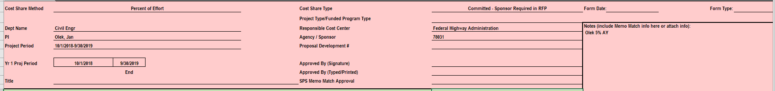
- Fill in the top section of the cost share budget template to match your form 32.

- Fill in the green section with your grant number (provided on the notice of award) the WBSE if already established or write NEW, and the name you want the WBSE to be called (for cost share always add C/S to the title.)

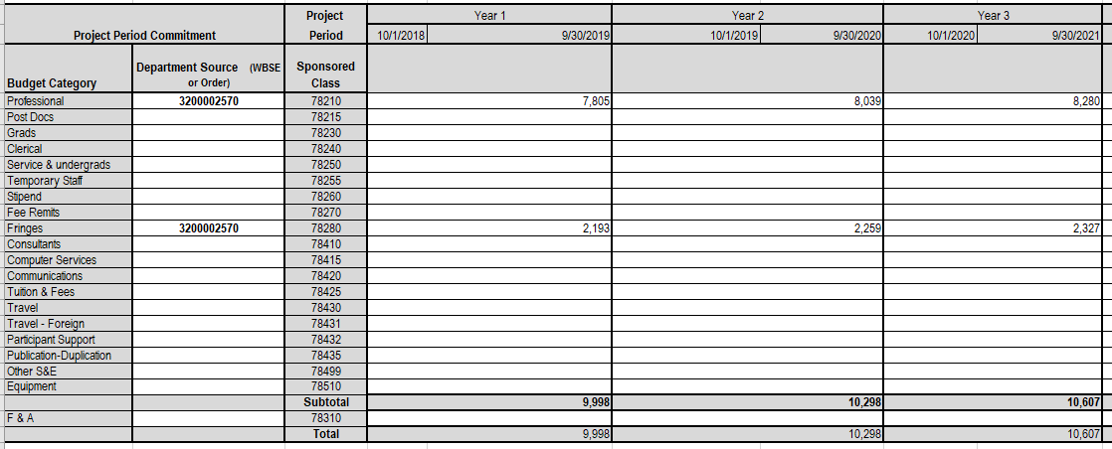
- Next fill in the Project Period Commitment information to match the Form 32. This identifies the budget per project period for this commitment. CAUTION: Make sure you put the numbers in the corresponding sponsored class. (So in this case, we know this is for PI salary so it makes sense that the sponsored class is professional salary.)

- Next fill in the Source account information. You’ll need to be provided this by your business manager or research specialist. They will help you determine who best to contact for this information.
Note: If you have multiple types of cost share you will complete a template for each type.
Each type of cost share could have more than one source account.

- Save your template in your grant file.
- Review—Have a Business Manager or Research Account Specialist review template.
- Send—Email template back to the Post Award Specialist setting up your accounts for you.

Grant Set Up Validation
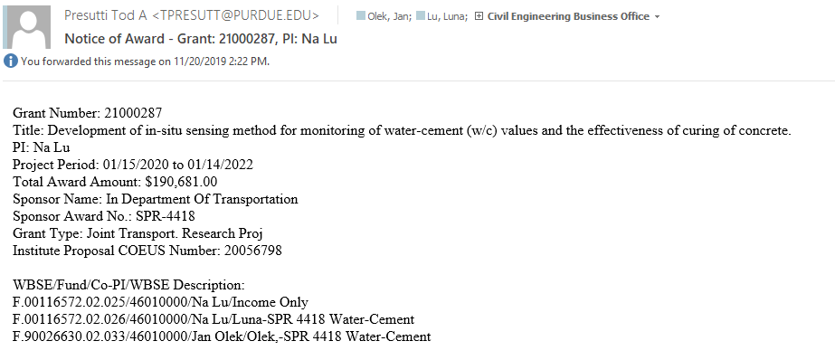
Sponsored Programs will send a new award email to the PI and responsible business office once a budget template has been uploaded.

- Use GMGRANTD QRG to go through and check for accuracy of grant set up. (Add Link to QRG)
- Check RCC of each WBSE set up for grant. Refer to page 1 and 2 of this QRG on how to check the RCC.
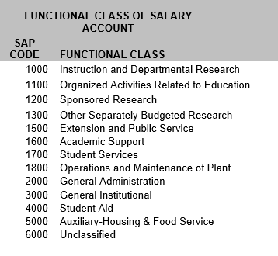
- Verify the Functional Area of the each WBSE. It is important to make sure the grant is set up under the correct functional area. Most sponsored research will be under the 1200 functional code; however, here is a list of all the functional areas for reference.
This could include testing agreements.
To check the functional area, Log into SAP Fiori through https://one.purdue.edu/

Enter the transaction code GMGRANTD

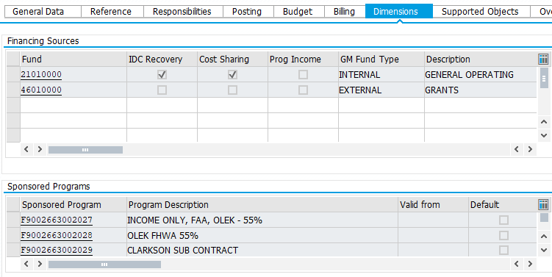
Click on the Dimension Tab and double click on the income only sponsored program account. Next click on the Budget transfer tab to view the functional area.
Double Click on WBSE for active accounts within the grant.
REMINDER: Never use the Income Only account.
