WebEx Getting Started – PC and Mac
- If you are a call center agent working remotely, sign into Purdue VPN. Instructions are provided in the link below. If you are not a call center agent or working on campus, VPN is not required. https://www.itap.purdue.edu/newsroom/200318_usewebvpn2.html.
- Make sure WebEx is installed on your computer and that you have a headset. WebEx can be installed and updated without admin rights.
https://www.webex.com/downloads.html
- WebEx (and Finesse if you are a call center agent) MUST be running on the local computer you are using. NOT your remote computer in the office.
- Launch WebEx and sign in with your Purdue alias-based email address.

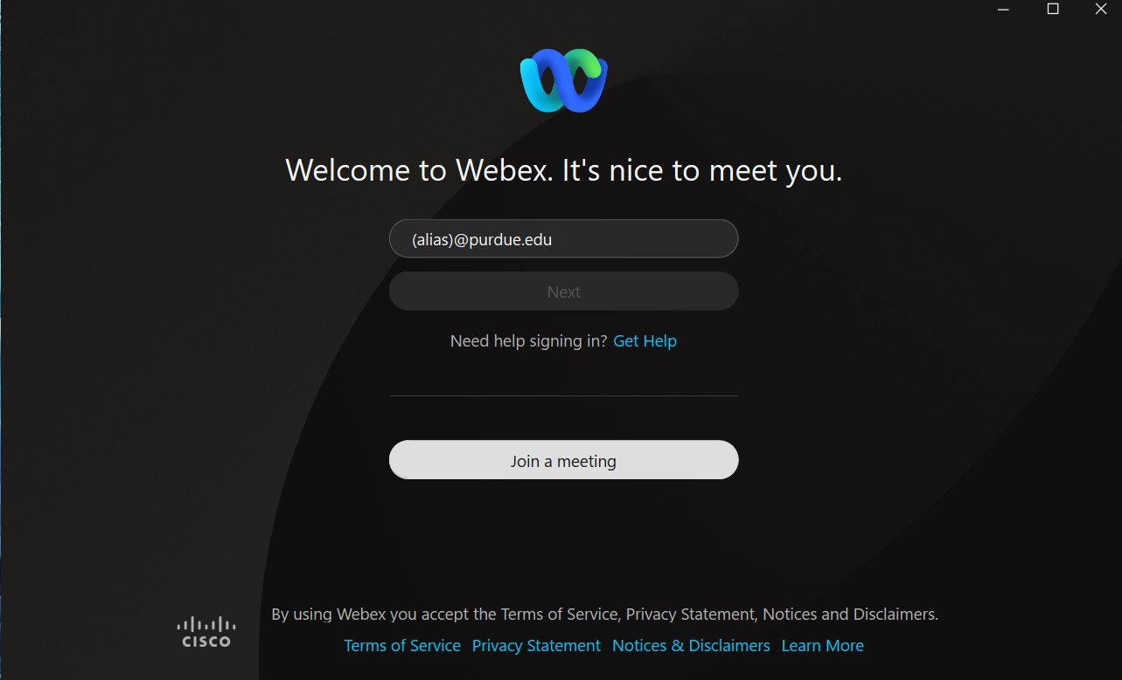

- Authenticate via Boiler Key when prompted.
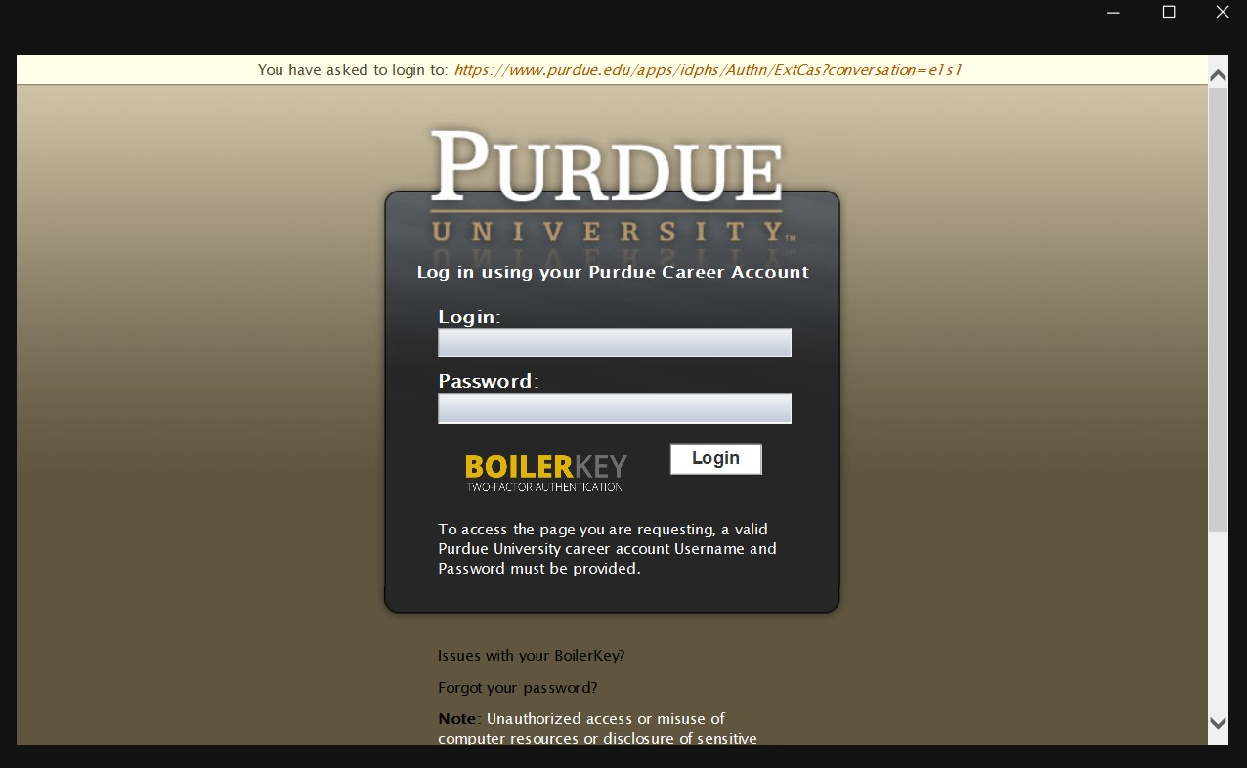

- If signing in for the first time on the campus network or over VPN, WebEx may default to controlling your desk phone in the office (if you have one). You must manually change it to soft phone mode. Enter softphone mode by clicking on your controlled desk phone in the upper right then click disconnect.

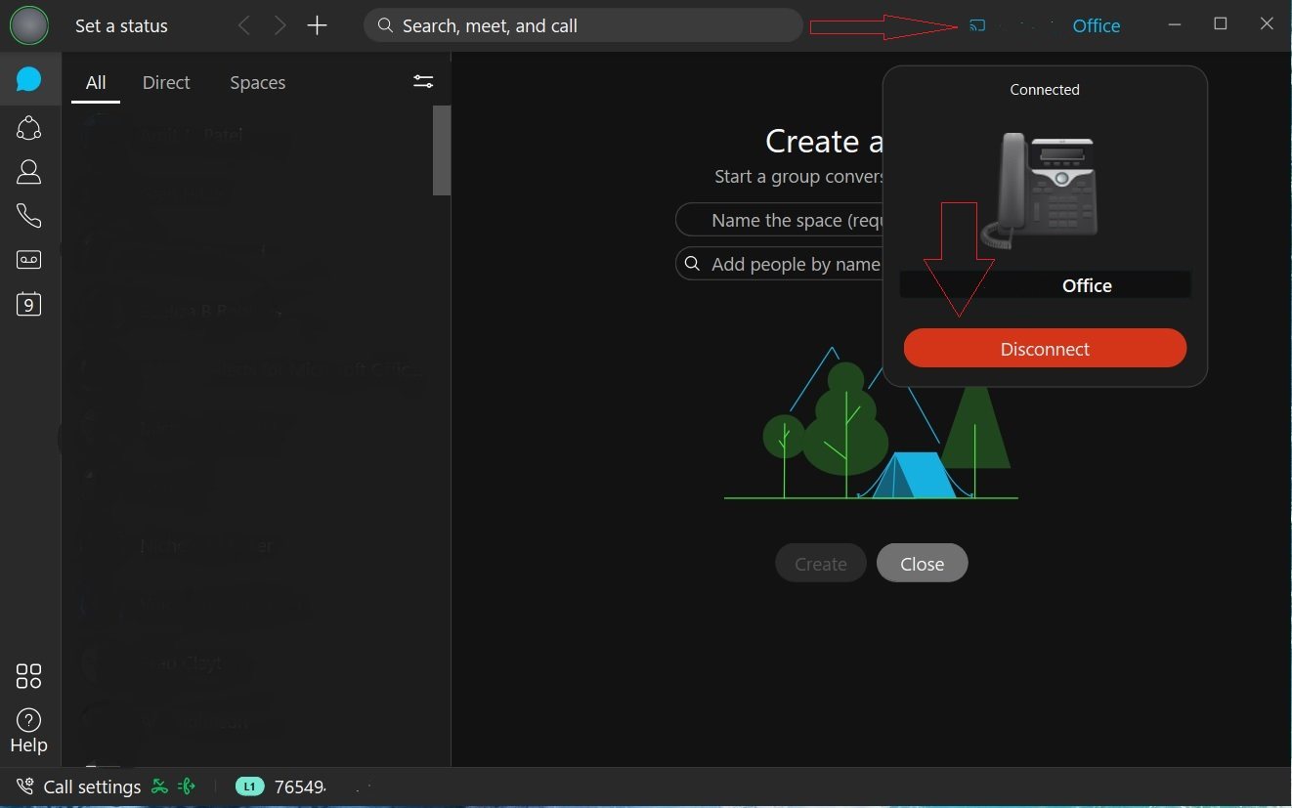

- If you have more than one line assigned, you should see your personal office number as well any others added to your account in the line selection box. Whichever line is selected in this box is the line your software will use for an outgoing call. If you are a call center agent, you should select your call center line if returning a call to a customer. All lines configured will ring in if called. They do not need to be selected first.

- NOTE- If you only have a single line assigned, the line selection box will NOT appear.
• Verify your headset is configured by clicking the green status circle in the upper left, choosing settings, then choosing the audio tab. You should select your headset in the speaker and microphone box.

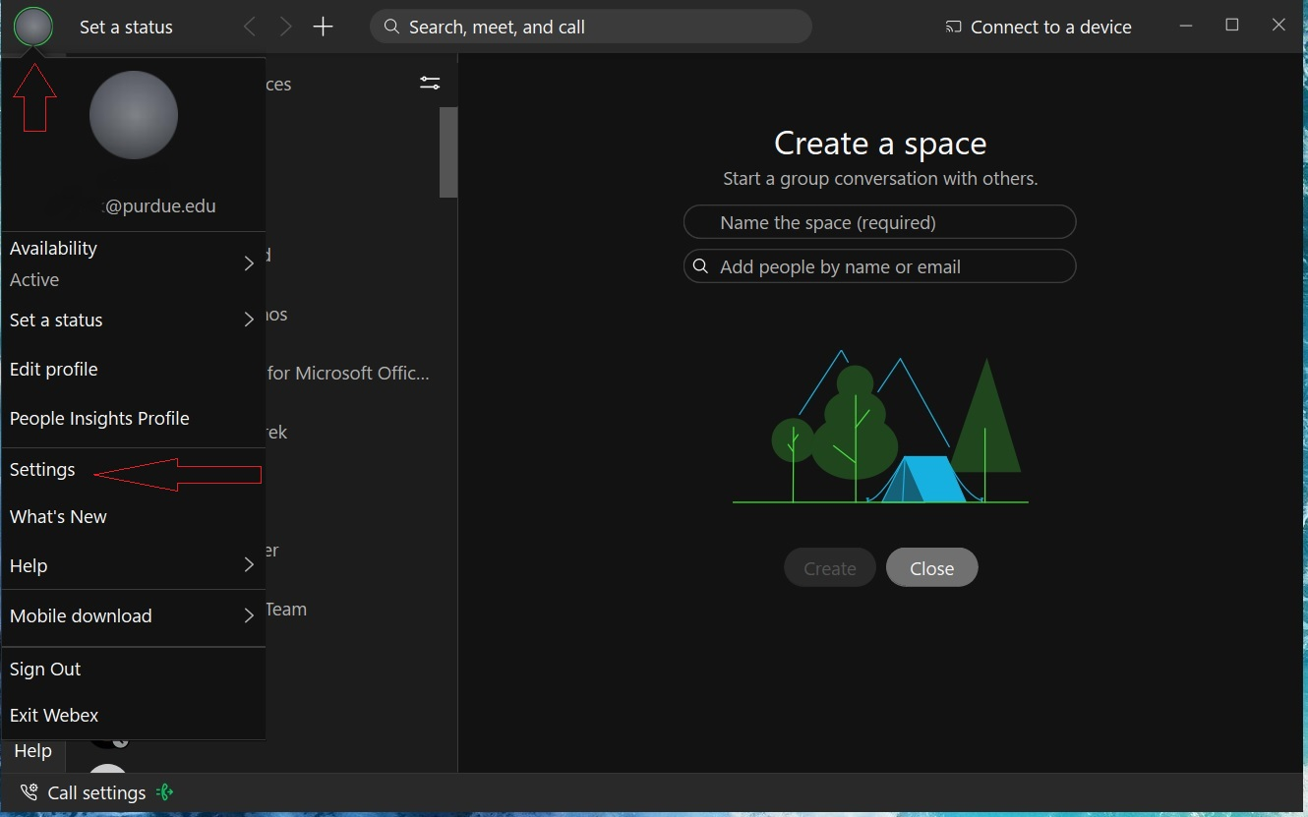
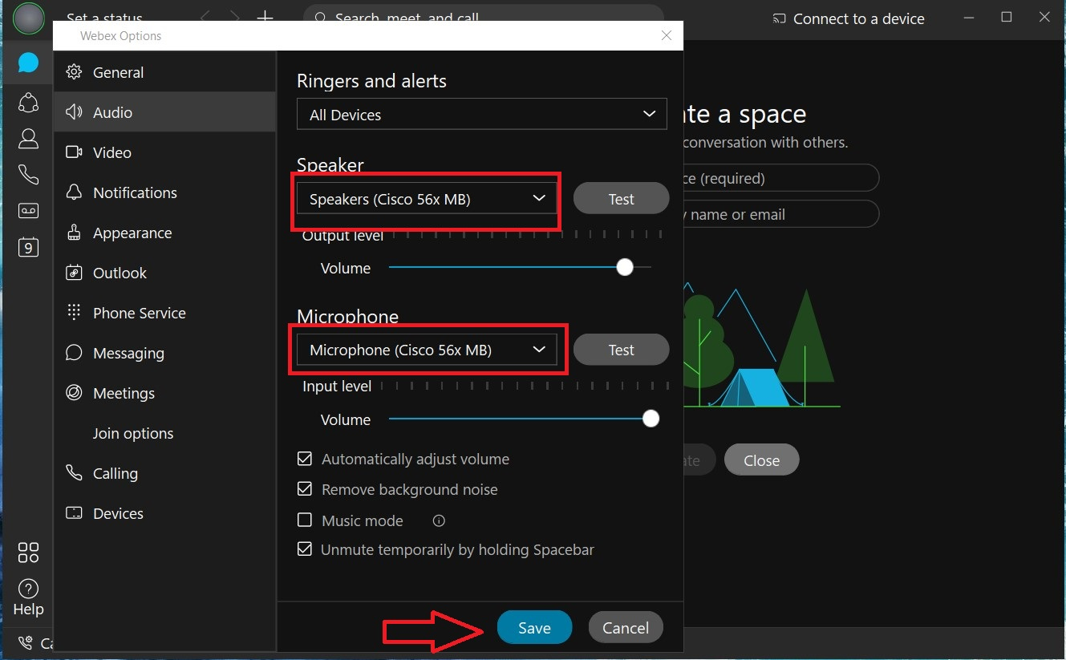
- After verifying your headset, please make a test call to cell phone or from your cell phone to your test your headset and audio. To place a call, enter the number in the search bar and press the ENTER key on your keyboard OR the click the phone tab to access the on-screen dial pad. Dial the number exactly as you would dial from a campus phone and click the phone icon to dial.
    - 5-digit campus number
    - 7(7digit local number)
    - 71(10-digit long distance number)

Dial From Search Bar:

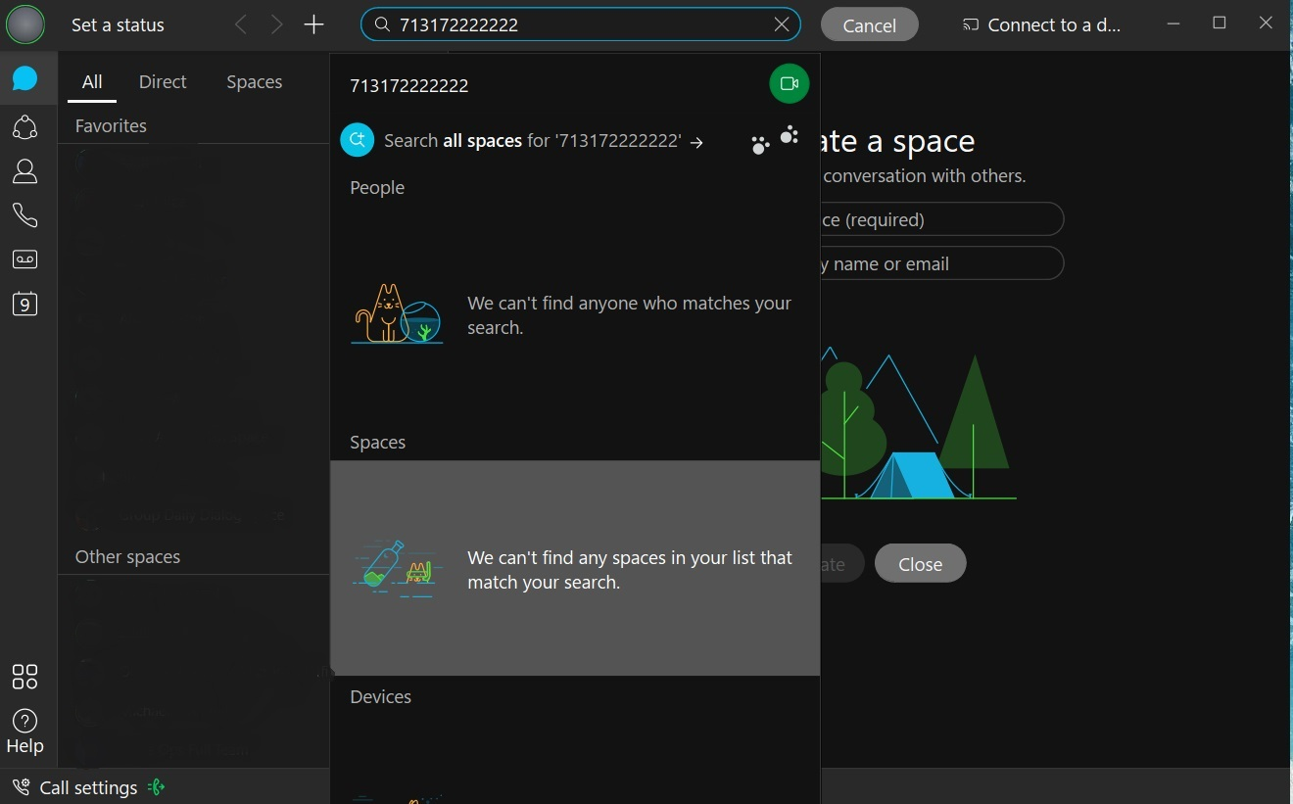

Dial from Phone Tab:

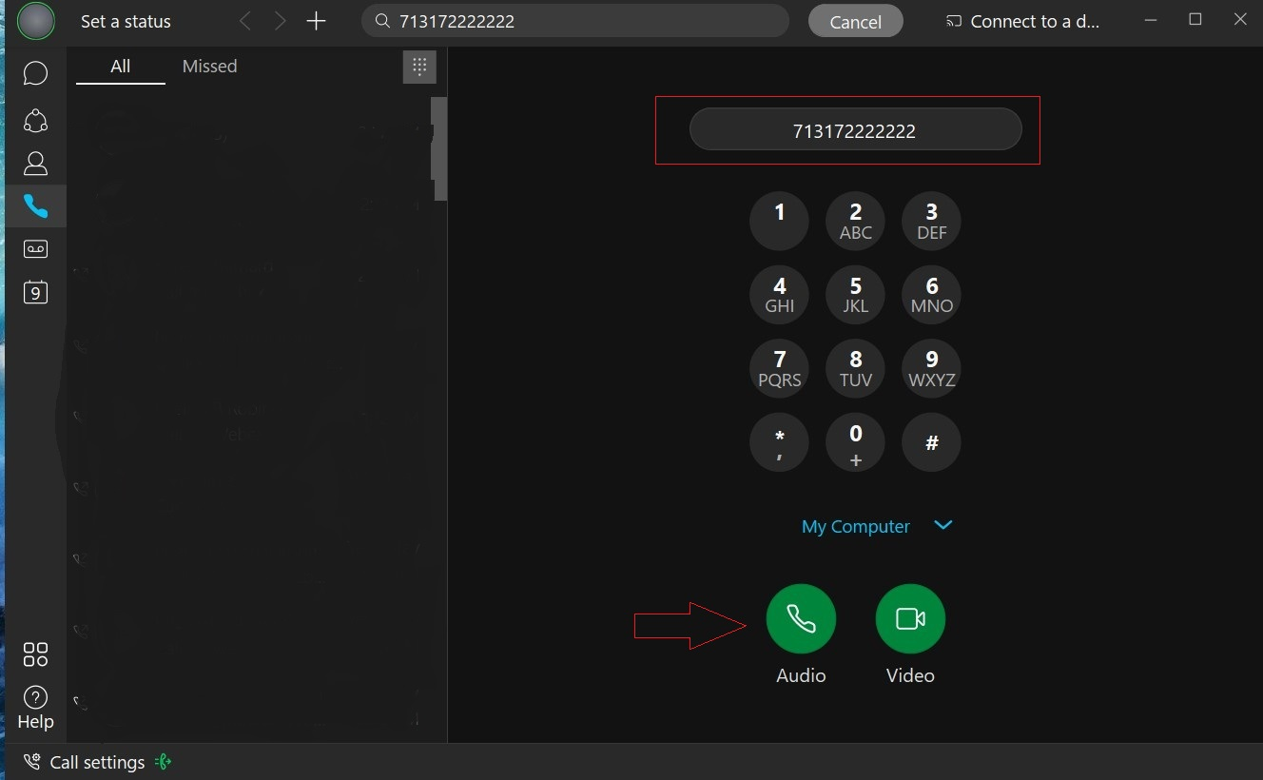

Finesse Tips (Call Center Agent):

Be sure that WebEx is not controlling your desk phone in the office per above. If WebEx is not registered in softphone mode, the Finesse sign in will always fail.

Once you have all of this set up and properly running, launch Cisco Finesse on your local workstation, and log in as you normally would.

Order of log in:
  - Log in to your computer
  - Log in to webvpn2.purdue.edu via Cisco AnyConnect VPN client (if working remote)
  - Log into WebEx. Place in softphone mode.
  - Log into Finesse using your normal agent log in.

