Alternate Ship To Address Quick Reference Guide
Last Updated: 04/2023
This document provides instructions for requesters to input a temporary alternate ‘ad-hoc’ ship to address to receive packages at an off-campus location. It is highly recommended that the requester receive departmental approval before shipping to an off-campus location. This change is allowed at the Line Item level of the requisition. Once work on campus resumes to normal, these ad-hoc addresses will be removed from Ariba.
NOTE: No changes to the ship to location in the user profile should be made.
Shipments being delivered to campus should maintain the regular process and select building location from the list of prepopulated entries.
Property Accounting policies and procedures must continue to be followed. Any capital equipment that will reside off-campus must follow the Use of University Equipment Off-Campus business process, which includes completion and submission of the requires the completion of the Form POC – Property Off Campus. Questions related to Capital Equipment need to be directed to Lisa Geisler at lgeisler@purdue.edu

Edit Line Item
From the requisition, select Line Items and click Actions.  From the drop-down, select Edit. | 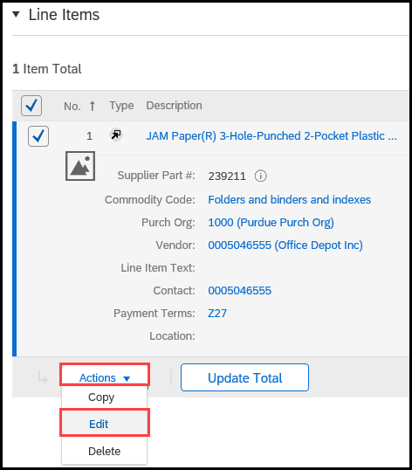
Under Shipping – by Line Item, click the Ship To/Plant drop-down.  Click Search More. | 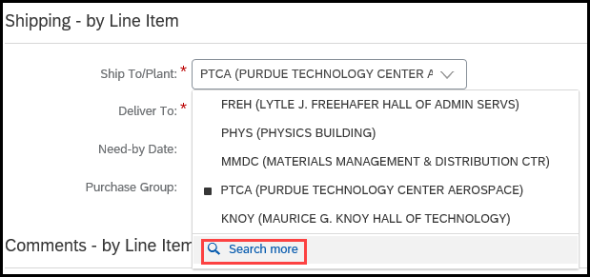
Click New. | 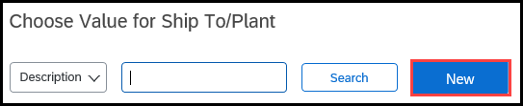
Create the Nonstandard Ship To/Plant entry.  - Do not create an address using ALL CAPS, this will cause errors.  - Use the two-character state code, IN.  - Although not marked, Postal (Zip) Code is required.  Complete the required fields, marked with a red asterisk (*), to create the new location.  Provide contact information such as phone number so the supplier or shipper can contact you with questions. | 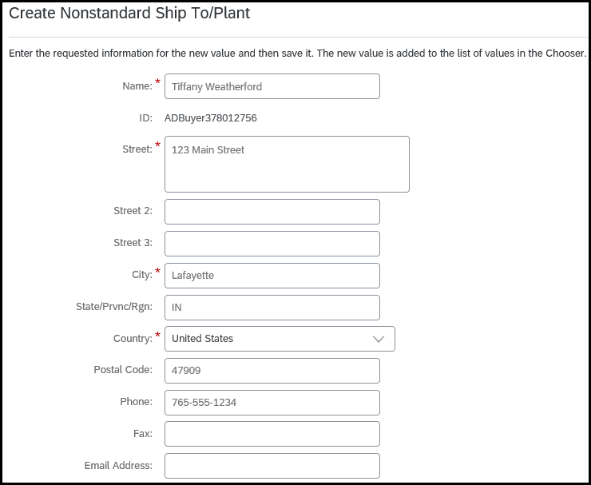
Click Save.
The created address is now available, click Select to add to requisition. | 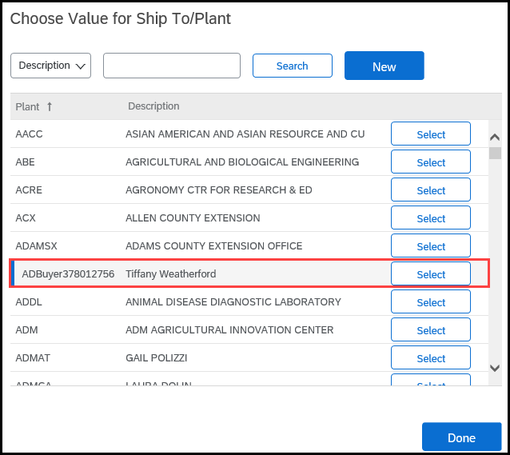
Once selected, the Ship To/Plant field will auto-populate with the Plant ID# created for the alternate address.  The system will auto-populate the name of the Requester in the Deliver To field; update to the appropriate name. | 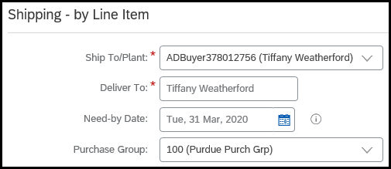
Once the alternate address has been created, it should be selected from the drop-down or located using the Search function. Do not create the alternate ship-to address each time it is to be used.

Purchase Order
The print view of the Purchase Order (PO) will contain the new address created in the Ship To/Plant section. | 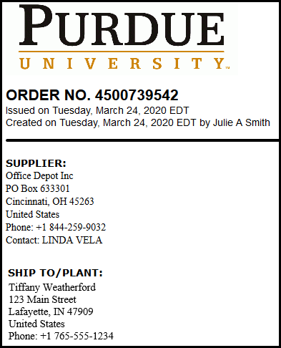

Approval
Requisitions with an off-campus address will be sent to Procurement Services to perform an appropriateness review. Procurement will contact the requester if they require additional information before releasing it for fiscal approval and payment.

