Ariba Basics, Navigation, and Settings Quick Reference Guide
Last Updated: 07/2023
This QRG provides the basic steps to navigate the Ariba site and edit user profile settings.
Jump Links: Access Ariba, Dashboard, Email Notifications, Accounting and Ship To Information, Expanding the To Do List, Searching for a Document

Access Ariba
Visit the OneCampus Portal and select Procurement – Ariba. | https://one.purdue.edu/
Log in using your Purdue Career Account Username and Password.  Click Log in. | 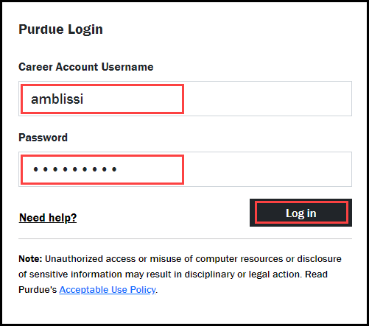

Dashboard
The Dashboard is the starting point for most activities in Ariba and contains three primary design elements that make it easy to navigate the solution: Dashboard Tabs, easy access to Common Actions, links and customizable Content Areas for quick access to documents, and a second Common Actions. Access to functions depends on permissions.
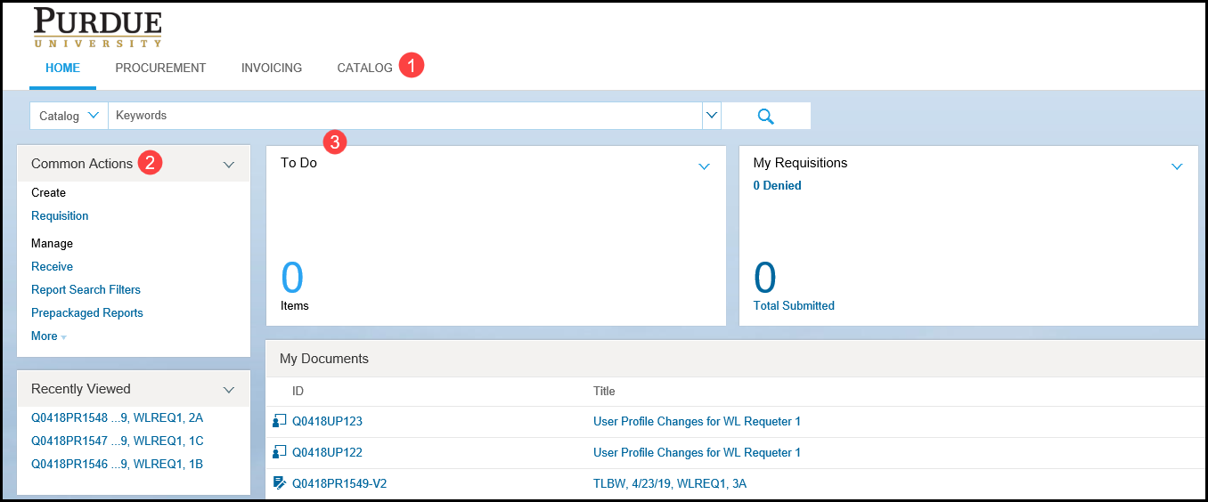

Tabs
Tabs are available on every page to provide access to specific components and pre-defined content based on the functional area you are working in.
The dashboard tabs that are displayed depends on site configuration and authorized functions of the individual user access based on group membership.
Tabs are set by default, but the names, content, and number of tabs can be changed from the Configure Tabs button.

Common Actions
The Common Actions panel appears on each tab and provides links to create and manage common tasks within the system.
For example, users can view up to the last 10 recently accessed documents in the Recently Viewed content area.

Content Areas
Content Areas are individual boxes for displaying content or commands.
Content areas can be placed in various locations, collapsed or expanded, or removed from the tab altogether.
Common content areas include:
- To Do – Used to manage the documents, such as tasks, that need some type of action.
- My Documents – Includes a list of the documents the user has created to date. The listing may be sorted using column headers of Title, Date and Status.
- Search – Used to search for documents such as requisitions, purchase orders, receipts invoice reconciliation. Use the down arrow to select the document type and enter the number.
- News – Important time sensitive information is added to the news portlet by the system administrators.

Email Notifications
Email notification settings can be edited and are separately maintained for emails regarding requisitions and receipts.

Requisitions
Click Down Arrow to the right of your name to view the Preferences drop-down menu.  Select Change email notification preferences. | 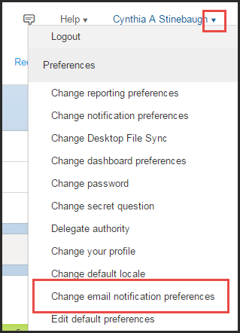
Click the Edit preferences for drop-down and select Requisition. | 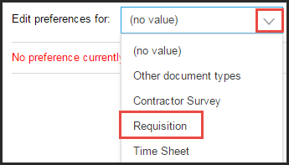
For Approvers and Watchers, select one of the following Notification method options for each:  - Send individual emails – An email is sent immediately for each requisition for which you are listed as an approver.  - Send consolidated email – One email is sent each day and includes a summary of pending approvals. | 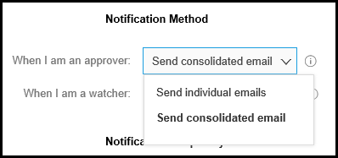
To reduce emails, uncheck the Send email each time my document is approved checkbox.  Notification frequency can also be edited by selecting an option from the drop-down for the following:  - When I need to approve a document  - When my approval is overdue  - When I am a watcher  These notifications can be sent repeatedly, once, or not at all. | 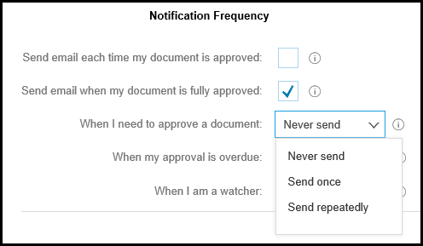
Click Save. | 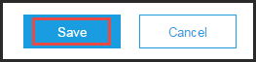

Receipts
Click Down Arrow to the right of your name to view the Preferences drop-down menu.

Select Change email notification preferences.
Click the Edit preferences for drop-down and select Receipt. | 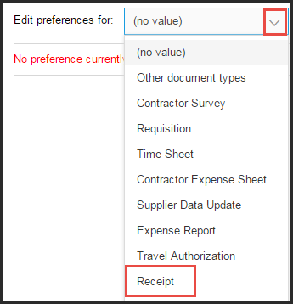
For Approvers and Watchers, select one of the following Notification method options for each:
- Send individual emails – An email is sent immediately for each requisition for which you are listed as an approver.
- Send consolidated email – One email is sent each day and includes a summary of pending approvals.
To best manage the number of emails received, use the recommended settings listed below:  - Uncheck both checkboxes.  - Select Never send for approvals.  - Select Send once for watcher. | 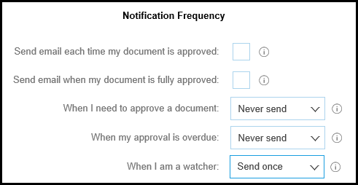
Click Save.

Accounting and Ship To Information
Accounting and Ship To information can be set in the User Profile. It is suggested that users create these settings only if they will be using the same Accounting information and shipping to the same location for each purchase.
Click Down Arrow to the right of your name to view the Preferences drop-down menu.  Select Change email notification preferences. | 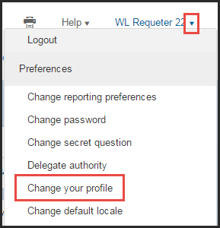
Select 2 Account/Ship. | 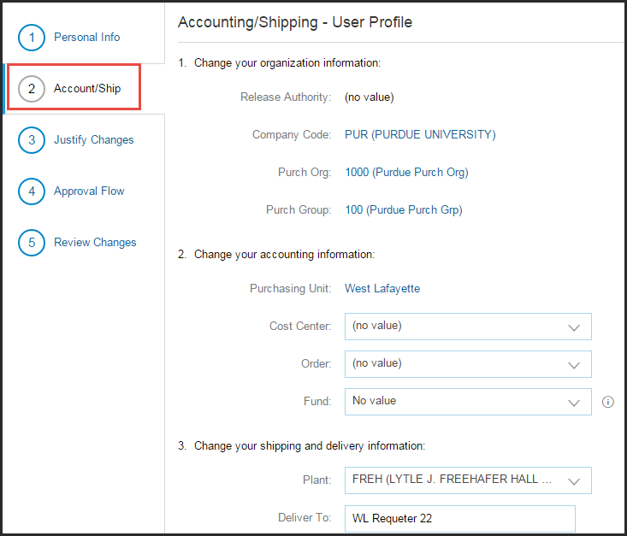
Under Option 2, enter the Order information in the appropriate field.  NOTE: WBS Elements cannot be used for default accounting information. | 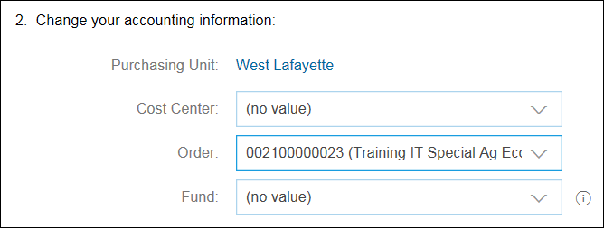
Under Option 3, click the Plant drop-down and select Search more. | 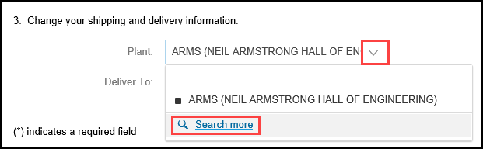
In field drop-down, select Plant.  Enter your building code and click Search. | 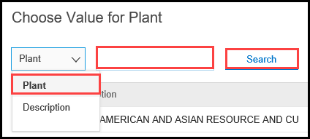
Click Select next to appropriate building location.  Click Done. | 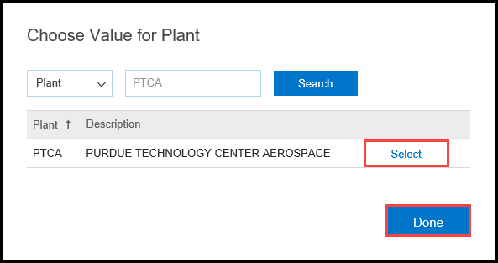
Click Next. | 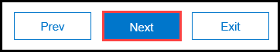
Enter Comments or Add Attachment, if necessary. | 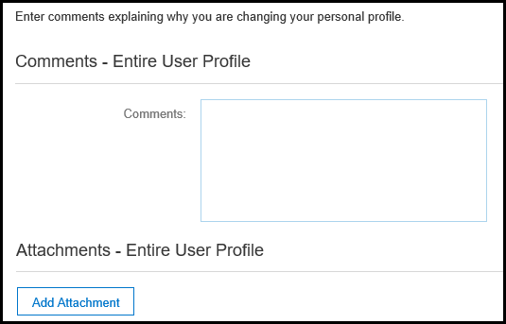
Click Next.
The Approval Flow for the request is displayed. | 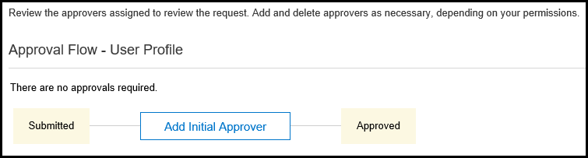
Click Next.
Review changes.
Click Submit. | 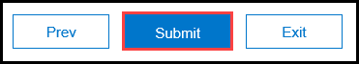
Click Home to return to the Ariba Home page. | 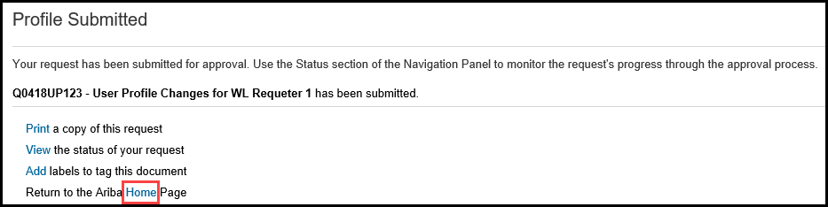

Expanding the To Do List
Many times there are more items than what is listed in the To Do tile, it is recommended to drill down and change the date to ensure all items are shown. The following steps will get you to the full list of items.
From the bottom right of the To Do list, click View All. | 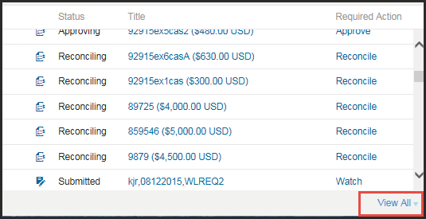
From the drop-down, select the type of actions to view. | 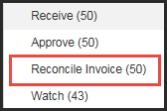
Click the arrow to expand Search Filters. | 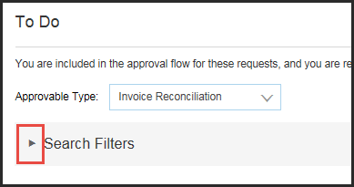
Enter desired filters. | 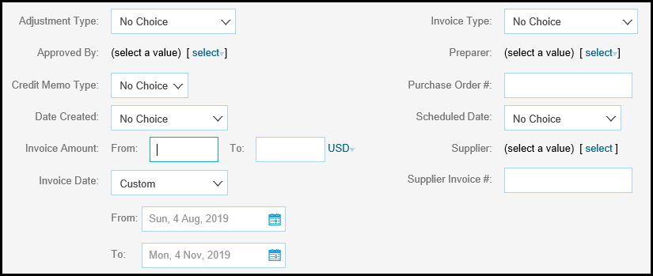
Click Search. | 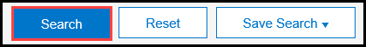
The expanded To Do list for the selected action and filters is displayed.

Searching for a Document
The most commonly searched documents are Requisitions, Purchase Orders, Receipts and Invoices. However, a search is not limited to only these document types.
From the Home tab, click arrow to display the search category drop-down.  Select type of document to search. | 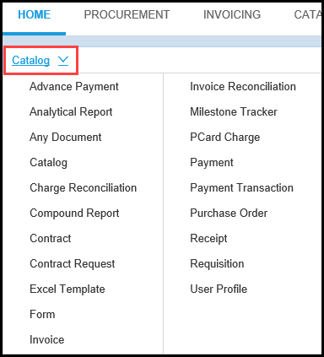
Enter the requested search criteria (which varies by document type selected).

Click the magnifying glass to execute search.
Available Search Filters are displayed.  Edit filters as needed to expand or narrow the results. | 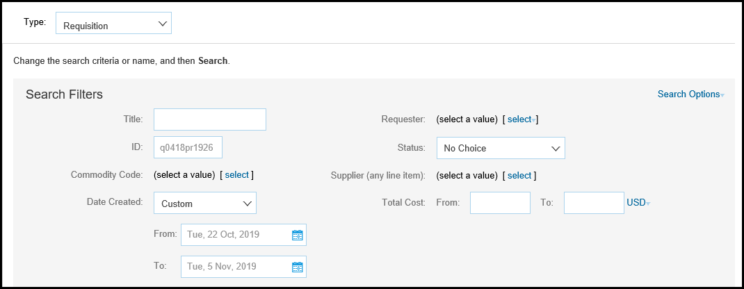
The Search Results are listed below the filter options. | 