Request for Purchase $10,000 and Over Quick Reference Guide
Last Updated: 07/2023
This QRG provides the steps for purchases greater than or equal to $10,000. Procurement Services facilitates the procurement method for purchases of $10,000 or more through formal solicitations.
Jump Links: Procurement Services Webpage, Complete the Request, Check the Status of Request

Go to the Procurement Services Webpage
Go to the Procurement Services Webpage.  Click Purchasing.  Click Special Purchases. | https://www.purdue.edu/procurement/  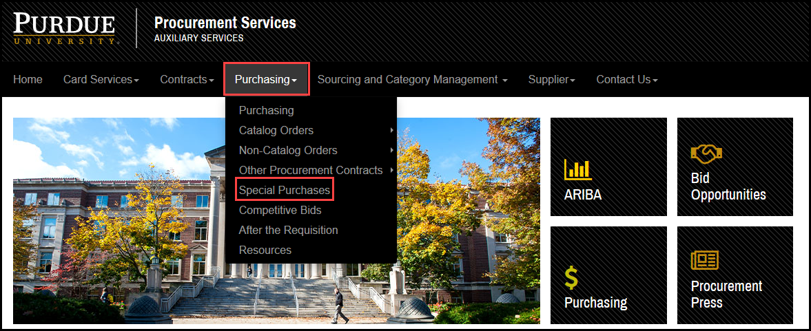
Click Request for Purchases $10,000 and Over Form. | 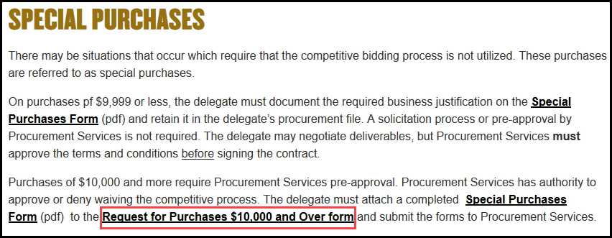
Click Submit a Request. | 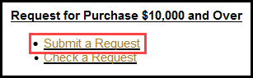

Complete the Request for Purchase $10,000 and Over
Complete the Request for Purchase $10,000 and Over providing as much information as possible.  Customer Contact Information is the information for the person that will be the owner of the purchase or primary end user (i.e., professor, researcher, requester). Look Up Directory is available.  Tip: Use the tab key to advance from one field to the next.  Note: Required fields are marked with a red asterisk (*). | 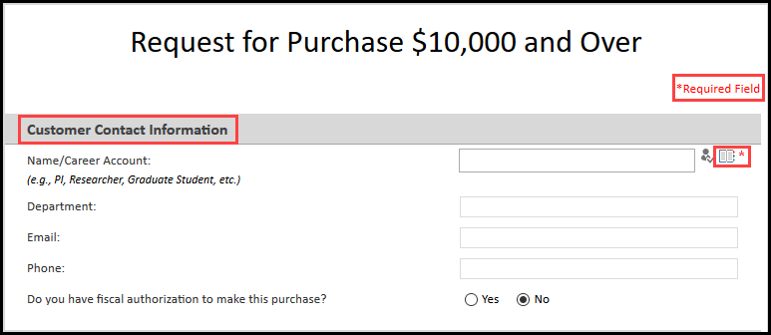
Business Office Contact information is needed to support the request. | 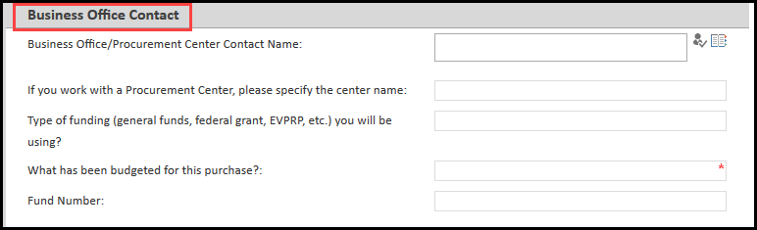
Project Information is essential to speeding up the review process.  Enter a brief, but specific, description of the item being purchased.  Attach all documents pertinent to the request by clicking on the Click here to attach a file.  Note: If the contract number is known and it is still a valid (non-expired) contract, this form should not be used. You can proceed with entering a requisition and note the contract number in the comment section of the requisition. | 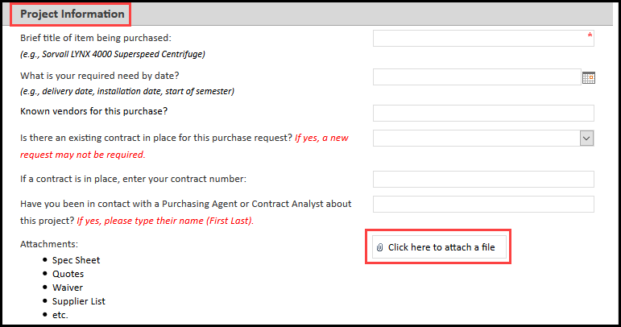
Preparer Comments allows the addition of comments regarding the request. | 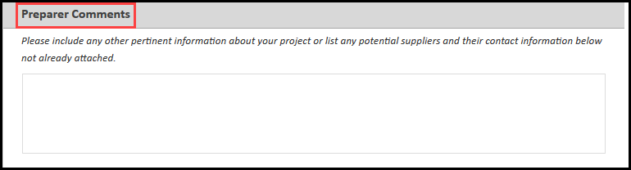
After all fields are completed, click the Submit button. | 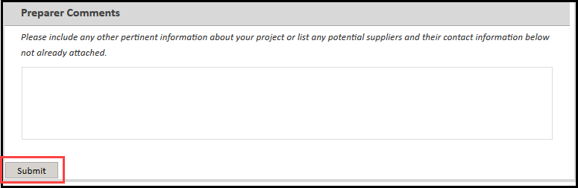
After clicking the Submit button, you will receive a confirmation of the submittal. | 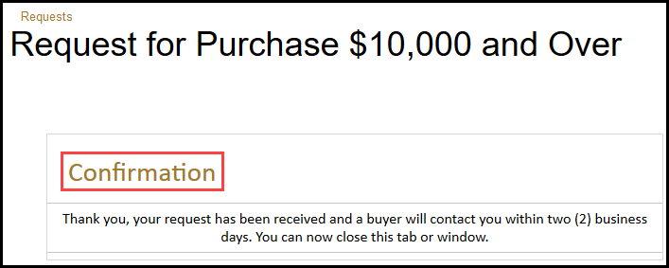

Check the Status of Request
Go to the Procurement Services Webpage.  Click Purchasing.  Click Special Purchases. | https://www.purdue.edu/procurement/
Click Request for Purchases $10,000 and Over Form.
Click Check a Request. | 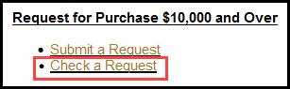
To search the database for your request, input your name or title of item being purchased in the Search This Site field and click the magnifying glass icon.

A screen of results will appear. Find your request and click. A screen will appear that shows the status of your request.
