INITIATING THE THESIS ACCEPTANCE FORM
Instructions for Students Depositing a Thesis or Dissertation
The Graduate School has released a new electronic Thesis Acceptance Form which replaces GS Forms 9, 32, 15, and 36. Please follow the instructions on the following pages if you are a student depositing a thesis or dissertation. You must have an approved Form 8 for the final exam before you will have access to initiate the Form 9.
We offer additional instructions for:
- Chairs
- Committee Members
- Graduate Program Department Head
If you experience an issue with the form or have questions about the process which are not covered here, please feel free to contact the Thesis & Dissertation Office by telephone at (765) 494-2600 or by email at thesishelp@purdue.edu.

TO INITIATE THE THESIS ACCEPTANCE FORM:
- Log into myPurdue (https://mypurdue.purdue.edu) using your Purdue Career Account Credentials.
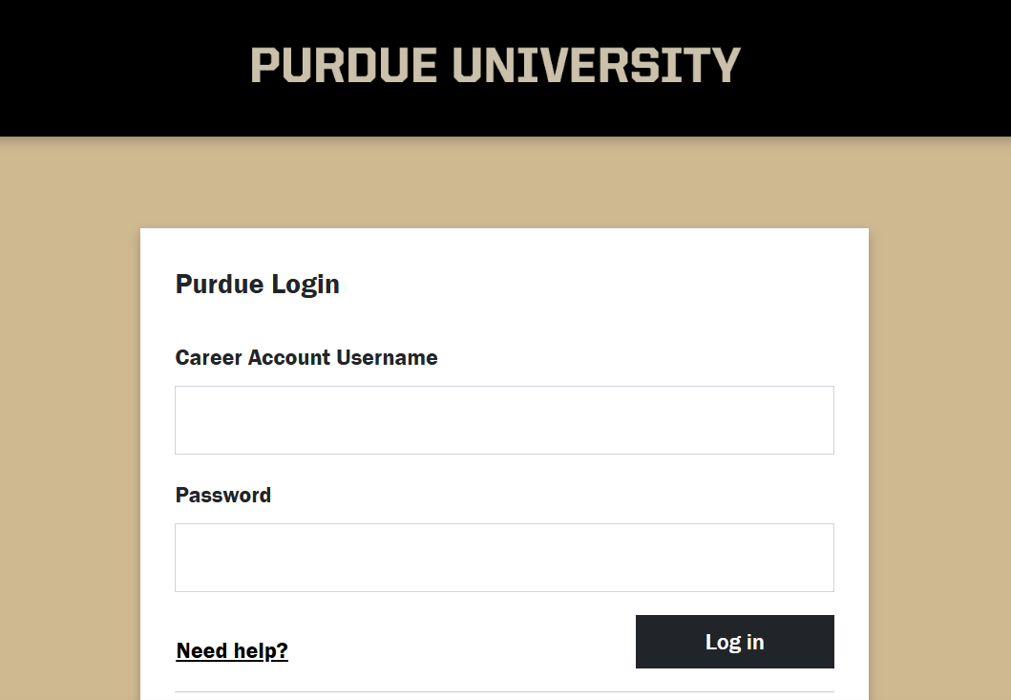
- Search for the Graduate Students card.
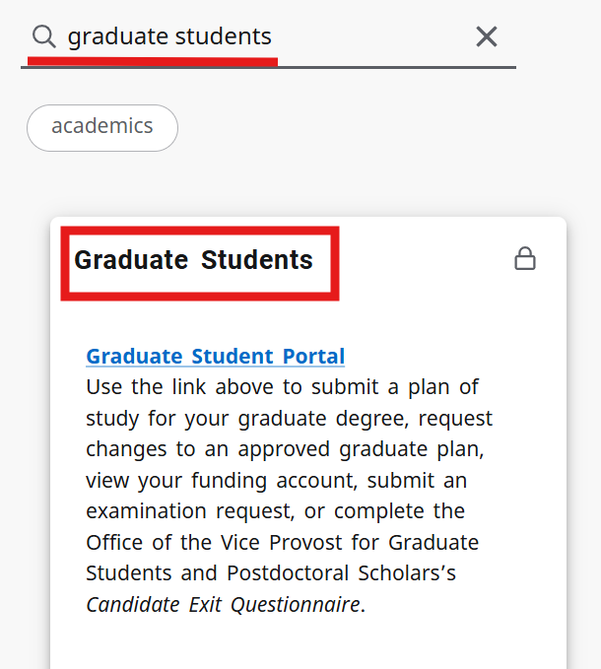
- Click the Graduate Student Portal link.
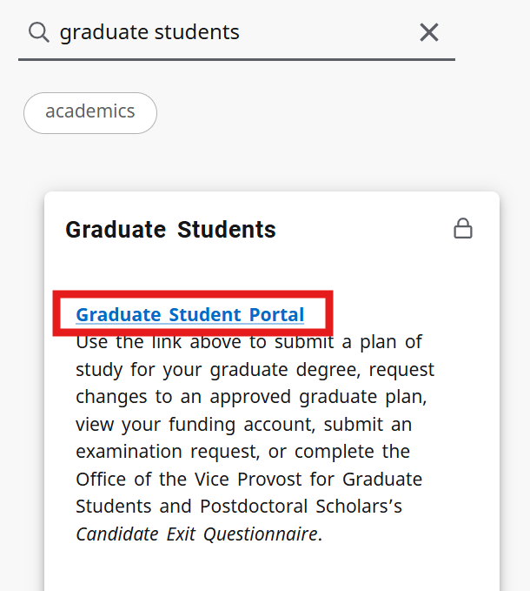
- If prompted, log into the Graduate Student Database. Your login is your Purdue career account credentials.
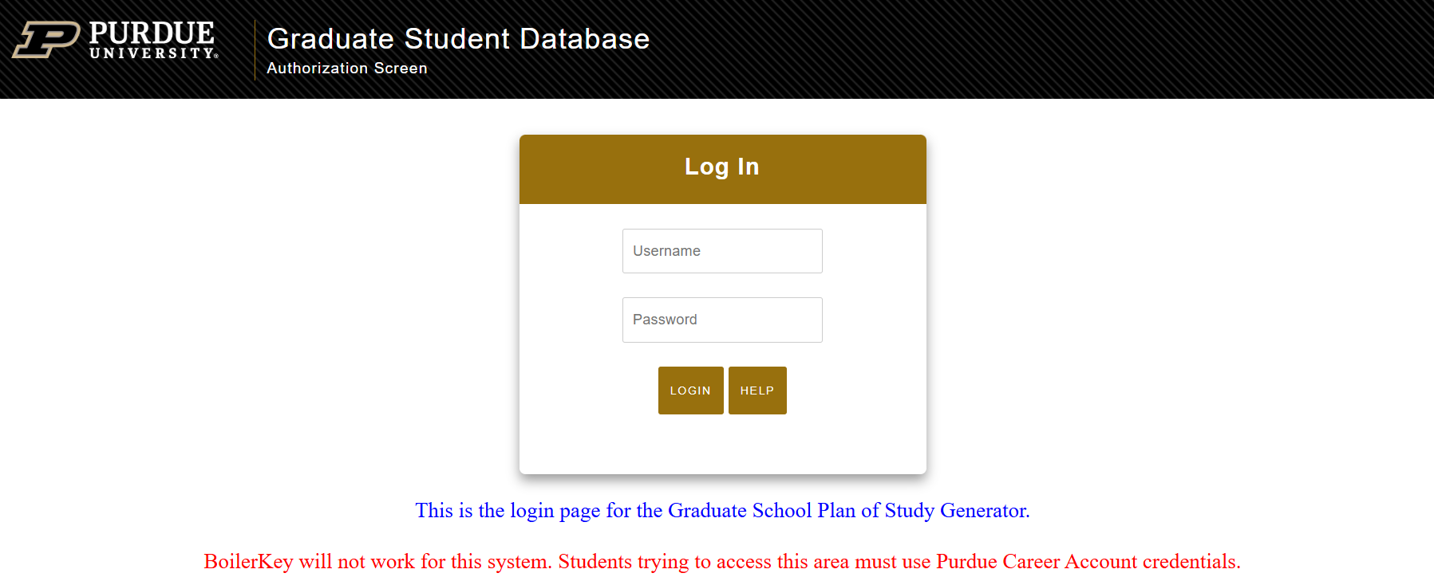

- Scroll down until you see Form 9: Electronic Thesis Acceptance Form (ETAF). Click on the link.
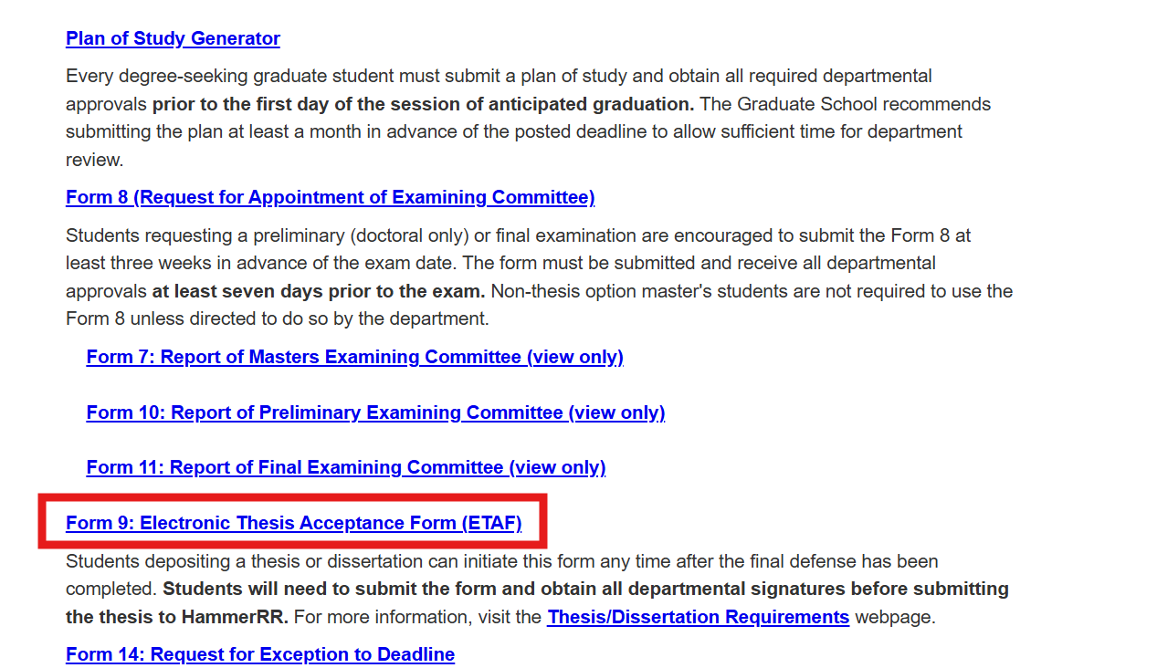
Note: If you have not submitted the Form 8 for the final exam, you will not see the Form 9. You will need to submit your Form 8 and get all required signatures before the Form 9 link displays.
- Click the Initiate Thesis/Dissertation Acceptance Form link.
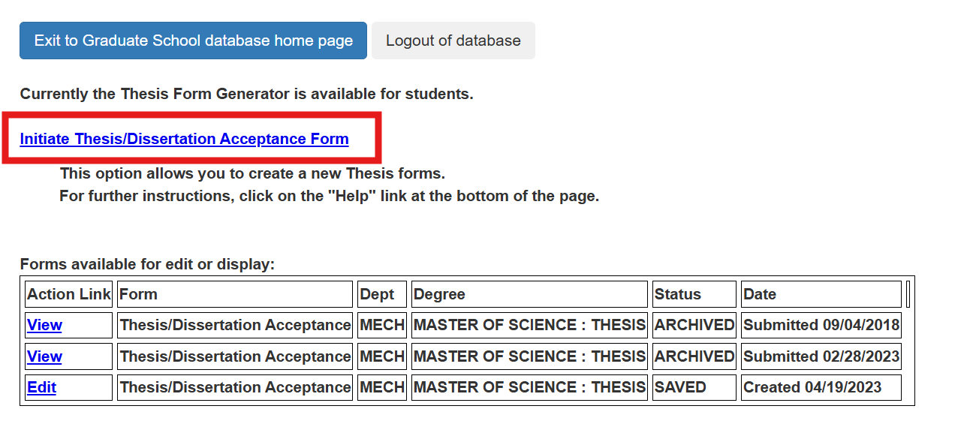
- If you have submitted a Form 8 for multiple graduate degrees, click on the radio button next to the degree that pertains to the thesis or dissertation you are currently depositing. At the bottom of the page, put your personal email address in the Permanent Email Address box, and click the Continue button.
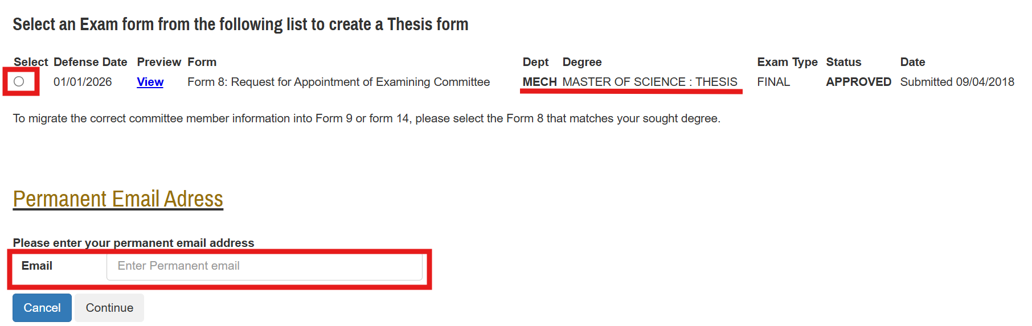
- Review your personal information, update your thesis or dissertation title if necessary, and then click Save and Continue.
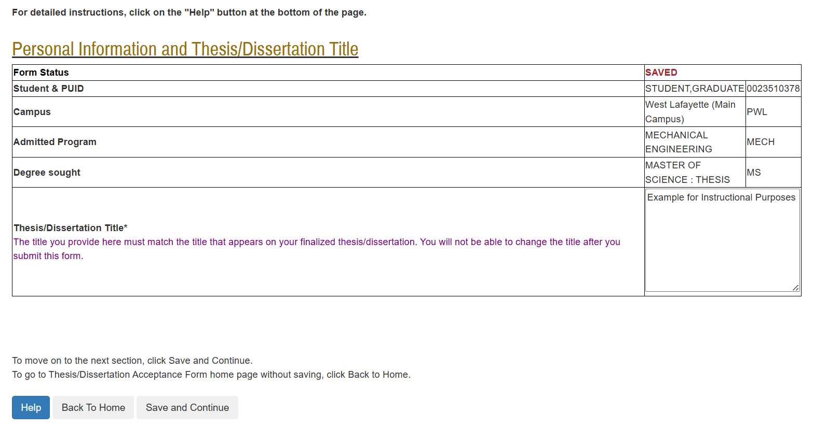

- Review your Thesis/Dissertation Committee. The committee must match the final exam committee listed on your Form 8. If the list is correct, click Save and Continue.
If you need to make a change to the list, click Save without submitting, log out of the Graduate School Database, and contact your department’s Plan of Study Coordinator. Ask him/her to email thesishelp@purdue.edu with your updated committee list. After you receive a confirmation email that your list has been updated, log back to the Graduate School Database and continue submitting the form.
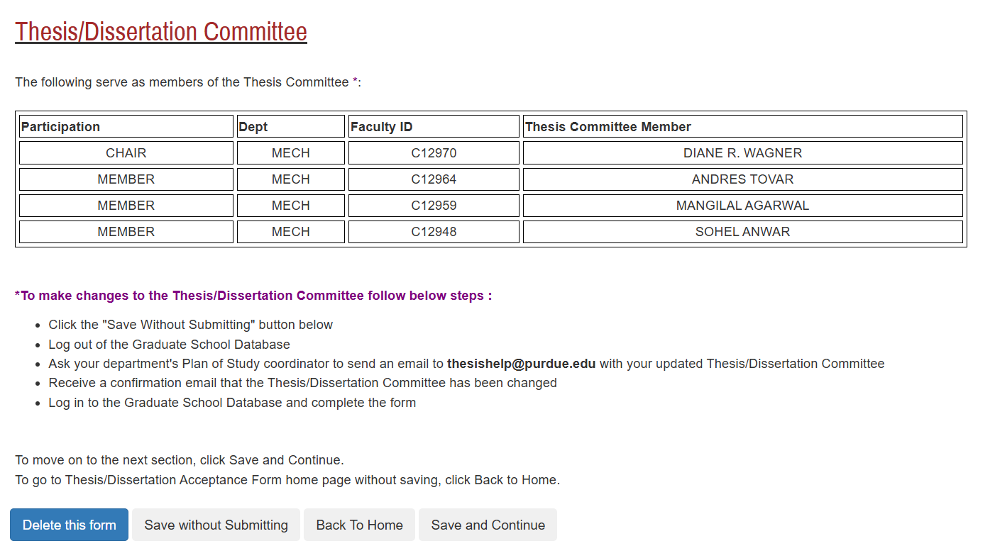
- Carefully read all material on the Thesis/Dissertation Agreement page, check the box indicating you acknowledge the terms of the agreement, and then click Save and Continue.
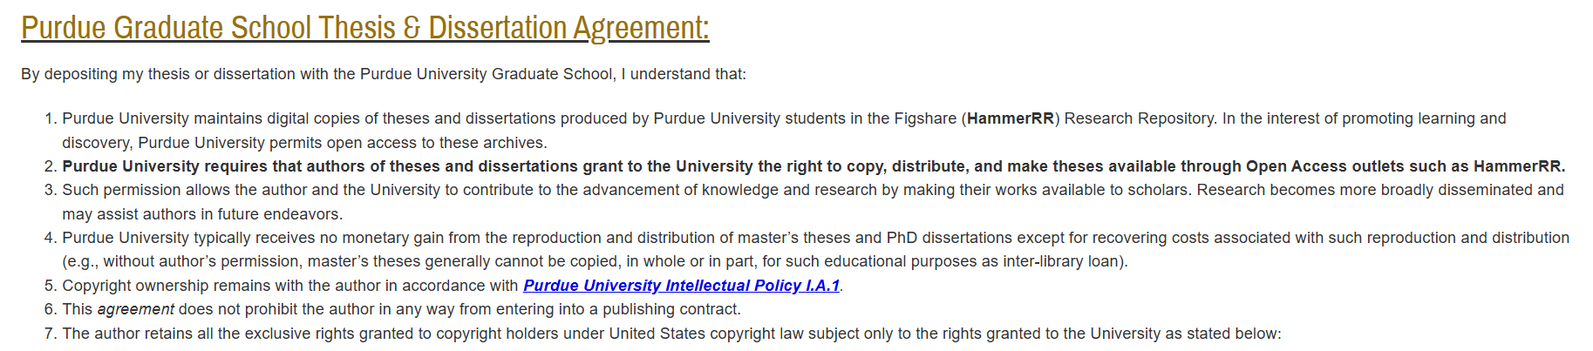
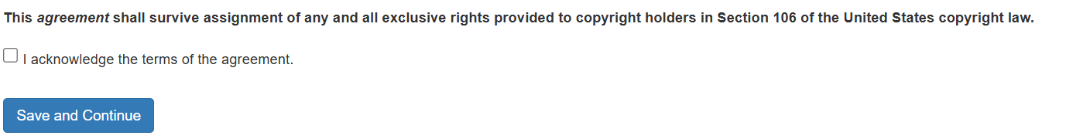
- Carefully read all material on the Embargo and Confidentiality Agreements page, discuss your options with your major professor, make your selection(s), and then click Save and Continue.
Note: Theses and dissertations that are not subject to export-controlled/CUI requirements may select an embargo or confidentiality period of 6 months, 1 year, or up to a maximum of 2 years. Theses and dissertations that are subject to export-controlled/CUI requirements must select an indefinite confidentiality period and include the Technology Control Plan (TCP) number, all secure storage locations of the thesis/dissertation, and all secure storage locations of the research data & documentation.


- Carefully read all material on the Research Integrity and Copyright Disclaimer page. To proceed with this form and deposit your thesis or dissertation, you must check the box next to “Yes, I certify”. After you have made your selection, click Save and Continue.
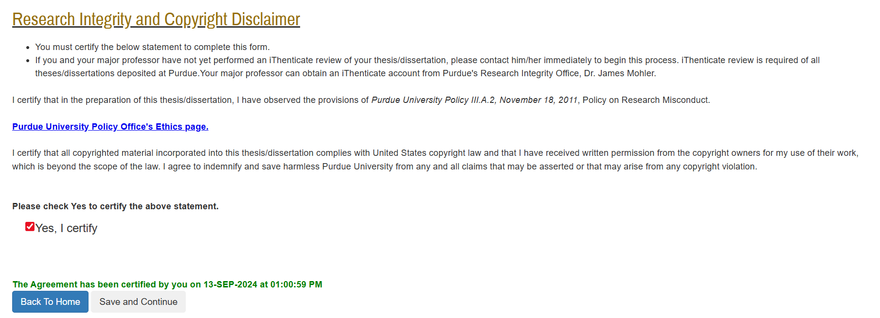

- Carefully read all material on the ADA Accessible Document Statement page. To proceed with this form and deposit your thesis or dissertation, you must check the box next to “Yes, I certify”. After you have made your selection, click Save and Continue.
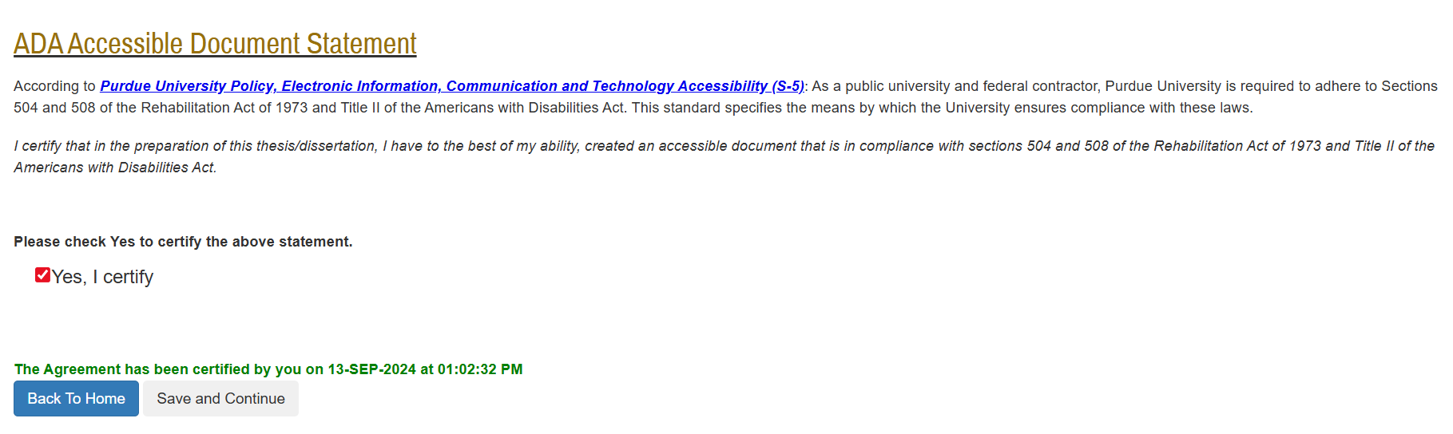
- Confirm that you have completed all sections (completed sections are marked with a check), and then click Preview Thesis/Dissertation Form.
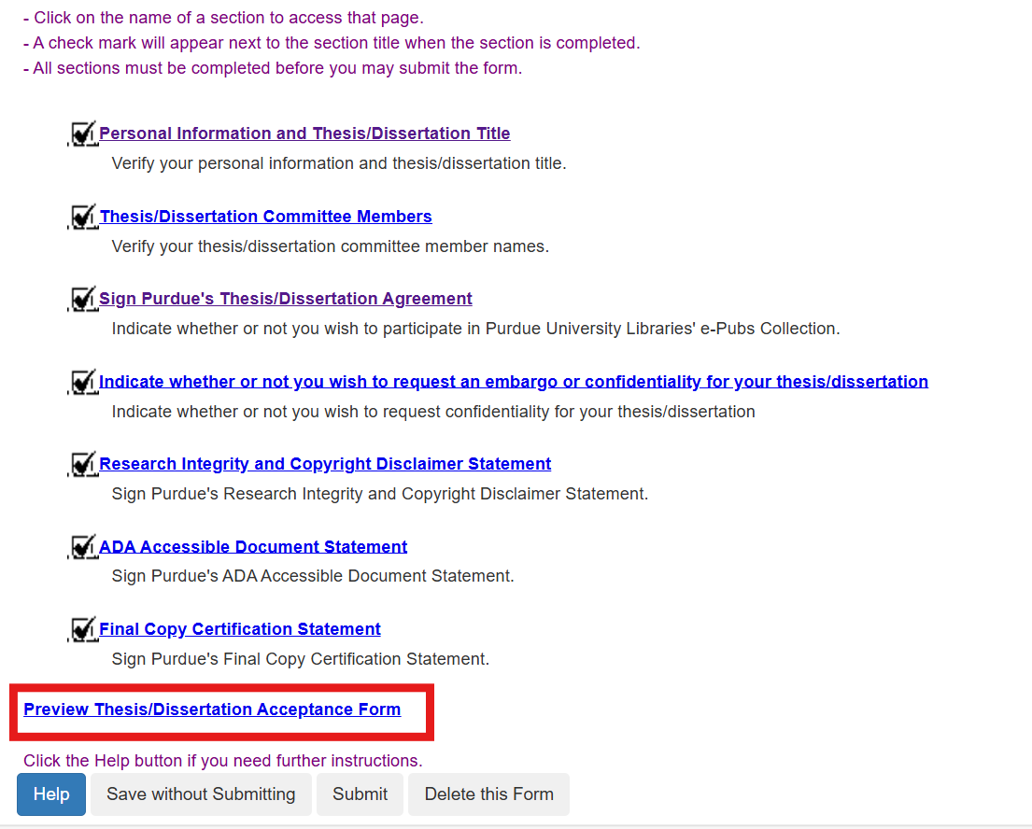

- Confirm that all your information and responses are correct, and then click Submit. If your form has been successfully submitted, you will see your decision has been successfully submitted in red at the top of the screen.
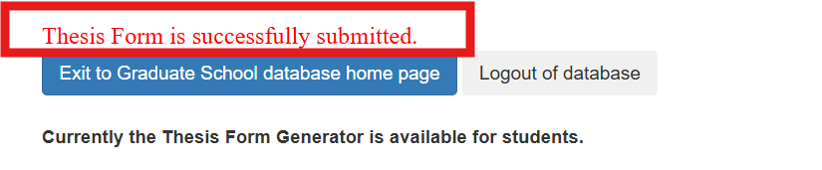
The form will now proceed to the members of your thesis or dissertation committee (or if you requested a Confidentiality Period longer than 1 year, the form will proceed to the Office of Sponsored Programs).
If you do not receive the “Thesis Form is successfully submitted” message, please check that you have completed all sections and resubmit. If after resubmitting you still do not receive the message, please contact us at thesishelp@purdue.edu.

