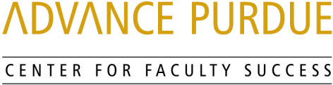

Faculty Advancement, Success and Tenure (FAST)

Agenda

September 13, 2016

9:00 – 9:10 Welcome, Introductions, and Orientation to FAST
9:10 – 9:50 “Things I wish I knew when I started”
Panel of Assistant Professors
Daniel Dawson, College of Science
Colin Gray, Purdue Polytechnic Institute
Jackie Linnes, College of Engineering
Kevin Solomon, College of Agriculture and Engineering
Robin Tanamachi, College of Science
9:50 – 10:00 Questions and Answers
10:00 – 10:10 Small Group Discussion
10:10 – 10:15 Wrap- Up

Upcoming Events

October 18, 2016 Promotion and Tenure
STEW 278 Peter Hollenbeck, Vice Provost for Faculty Affairs and Professor of Biological Sciences, College of Science

Karen Plaut, Senior Associate Dean for Research and Faculty Affairs and Professor, Animal Sciences, College of Agriculture

http://www.purdue.edu/discoverypark/advance/cfs/FAST.php

