Process: This job aid describes the steps involved in searching for a grant file in Perceptive Content.

‘File’ document in ImageNow
Perceptive Content Login | Log into WebNow using your Purdue Career Login Credentials. (https://cm.itap.purdue.edu/webnow/)
You can also get to Perceptive Content using from GMGRANTD in SAP. Click on the ‘View Documents in WebNow’ and it will take you directly to all the documents in Perceptive Content for that grant.
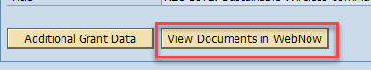
Selection Criteria | You can search by grant number proposal number or perform a content search.  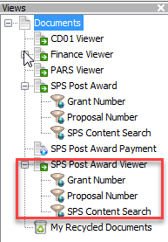  Enter grant number:  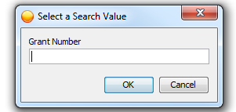  Or  Enter proposal number:  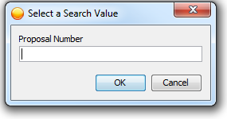
Grant File | All documents are displayed for that grant. See the Spreadsheet for Document Type definitions.  