Summarized Account List (∑)
The Summarized Account List is available from a portal navigation link and provides a listing of all grants and/or sponsored programs for the individual logged in. Report includes: Grant Number, Cost Sharing Flag, Sponsored Program Number, Sponsored Program Description, Sponsored Program Project Period, Co-PI and Available Balance.
Links are available from within the report to the full Account List as well as Grant or Sponsored Program views of the Account Summary.

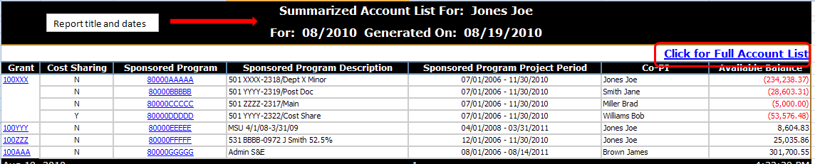
Account List (∑)
Account List is accessed via the Summarized Account List and provides a listing of all grants and associated sponsored programs for the logged in individual. Report includes: Grant Master Data for Each Grant: Grant Number, Grant Title, Sponsor, Prime Sponsor (if applicable), Grant Start Date, Grant End Date, PI Name. Also includes: Sponsored Program Number, Sponsored Program Description, Cost Sharing Flag, Co-PI, Life to Date Budget, Life to Date Expenses, Open Commitments, Available Balance and Percent Expended.
Links are available from within the report to the Grant or Sponsored Program views of the Account Summary.

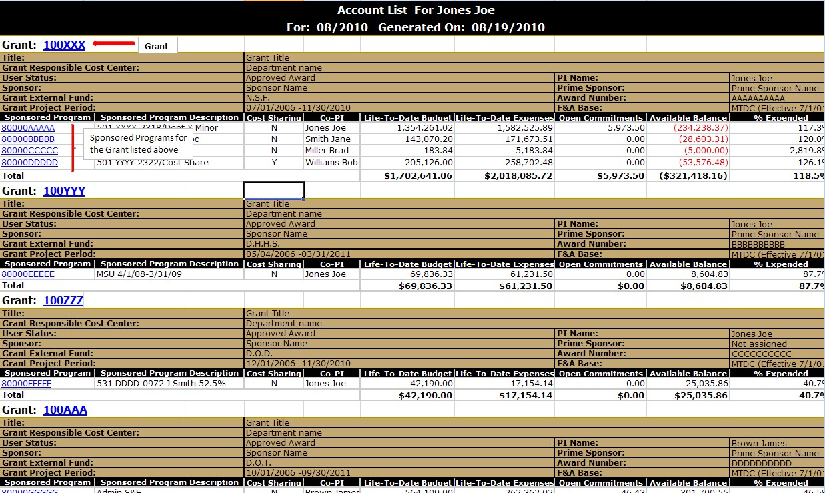

Account Summary (∑)
The Account Summary report is available in Grant (consolidated) or Sponsored Program view. This report is accessible from either the Summarized Account List or the Account List. The Account Summary has links to most other reports and acts as the “hub” of the suite of reports. The report also contains top links as well as links from within.
Report includes Description (sponsor class with subtotals for S&W, fringe benefits, S&E, direct costs, indirect costs and total), Budget, Month to Date Expenses, Life to Date Expenses, Open Commitments, Available Balance and Percentage Expended.
This report has the ability to change dates to be summarized data through a previous period. Grant view has all sponsored programs listed at the bottom of the report.

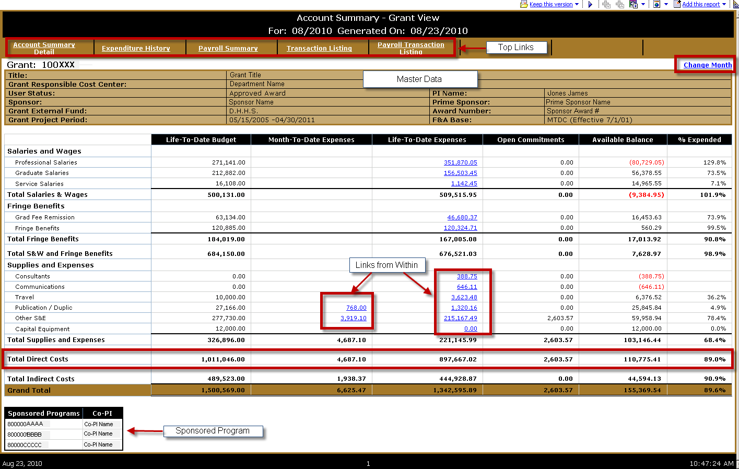

Account Summary Detail (∑)
Account Summary Detail report is available in Grant View only and is accessed via a top link on the Account Summary Grant View report. This report is very similar to the Account Summary but breaks down data by Fund, Sponsored Program and Description.
This report has the ability to change dates to be summarized data through a previous period.

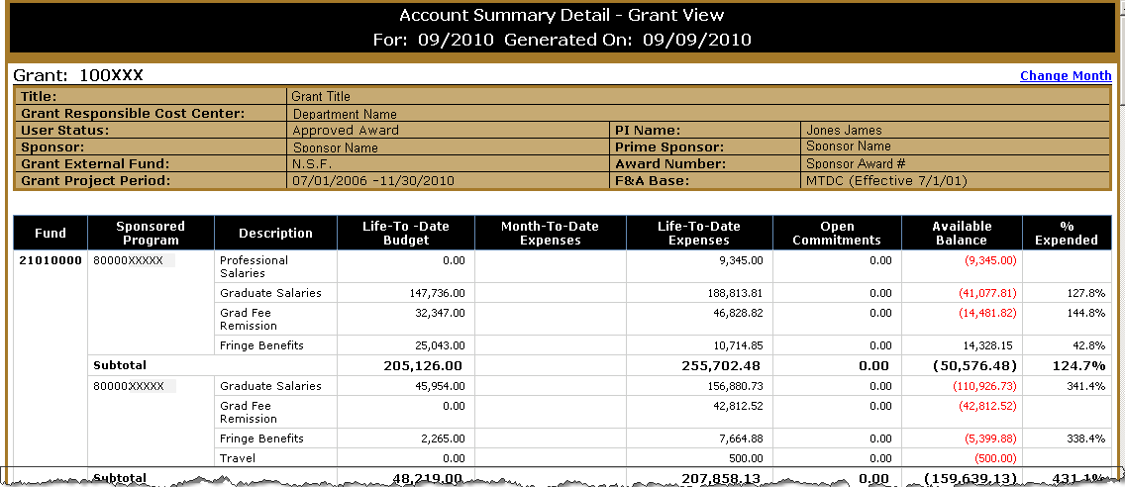

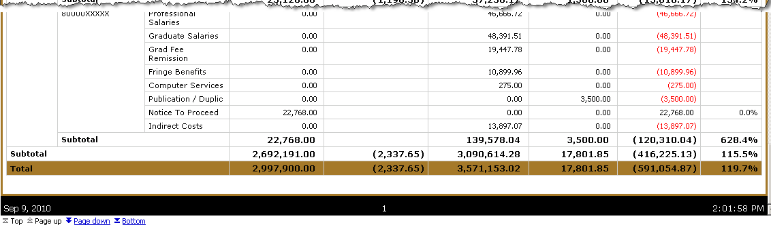

Expenditure History (∑)
Expenditure History is available in Grant or Sponsored Program view and is accessed via a top link on the Account Summary report. This report shows Life to Date expenses and the last 13 months expenditures at the description level for a specified grant or sponsored program.
This report has the ability to change dates to be summarized data through a previous period.

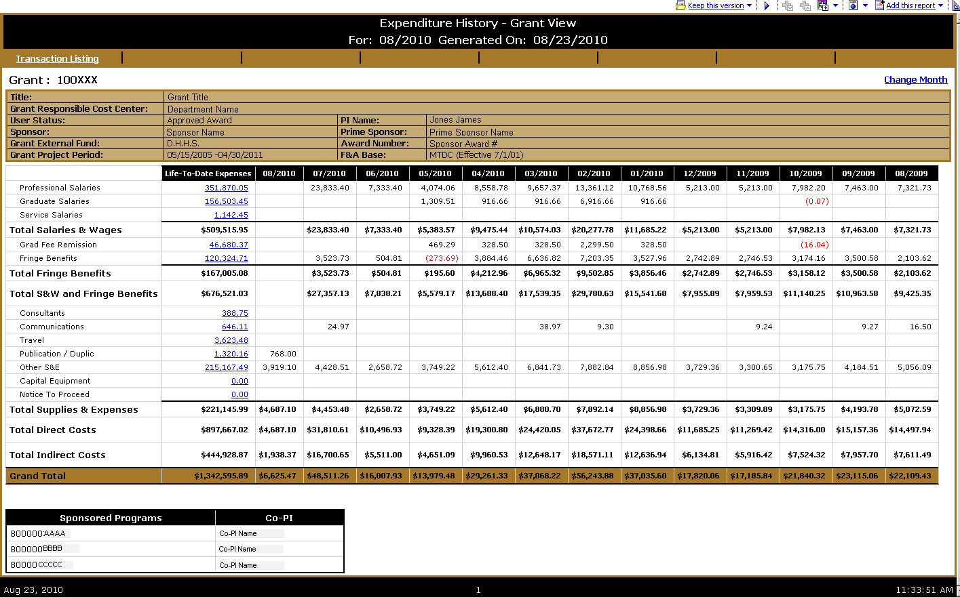

Payroll Summary (∑)
Payroll Summary is available in Grant or Sponsored Program view and is accessed via a top link from the Account Summary report. This report is a detailed list of employees and what they have been paid on the grant or sponsored program for the life of the grant or sponsored program.
This report contains only payroll data since SAP Payroll went live (7/1/07) through the period indicated in the header. Payroll posted prior to 7/1/07 is not included.
This report has the ability to change dates to be summarized data through a previous period.

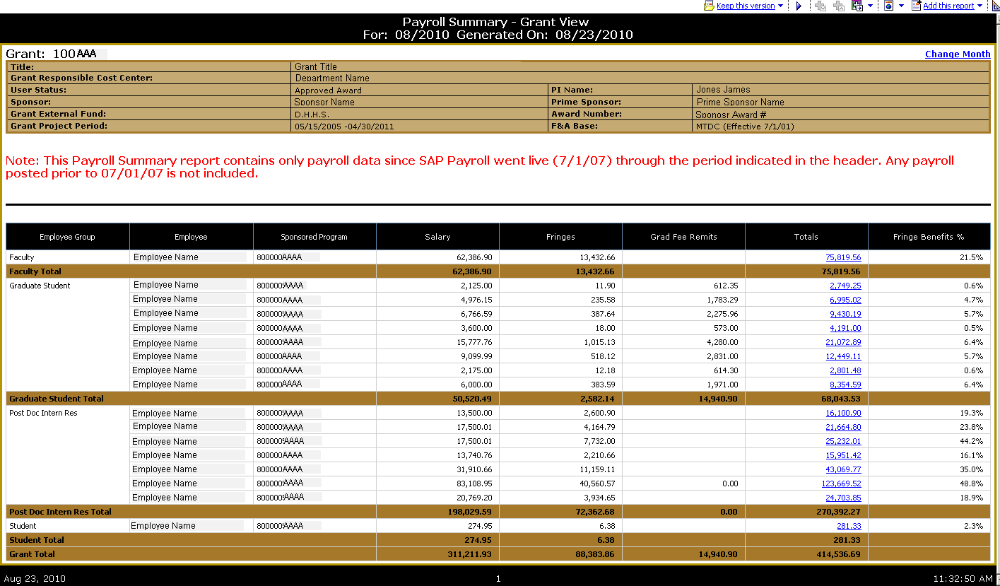

Transaction Listing (≡)
The Transaction Listing report is available in Grant or Sponsored Program view and can be accessed via a top link or link from within on the Account Summary. The Transaction Listing report is a detailed listing of all transactions for a given period of time (default to current month). Report includes Sponsored Program (grant view only), Posting Date, Expense Category, Vendor, Text, PO Number and Amount.
This report has the ability to change dates to a specific date, date range or a specific calendar month.
This report also has the ability to be sorted by different columns (Sponsored Program, Posting Date, Expense Category, Vendor, PO or Amount). Default sorting is by Posting Date then Commitment Item.

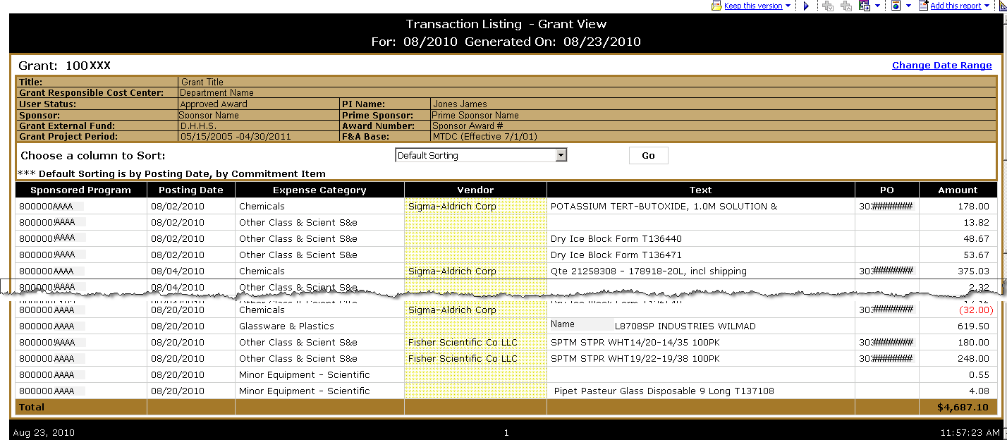

Payroll Transaction Listing (≡)
The Payroll Transaction Listing is available in Grant or Sponsored Program view and can be accessed via a top link from the Account Summary report or a link from within in the Payroll Summary report. The Payroll Transaction Listing report lists summarized payroll and fringe benefit transactions with employee details for a specific period of time. Report is sorted and subtotaled by employee group. Report includes Employee Group, Employee, Sponsored Program (grant view only), Posting Date, Posted For-Period for Payroll, Posted In-Period for Payroll, Salary, Fringes, Grad Fee Remits, Total, Fringe Benefit Percentage.
This report has the ability to change dates to a specific date, date range or a specific calendar month.

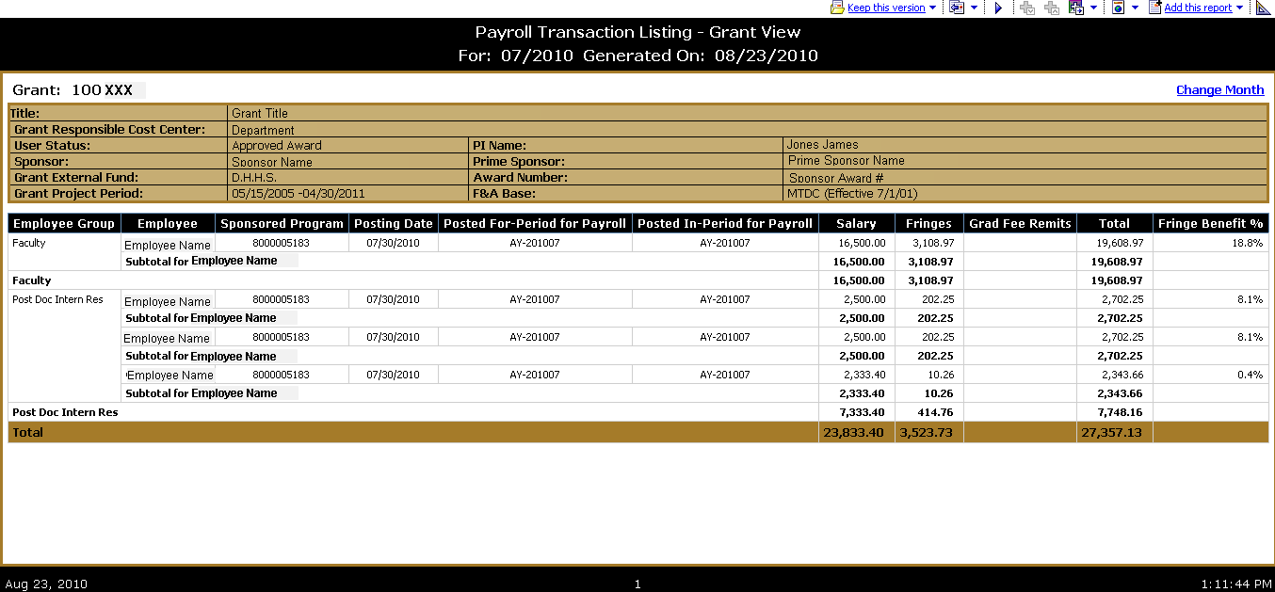

Budget Transaction Listing (≡)
The Budget Transaction Listing is available in Grant or Sponsored Program view and can be accessed via a top link from the Account Summary report. The Budget Transaction Listing report is a detailed listing of all budget transactions for a given period of time (default to current month) based on created on date. Report includes Sponsored Program (grant view only), Fund, Created on Date, Sponsored Class, Sponsored Class Description, Accounting Document Nbr, Description and Amount.
This report has the ability to change dates to a specific date, date range or a specific calendar month.
This report also has the ability to be sorted by different columns (Sponsored Program, Created On Date, Sponsored Class or Amount). Default sorting is by Created On Date then by Sponsored Class.

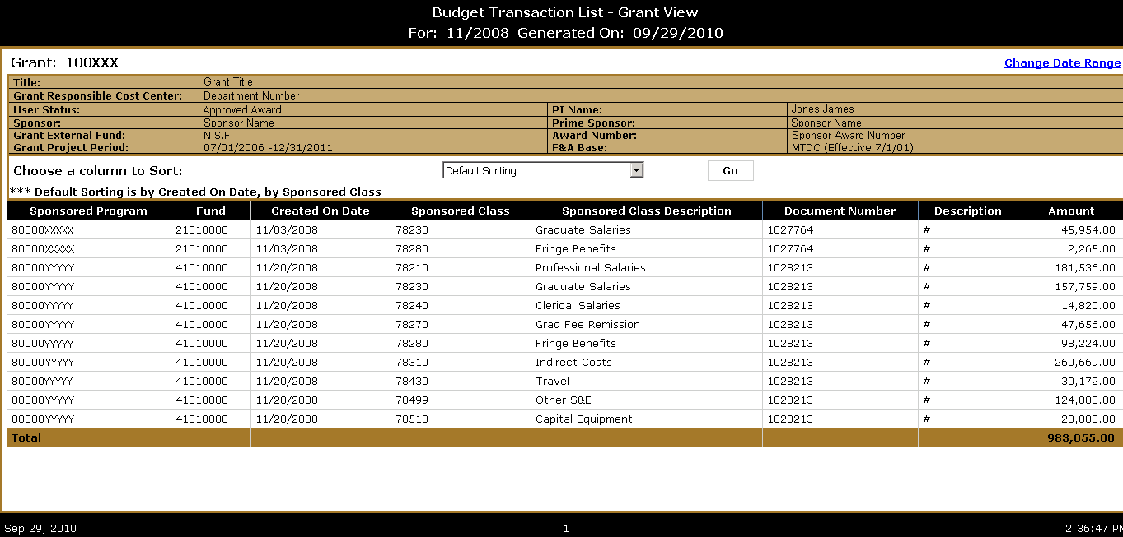

Commitment Transaction Listing (≡)
The Commitment Transaction Listing is available is available in Grant or Sponsored Program view and can be accessed via a top link from the Account Summary report. The Commitment Transaction Listing report is a detailed listing of all commitment transactions for a given period of time (default to current month) based on posting date. Report includes Sponsored Program (grant view only), Posting Date, Fund, Sponsored Class, Commitment Item, Expense Category (commitment item text), Vendor, Text, PO Number, Document Type, GM Value Type and Amount.
This report has the ability to change dates to a specific date, date range or a specific calendar month.
This report also has the ability to be sorted by different columns (Sponsored Program, Posting Date, Expense Category, Vendor, PO or Amount). Default sorting is by Posting Date then Commitment Item.

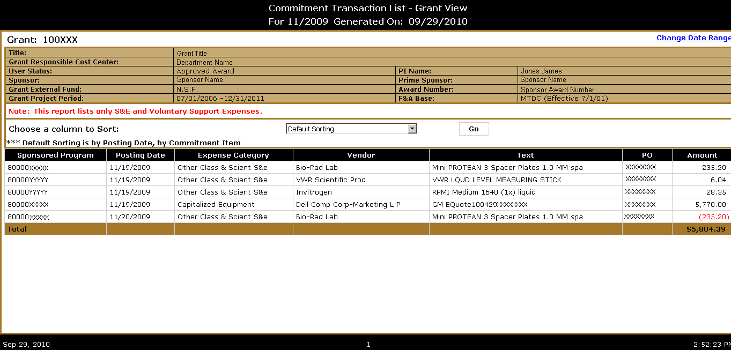

Equipment Transaction Listing (≡)
The Equipment Transaction Listing is available is available in Grant or Sponsored Program view and can be accessed via a top link from the Account Summary report. The Equipment Transaction Listing report is a detailed listing of all equipment transactions for a given period of time (default to current month) based on posting date. Report includes Sponsored Program (grant view only), Transaction Date, Expense Category (commitment item text), Vendor, Description, Ownership, PO Number, Inventory Number, Asset Number, Accounting Document Number and Amount.
This report has the ability to change dates to a specific date, date range or a specific calendar month.
This report also has the ability to be sorted by different columns (Sponsored Program, Posting Date, Expense Category, Vendor, PO or Amount). Default sorting is by Posting Date then Commitment Item.

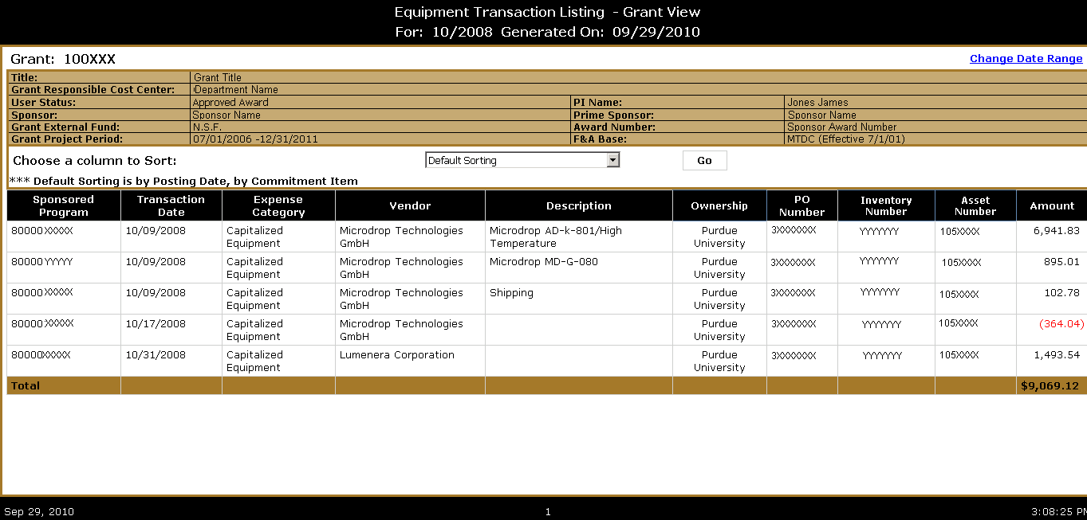

Balance Trends (∑)
The Balance Trends report includes a chart of the available (management) balance for each grant where the individual logged in is the PI or Co PI over the past 12 months (or number of months grant has been open if new grant), as well as a chart showing the same data below.
Available in grant or sponsored program view. The grant view report will jump to the sponsored program view via grant view.
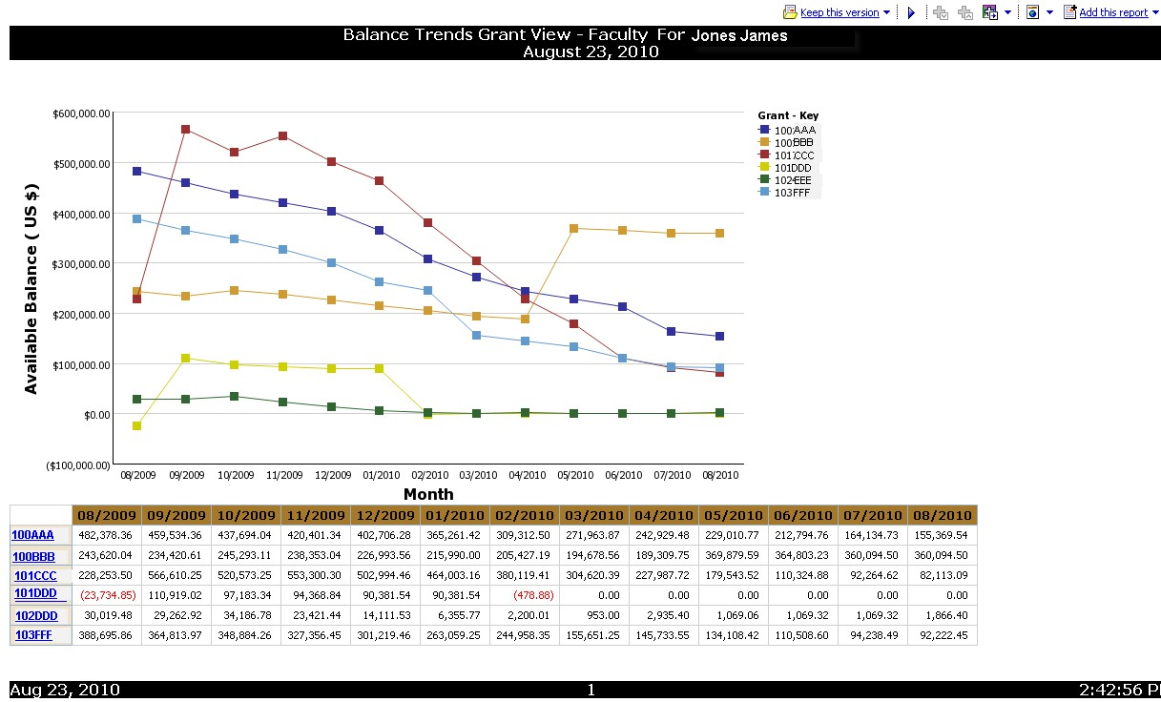

Technical Reports Due
The Technical Reports Due report lists technical reports (from Deliverables tab in PERA Awards) due on current grants, for the logged in individual who is PI or Responsible Party of Deliverables. This report has three tabs, (1) report due in the next 90 days, (2) report past due date, (3) all reports due. The report lists Grant, Award, PI, Title, Sponsor, Recurrence, Report Name, Deliverable Description, Report Due Date, and SPS Contact.

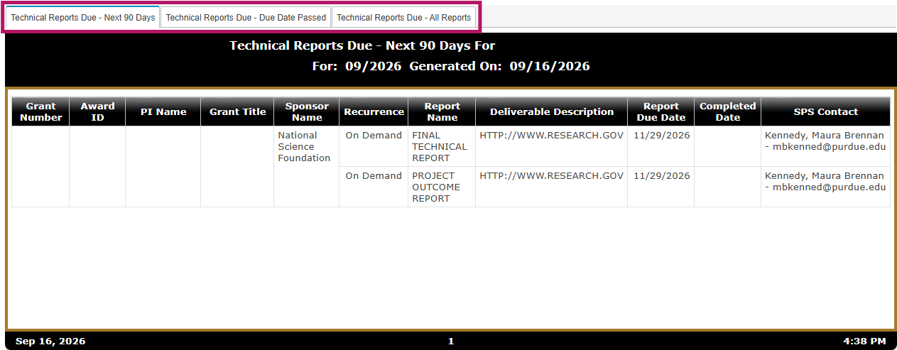

Current Awards and Pending Proposals
The Current Awards and Pending Proposals report contains two tabs: Awards and Pending Proposals. The data for this report comes from the PERA.
Awards Tab contains Award Number, Grant, PI, Grant Sponsor, Grant Title, Grant Project Period, Location (campus), Staff Credit %, Staff Proposal Amount, Staff Awarded Amount, and Total Awarded Amount. This section contains links from within to the listing of award details.
Pending Proposal section of the report contains Proposal Number, PI, Proposal Sponsor, Proposal Title, Proposal Project Period, Location (campus), Staff Credit %. Staff Proposal Amount, and Total Proposal Amount. This section contains links from within to a listing of proposal details.

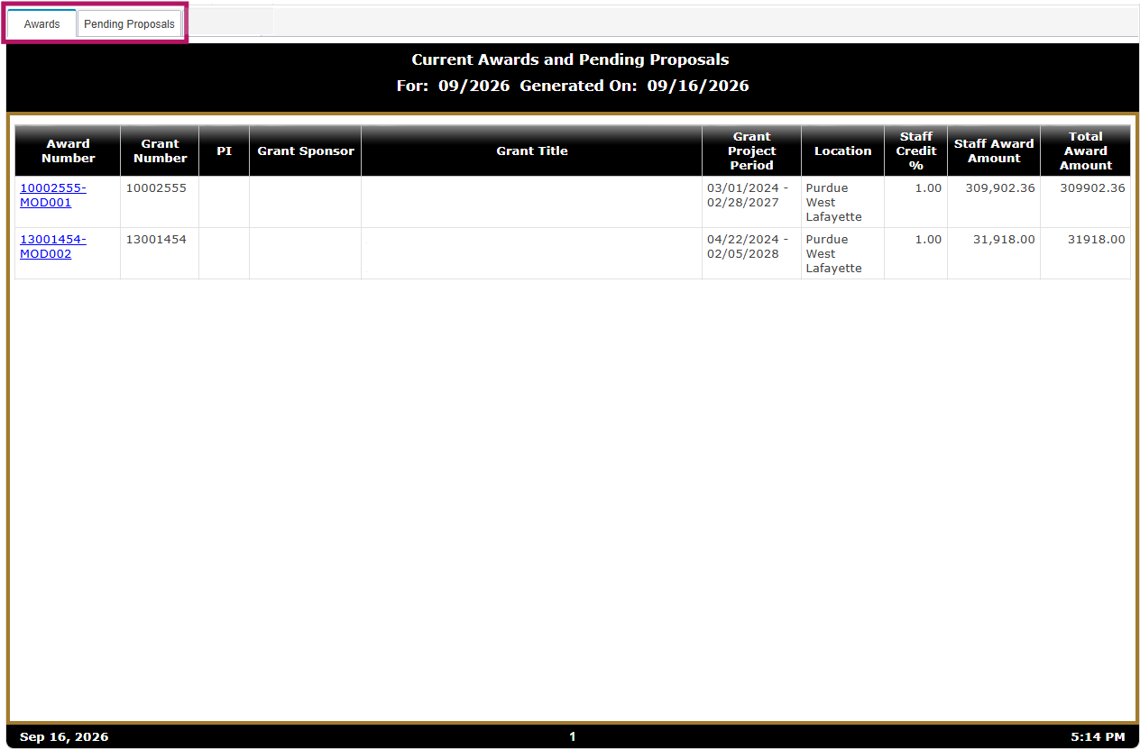

Expenditure Trends
The Expenditure Trends report contains two sections: A chart of expenditures by grant by month, and a table with the same expenditure numbers by grant.

