New Search Option in GMGRANTD: Locate grants using the PERA Award Number
We are pleased to share an update to GMGRANTD that makes it easier to locate awards using the PERA Award number (External Award ID).
GMGRANTD has been updated to allow users to search directly by the PERA Award number, aligning SAP search functionality with how awards are identified in PERA. This enhancement improves efficiency and reduces the need to cross-reference multiple systems when reviewing award information.
How to Use the New Search:
To support this new functionality, GMGRANTD selection screen has been updated:
- Click on the radio button to open the search options
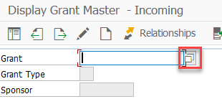
- A new tab “0” has been added to search by External Award ID (tab “A” has been hidden & replaced with “0”
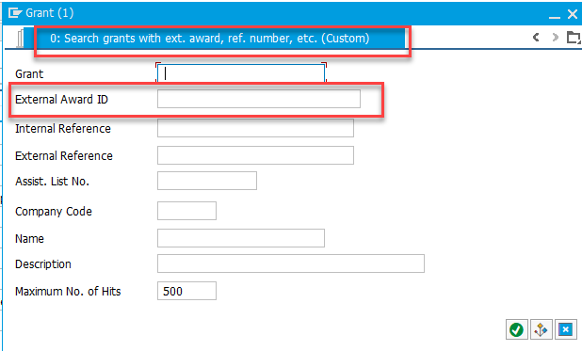

RAD has also been updated to include the PERA award number in both the Grant Details and Sponsored Program Details page.

