Standard Operating Procedure
Alkali Metals
This is an SOP template and is not complete until: 1) lab specific information is entered into the box below 2) lab specific protocol/procedure is added to the protocol/procedure section and
3) SOP has been signed and dated by the PI and relevant lab personnel.
Print a copy and insert into your Lab-Specific Chemical Hygiene Plan.
Section 1 – Lab-Specific Information
Building/Room(s) covered by this SOP: | Click here to enter text.
Department: | Click here to enter a date.
Principal Investigator Name: | Click here to enter a date.
Principal Investigator Signature: | Click here to enter text.
Section 2 – Hazards
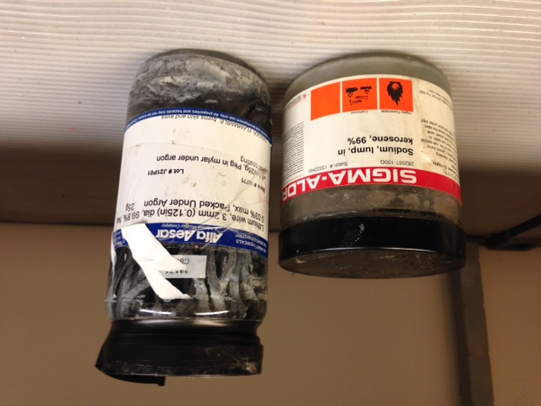
Alkali metals are extremely reactive with water producing flammable hydrogen gas that can ignite spontaneously. It also produces a caustic hydroxide solution (i.e., Sodium hydroxide) upon contact with water. It may be harmful if inhaled, ingested, or absorbed through the skin. Alkali metals are extremely destructive to the tissue of the mucous membranes and upper respiratory tract.
Alkali metals include: Lithium, Sodium, Potassium, Rubidium, Cesium, and Francium
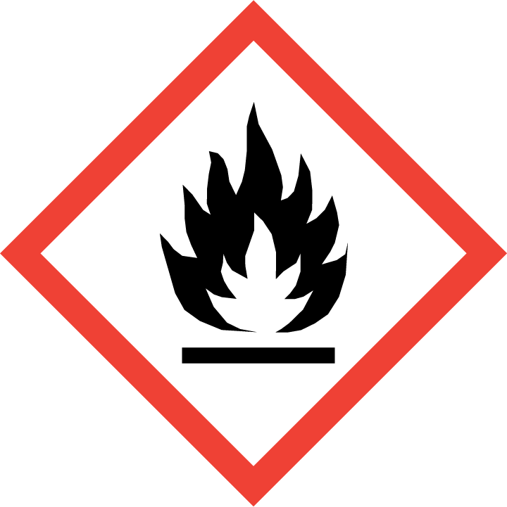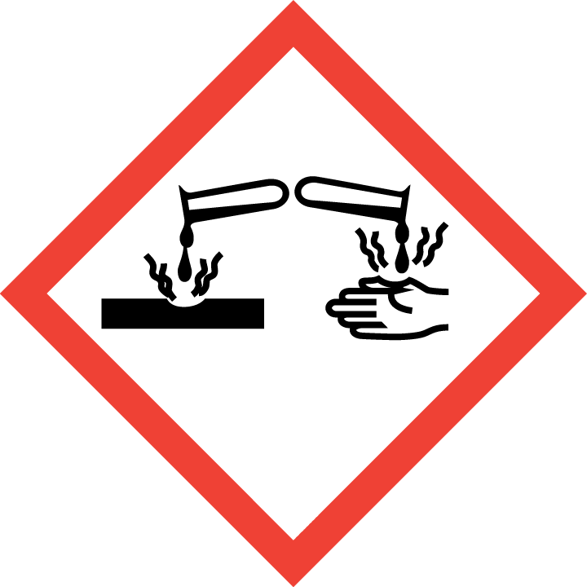
Section 3 – Personal Protective Equipment (PPE)
Engineering Controls: Use of alkali metals should be conducted in a properly functioning glove box, whenever possible, or chemical fume hood. The chemical fume hood must be approved and certified by REM and have a face velocity between 80 – 125 feet per minute.
Hygiene Measures: Avoid contact with skin, eyes, and clothing. Wash hands before breaks and immediately after handling the product.
Hand Protection: Chemical-resistant gloves must be worn, nitrile gloves are recommended for low volume applications. Wearing two pairs of nitrile gloves is recommended. NOTE: Consult with your preferred glove manufacturer to ensure that the gloves you plan on using are compatible with the specific chemical being used.
Eye Protection: ANSI approved properly fitting safety glasses or chemical splash goggles are required. A face shield may also be appropriate depending on the specific application.
Skin and Body Protection: Flame resistant laboratory coats must be worn and be appropriately sized for the individual and buttoned to their full length. Personnel must also wear full length pants, or equivalent, and close-toed shoes. Full length pants and close-toed shoes must be worn at all times by all individuals that are occupying the laboratory area. The area of skin between the shoe and ankle must not be exposed.
Respiratory Protection: If alkali metals are being used outside of a chemical fume hood, respiratory protection may be required. If this activity is necessary, contact REM (49-46371) so a respiratory protection analysis can be performed.
Section 4 – Special Handling and Storage Requirements
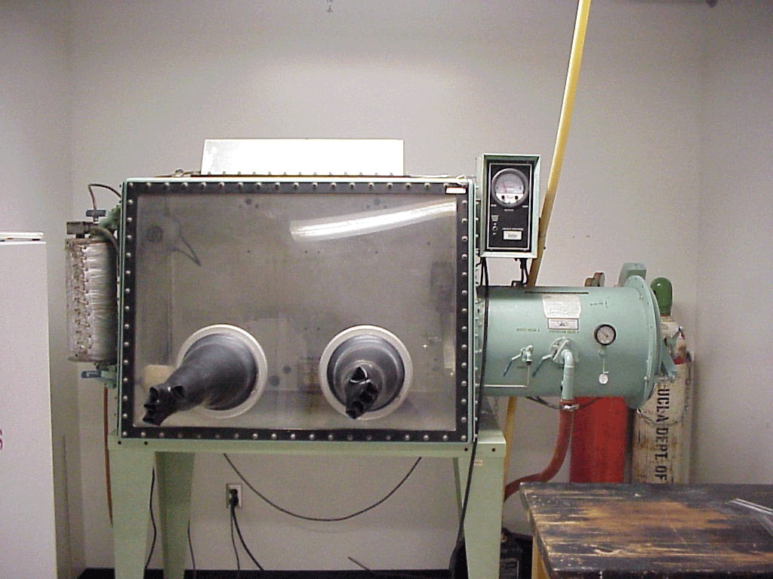
- Precautions for safe handling: water-reactive, use extreme care when handling.
- Alkali metals should be stored in mineral oil or kerosene.
- Only handle under inert gas; use a glove box if possible. Do not expose to air or water.
- Avoid contact with skin and eyes and inhalation.
- A “dry-run” of the experiment should be performed using low-hazard materials.
- Never work with alkali metals alone.
- Conduct the procedure only after a supervisor has observed the user performing the proper technique unassisted.
- All glassware used for alkali metals should be oven-dried and free of moisture.
- Keep away from sources of ignition.
- Keep containers tightly closed. Store in a cool, dry and well-ventilated area away from incompatible substances such as aqueous solutions and halogenated alkanes (i.e., carbon tetrachloride).
- A current copy of the SDS for the specific alkali metal being used must be made available to all personnel working in the laboratory at all times.
- The amount of alkali metals stored should be kept at a minimum.
- Any expired or unnecessary reactive materials should be properly disposed of as hazardous waste.
- All alkali metals should be clearly labeled with the original manufacturer’s label, which should have the chemical name, hazard labels, and pictograms. The label should not be defaced in any way.
- All alkali metals should be placed into secondary containment as a precautionary measure.
- Suitable storage locations include inert gas-filled desiccators or glove boxes, flammable storage cabinets that do not contain aqueous or other incompatible chemicals, or intrinsically safe refrigerators or freezers that also do not contain aqueous or other incompatible chemicals.
Section 5 – Spill and Accident Procedures
Immediately evacuate area and ensure others are aware of the spill. If there is an imminent threat of a fire, pull the nearest fire alarm station to evacuate the building and dial 911. If personnel have become exposed and need medical assistance, dial 911. If the spill is minor and does not pose a threat to personnel, contact REM at 49-40121 during normal business hours (Monday – Friday, 7 AM – 4 PM) for spill cleanup assistance (dial 911 if spill occurs after hours and assistance is needed).
Section 6 – Waste Disposal Procedures
Alkali metals and associated waste must be collected for proper disposal by REM. Store hazardous waste in closed containers that are properly labeled, and in a designated area (flammable cabinet is recommended). Complete a Chemical Waste Pickup Request Form to arrange for disposal by REM; detailed instructions are provided at the following link: http://www.purdue.edu/ehps/rem/hmm/chemwaste.htm.
Section 7 – Protocol/Procedure (Additional lab protocol may be added here)
Click here to enter text.
NOTE: Any deviation from this SOP requires approval from Principal Investigator.
Section 8 – Documentation of Training (signature of all users is required)
Prior to conducting any work with alkali metals, the Principal Investigator must ensure that all laboratory personnel receive training on the content of this SOP.
I have read and understand the content of this SOP:
Name | Signature | Date
Click here to enter text. |  | Click here to enter a date.
Click here to enter text. |  | Click here to enter a date.
Click here to enter text. |  | Click here to enter a date.
Click here to enter text. |  | Click here to enter a date.
Click here to enter text. |  | Click here to enter a date.
Click here to enter text. |  | Click here to enter a date.
Click here to enter text. |  | Click here to enter a date.
Click here to enter text. |  | Click here to enter a date.

