Standard Operating Procedure
Phosgene Solution 20% in Toluene
This is an SOP template and is not complete until: 1) lab specific information is entered into the box below 2) lab specific protocol/procedure is added to the protocol/procedure section and
3) SOP has been signed and dated by the PI and relevant lab personnel.
Print a copy and insert into your Lab-Specific Chemical Hygiene Plan.
Section 1 – Lab-Specific Information
Building/Room(s) covered by this SOP: | Click here to enter text.
Department: | Click here to enter a date.
Principal Investigator Name: | Click here to enter text.
Principal Investigator Signature:

Section 2 – Hazards
Phosgene solution is potentially fatal; it is especially damaging to the lungs. Phosgene solution can be fatal if swallowed and the toluene has been found to lead to stomach problems. It is corrosive and can cause severe skin and eye damage. It is also a reproductive toxin and can affect fertility and unborn children. It is also flammable due to the toluene solvent.
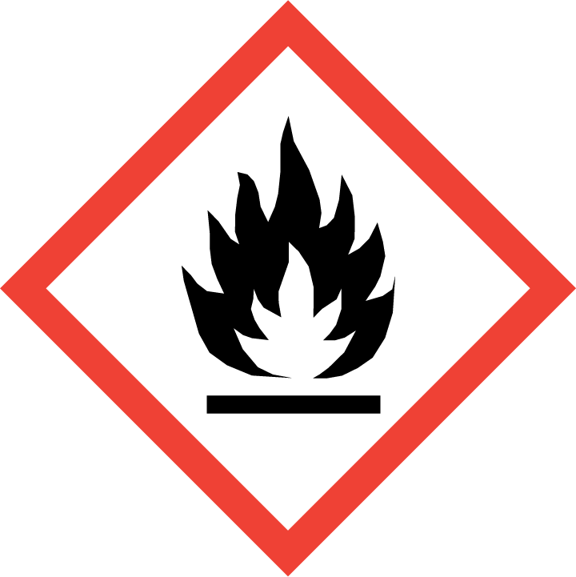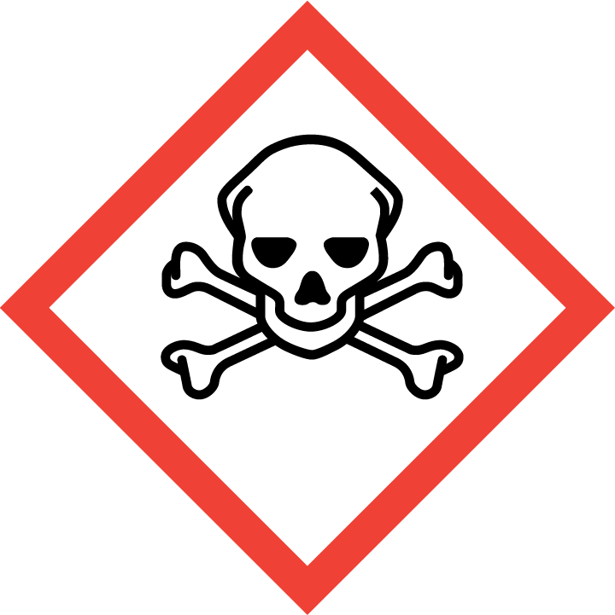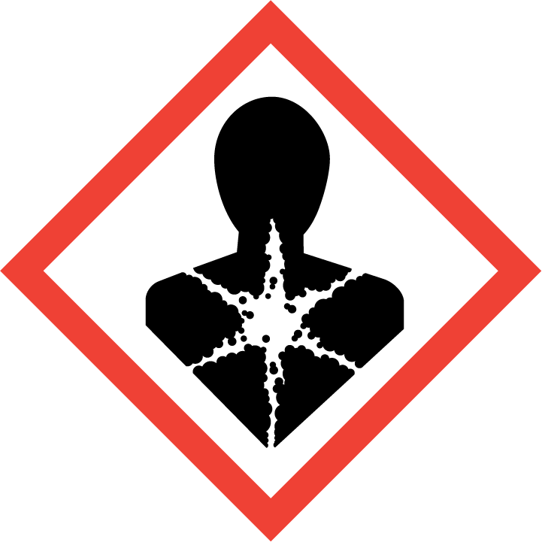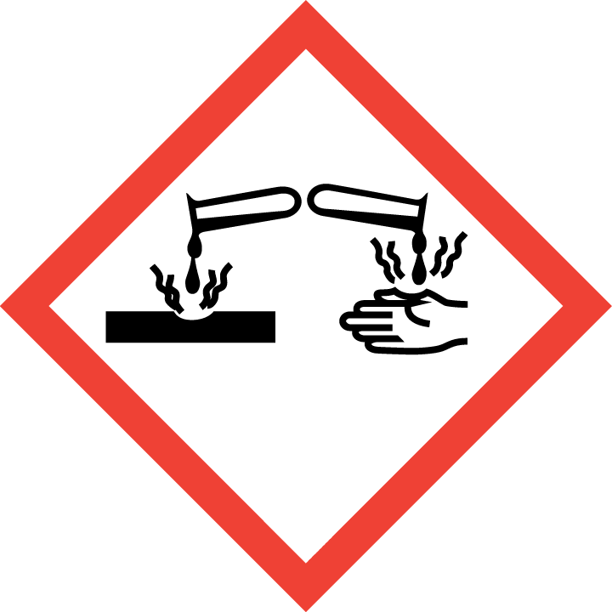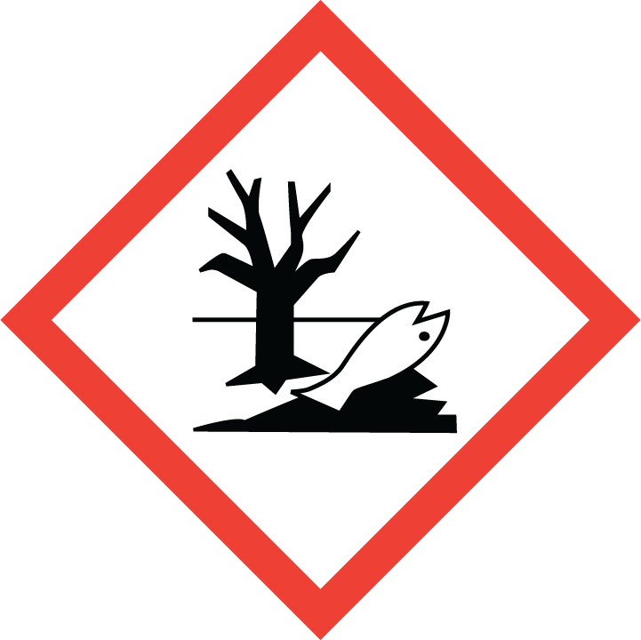
Section 3 – Engineering Controls and Personal Protective Equipment (PPE)
Engineering Controls: Use of phosgene solution must be conducted in a properly functioning chemical fume hood. The chemical fume hood must be approved and certified by REM and have a face velocity between 80 – 125 feet per minute. Install a phosgene sensor outside of the fume hood in the lab to ensure the exposure limit is never exceeded.
Hygiene Measures: Avoid contact with skin, eyes, and clothing. Wash hands before breaks and immediately after handling the product.
Hand Protection: Chemical-resistant gloves must be worn; Teflon® gloves are recommended. Wearing two pairs of Teflon gloves is recommended. Contaminated gloves (even just a few drops) must be disposed of as hazardous waste immediately. NOTE: Consult with your preferred glove manufacturer to ensure that the gloves you plan on using are compatible with the specific chemical being used.
Eye Protection: ANSI approved properly fitting chemical splash goggles are required. A face shield may also be appropriate depending on the specific application.
Skin and Body Protection: Flame-retardant laboratory coats must be worn and be appropriately sized for the individual and buttoned to their full length. A rubber, splash-proof apron should also be worn over the lab coat. Personnel must also wear full length pants, or equivalent, and close-toed shoes. Full length pants and close-toed shoes must be worn at all times by all individuals that are occupying the laboratory area. The area of skin between the shoe and ankle must not be exposed.
Respiratory Protection: Phosgene solution should never be used outside of a chemical fume hood or glove box. However, a full-face supplied air respirator should be worn during certain experiments.

Section 4 – Special Handling and Storage Requirements
- Do not over purchase; only purchase what can be safely stored in the laboratory.
- Avoid contact with skin, eyes, and clothing. Avoid inhalation of vapor or mist.
- Always use inside of a chemical fume hood. Phosgene solution use may even require a full-face supplied air respirator under certain circumstances or experiments. Therefore, extreme care should be taken when handling; always work with under a chemical fume hood.
- When working with phosgene, use explosion-proof equipment. Keep away from sources of ignition. Decomposition creates hazardous gases over time or during combustion. Take measures to prevent the buildup of electrostatic charge.
- Keep container upright and tightly closed in a dry and well-ventilated place. Containers should remain closed when not in use. Store in a dark, refrigerated (2 to 8 °C), spark-proof environment. Place in separate secondary containment.
- May decompose over time, do not store past manufacturer-recommended date.
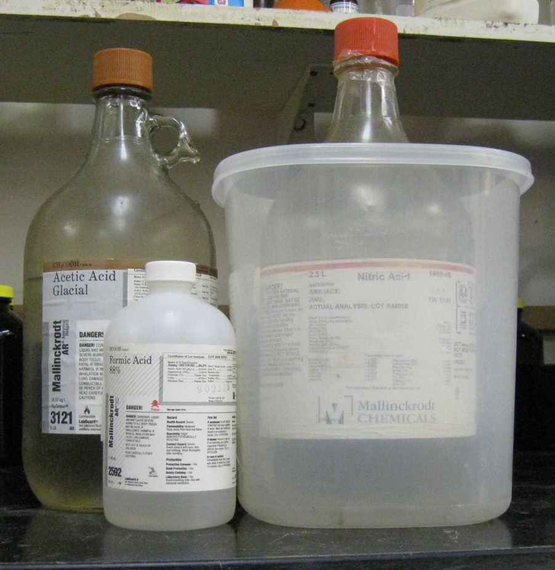
- Containers which are opened must be carefully resealed.
- Keep away from incompatible materials: Strong oxidizing agents, potassium, amines, ammonia, alcohols, and sodium/sodium oxides.
Organic acid
Oxidizing acid
- Use in the smallest practical quantities for the experiment being performed.
- Containers should be labeled appropriately. Label should indicate the name of the chemical(s) in the container. Avoid using chemical abbreviations (acceptable if a legend is present in the lab) and formulae.
Section 5 – Spill and Accident Procedures
If a leak occurs and phosgene is vaporized, dial 911 immediately and pull the nearest fire alarm to alert others. Ensure others in the vicinity evacuate immediately. If personnel have become exposed and need medical assistance, emphasize this during the 911 call. Avoid breathing gases, mist, or vapors and use a respirator if available. Eliminate all sources of ignition, and evacuate personnel to safe areas. Beware of vapor accumulation, particularly in low areas as it can form an explosive vapor-air mixture. Prevent further leakage if it is safe to do so. Never allow phosgene waste to enter a drain or the environment as it can be environmentally destructive.
If there are any questions regarding safe handling of a spill prior to the accident occurring, contact REM at 49-40121 during normal business hours (Monday – Friday, 7 AM – 4 PM). However, because phosgene solution can lead to the accumulation of explosive vapors when spilled, even a small amount could be very dangerous. Therefore, laboratory personnel should always dial 911 and evacuate the vicinity and should never try and clean up the spill on their own.
Section 6 – Waste Disposal Procedures
Store hazardous waste in a closed container that is properly labeled in an explosion-proof environment. Do not mix waste with incompatible chemicals, and collect separately if possible. Store waste containers in separate secondary containment. Any contaminated disposable wastes such as gloves or clothing should be disposed of as solid hazardous waste. Complete a Chemical Waste Pickup Request Form to arrange for disposal by REM; detailed instructions are provided at the following link: http://www.purdue.edu/ehps/rem/hmm/chemwaste.htm.
Section 7 – Protocol (Add lab specific Protocol here)

NOTE: Any deviation from this SOP requires approval from Principal Investigator.
Section 8 – Documentation of Training (signature of all users is required)
Prior to conducting any work with phosgene solution, the Principal Investigator must ensure that all laboratory personnel receive training on the content of this SOP.
I have read and understand the content of this SOP:
Name | Signature | Date

