Cervical Rotation Stretch  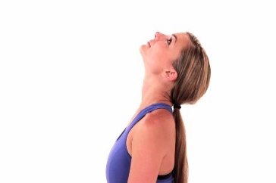  Tip your head backward, looking up toward the ceiling, then return to the starting position and repeat | Upper Trapezius Stretch  Reach your hand toward the floor, then slowly sidebend your head to the opposite side and hold. | Triceps Stretch  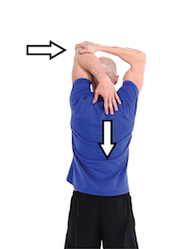  Lift one arm straight overhead, then bend your elbow as far as possible behind your head. With your other hand, apply gentle pressure to your elbow until you feel a stretch in your triceps. Hold this position.
Chest Stretch  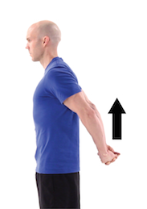  With arms straight and fingers interlaced, raise arms upward until a stretch is felt. | Standing Wrist Flexion Stretch  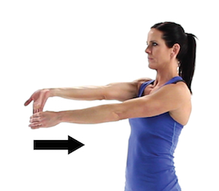  With your other hand, bend your wrist downward until you feel a stretch. Then reverse palm and repeat stretch. | . Finger Spread Stretch  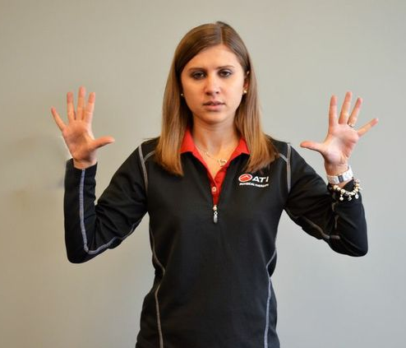  Begin with a fist, slowly release to a claw and then extend and spread fingers outward.
Standing Lumbar Extension  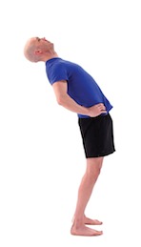  Slowly bend backward, arching in your low back, then return to the starting position and repeat | Standing Hamstring Stretch  Exhale and bend forward, lowering your hands toward the floor, bending at your hips and keeping your knees slightly bent. You should feel a stretch in the back of your upper legs. | Standing Quad Stretch  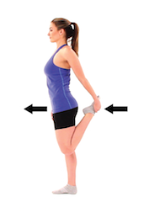  Bend one knee upward and grasp your foot, pulling it toward your body and pushing your hips forward until you feel a stretch in the front of your thigh and hold.
*Hold each stretch for 20 seconds and repeat 3 times each set*

