ME 323: Mechanics of Materials Homework 9
Spring 2025 Due: April 11, 2025

Problem 1 (10 points):
A rod is made of three segments: BC, CD, and DH (see Figure 1). All segments have length L and are made of a material with Young’s modulus E. The cross-sectional area of segment BC decreases linearly from 2A at B to A at C. The cross-sectional area of segment C is constant. The cross-sectional area of segment DH increases linearly from A at D to 3A at H. A force P acts to the left at point D.
Use a three-element (four-node) finite element model to do the following:
a) Construct the global stiffness matrix [K] in terms of E, A, and L.
b) Construct the force vector [F] in terms of P.
c) Enforce the displacement boundary conditions.
d) Solve for the nodal displacements in terms of PL/EA.
e) Determine the reactions at walls B and H in terms of P.
f) Compare the results from different numbers of elements (use 5 and 7). Use the code provided in the lecture book or write your own.
Note: Attach your modified code to your submission.

Figure 1: Structure for Problem 1

Problem 2 (10 points):

A cylindrical vessel (shown in Figure 2) has an internal radius of r = 2.5 m, and a wall thickness of t = 15 mm. The internal pressure in the vessel is P = 1.5 MPa and the maximum allowable stress in the walls of the vessel is 400 MPa. Determine:
- Axial stress σ_{a} and hoop stress σ_{h} in the cylindrical part of the vessel.
- Principal stresses σ_{p1} and σ_{p2}
- Maximum in-plane shear stress τ_{max}
- Maximum allowable pressure P_{allow} such that σp1 doesn’t exceed σ_{allow}.

Figure 2: Thin-walled cylindrical vessel for Problem 2

Problem 3 (10 points):
The stress element shown below represents the state of stress measured along the x'y' axis in a component loaded under plane stress. No information is known about the stress α except that it is compressive.
(a) Determine the magnitude of the maximum compressive normal stress that can be applied, if the component is made of a material which can withstand a maximum in-plane shear stress of 100 MPa.
(b) Determine the stress components when the element is oriented along the x-y axes.
(c) Draw a stress element oriented along the maximum in-plane shear stress directions. (Show the angle of this rotated element with respect to the axis x')

Figure 3: Stress element for Problem 3

Problem 4 (2 points + 2 points + 1 point):
Consider rod ABCDE made of 5 nodes and 4 elements, which is fixed to the wall at node 1 and has a force F applied at node 5.
- What is the size of the stiffness matrix after enforcing the boundary conditions?
- If the rod is split into 9 nodes and 8 elements and subjected to the same loading conditions as part a, what is the new size of the stiffness matrix (after enforcing the boundary conditions)?
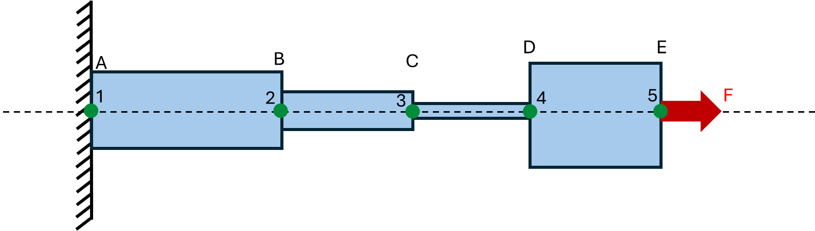
- How does the displacement at section B (u_{B}) compare in parts a and b?

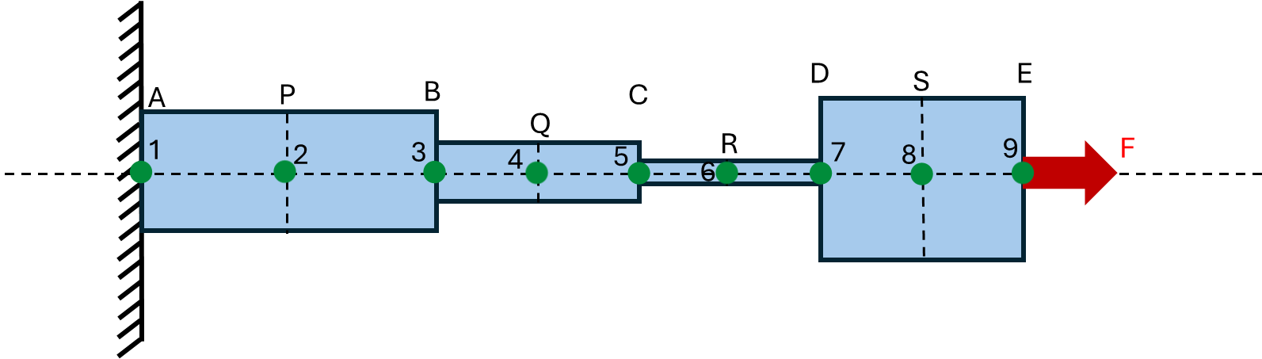
Figure 4.1: Schematics for Problem 4 part a)

Figure 4.2: Schematics for Problem 4 part b)

