Engineering Design Process Student Activity Sheet 2.3a

Student Name: .

Gummi Bear Tolerances & Dimensions

Question for Analysis

What are the pros and cons of variation in manufacturing?

Instructions

Use a pair of calipers to determine the dimensions of 10 gummi bears. Use the pictures as helps for how and where to measure on the gummi bear. Use the space provided to write down your findings. 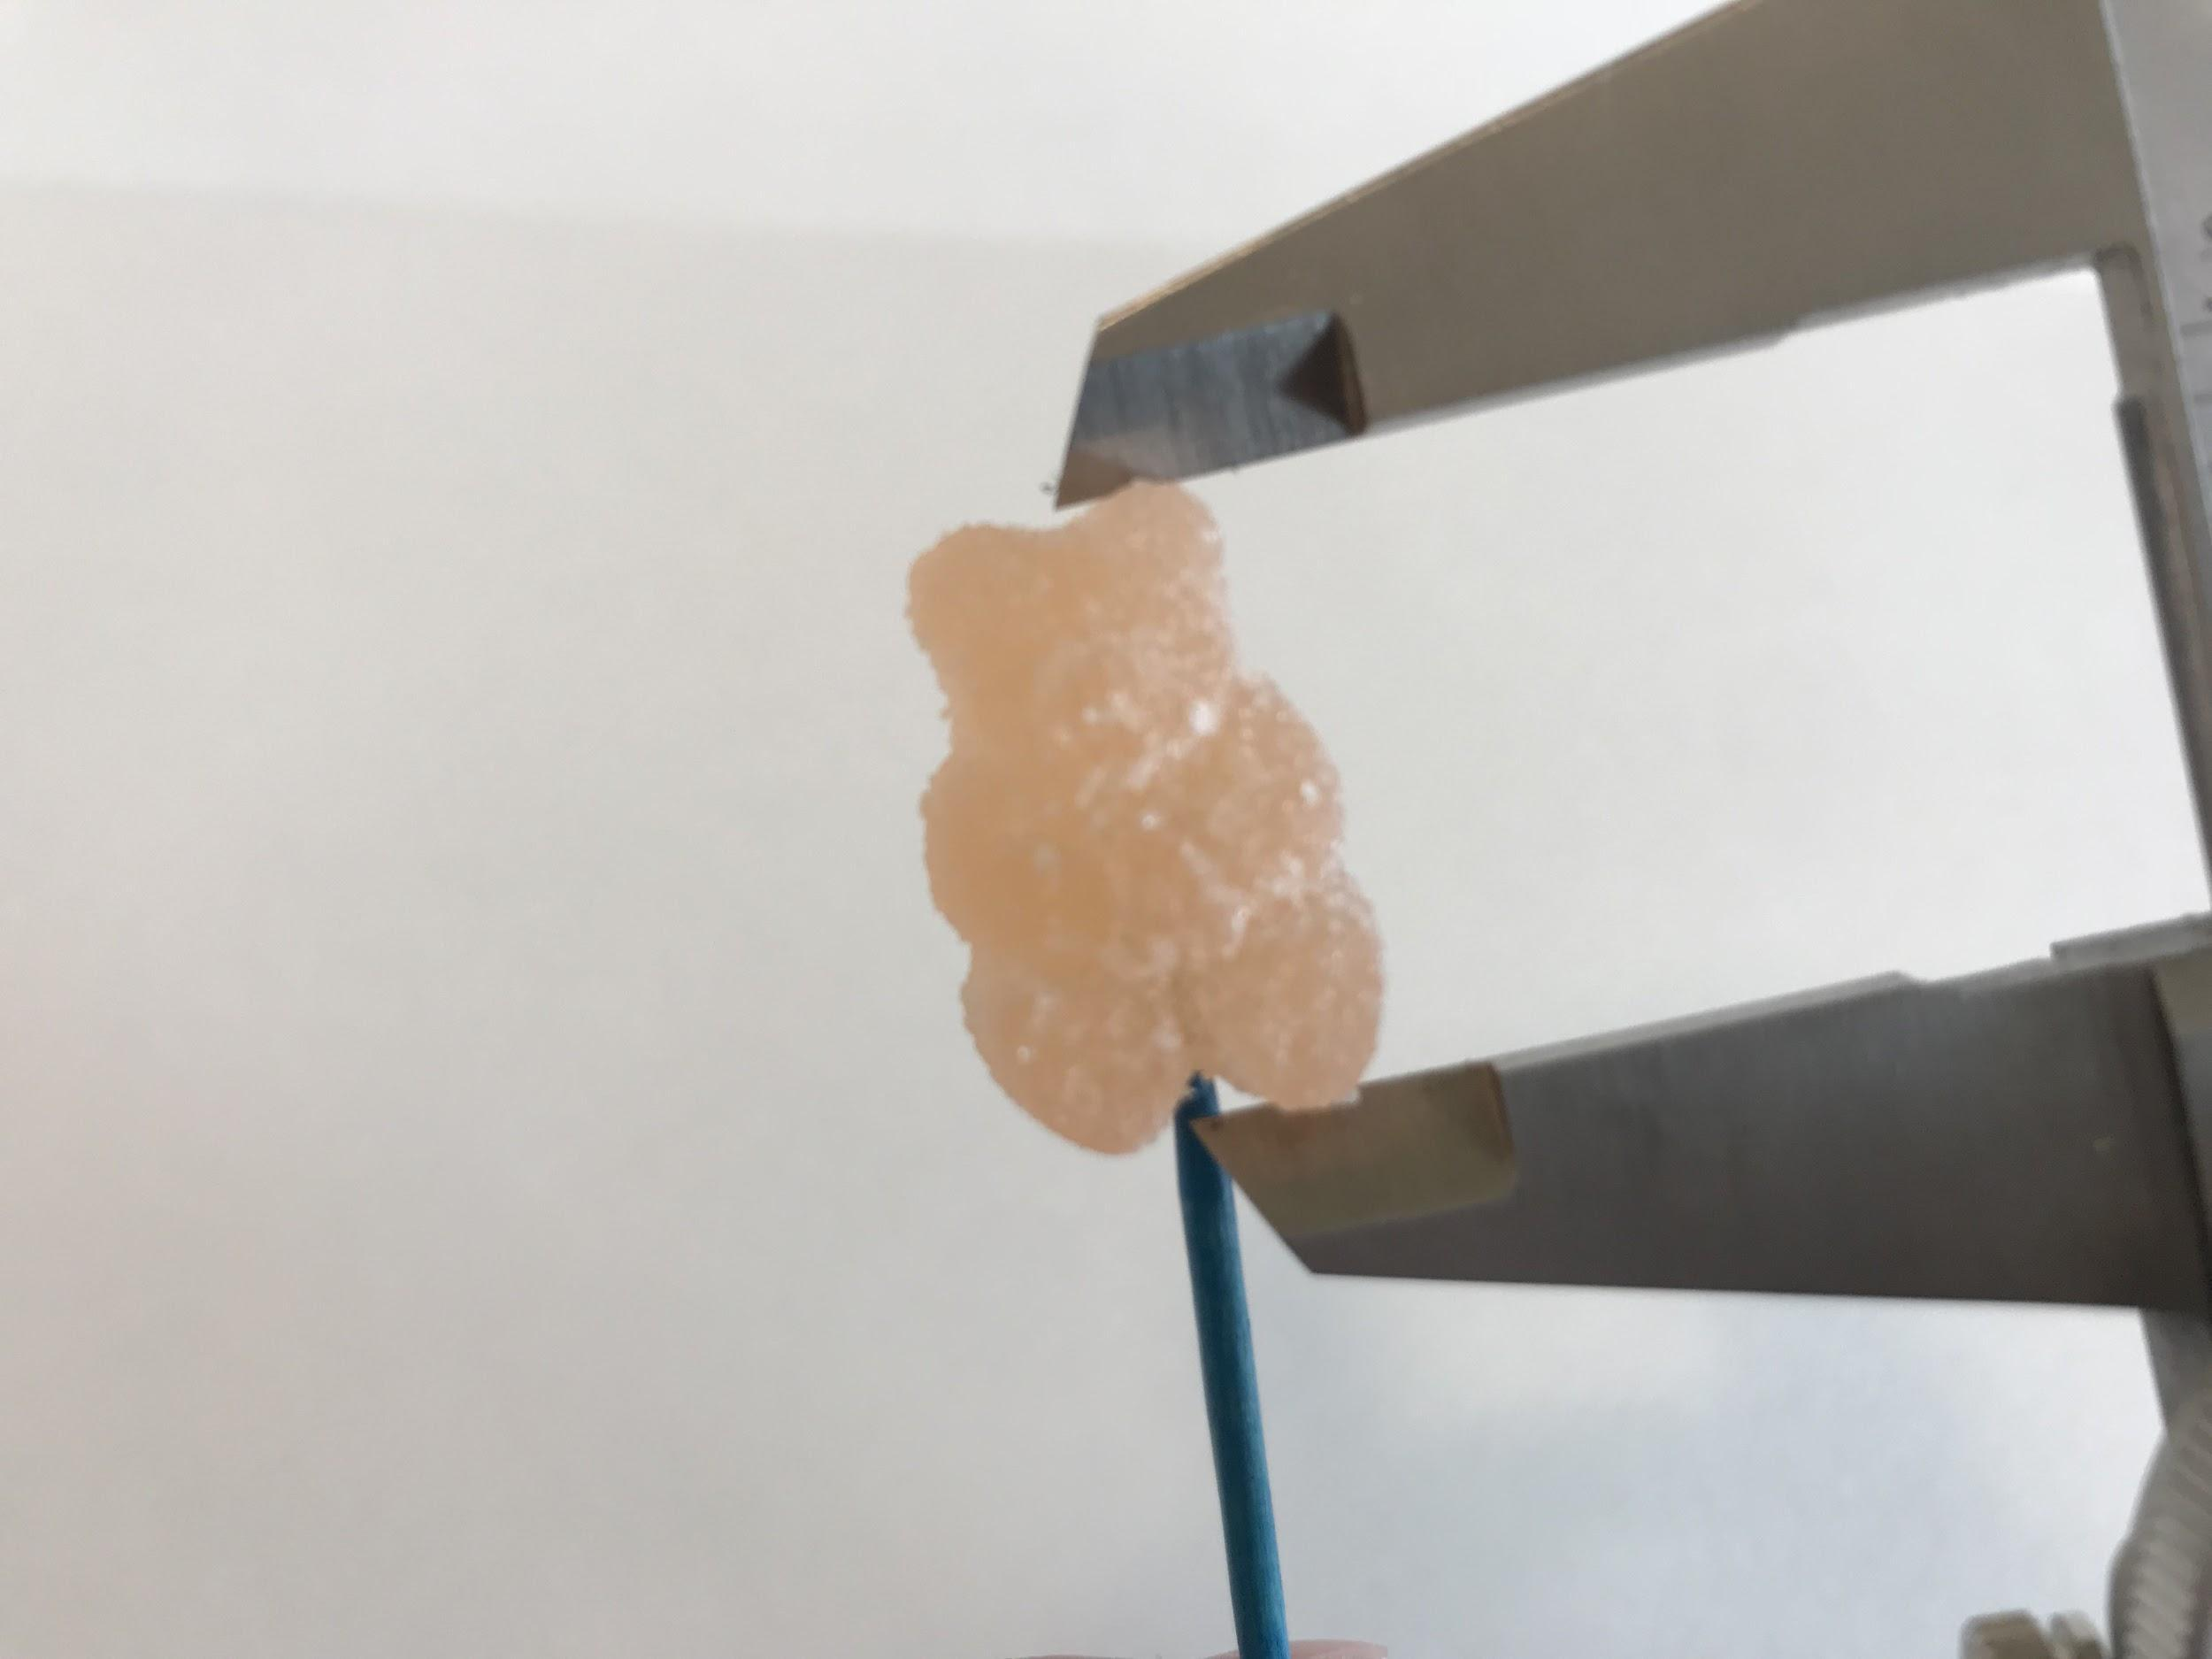

1. **Total Height** (top of the ear to the base of the feet)

Average Height: .

|  |  |  |  |  |  |  |  |  |  |
| --- | --- | --- | --- | --- | --- | --- | --- | --- | --- |
| **Bear 1** | **Bear 2** | **Bear 3** | **Bear 4** | **Bear 5** | **Bear 6** | **Bear 7** | **Bear 8** | **Bear 9** | **Bear 10** |
|  |  |  |  |  |  |  |  |  |  |

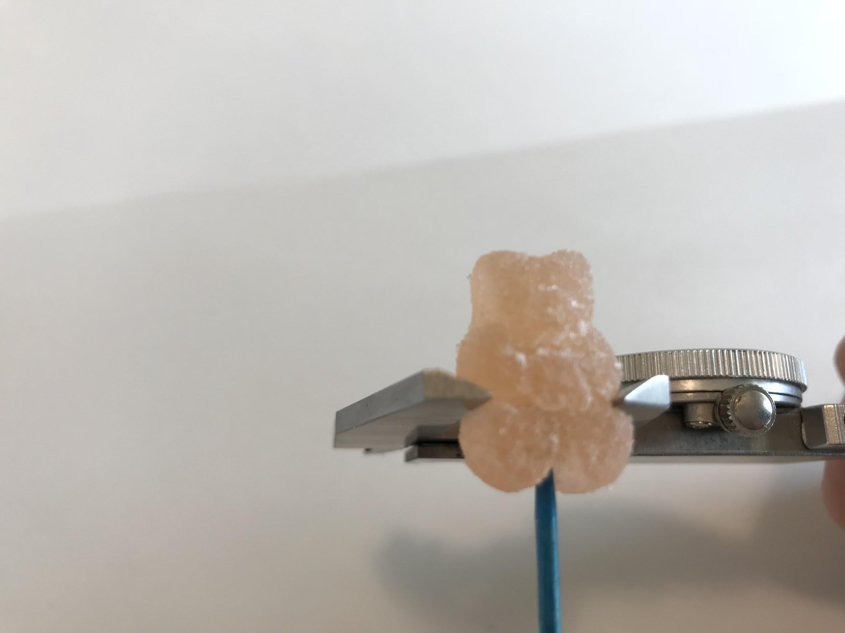

1. **Total Width** (place calipers where there is the indent under the arms)

Average width: .

|  |  |  |  |  |  |  |  |  |  |
| --- | --- | --- | --- | --- | --- | --- | --- | --- | --- |
| **Bear 1** | **Bear 2** | **Bear 3** | **Bear 4** | **Bear 5** | **Bear 6** | **Bear 7** | **Bear 8** | **Bear 9** | **Bear 10** |
|  |  |  |  |  |  |  |  |  |  |

1. **Depth of Head** (from tip of nose to back of head)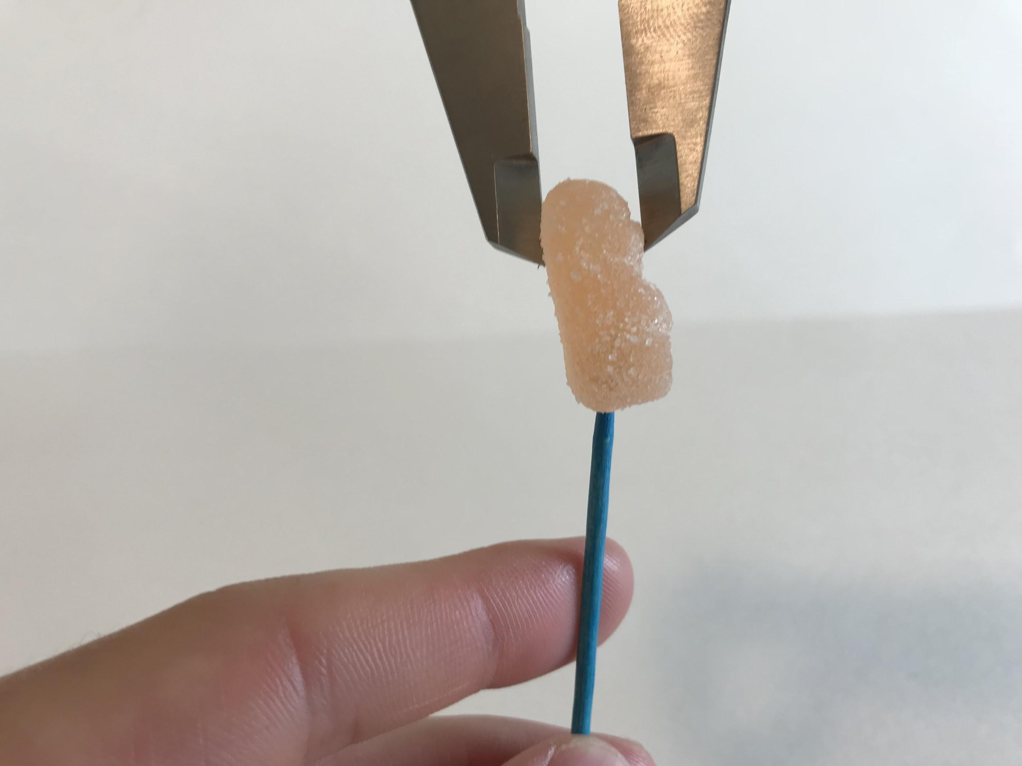

Average Head Depth: .

|  |  |  |  |  |  |  |  |  |  |
| --- | --- | --- | --- | --- | --- | --- | --- | --- | --- |
| **Bear 1** | **Bear 2** | **Bear 3** | **Bear 4** | **Bear 5** | **Bear 6** | **Bear 7** | **Bear 8** | **Bear 9** | **Bear 10** |
|  |  |  |  |  |  |  |  |  |  |

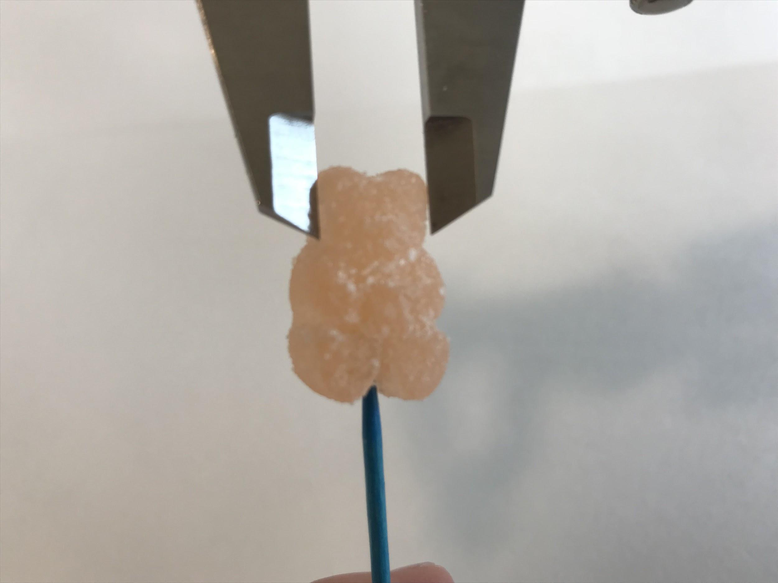

1. **Width of Head by Ears** (from edges of ears, may not necessarily be the edge of the face)

Average Head Width: .

|  |  |  |  |  |  |  |  |  |  |
| --- | --- | --- | --- | --- | --- | --- | --- | --- | --- |
| **Bear 1** | **Bear 2** | **Bear 3** | **Bear 4** | **Bear 5** | **Bear 6** | **Bear 7** | **Bear 8** | **Bear 9** | **Bear 10** |
|  |  |  |  |  |  |  |  |  |  |

1. **Height of “A” Object** (the bear holds a heart with the Albanese A on it; measure from the top to the bottom of this object)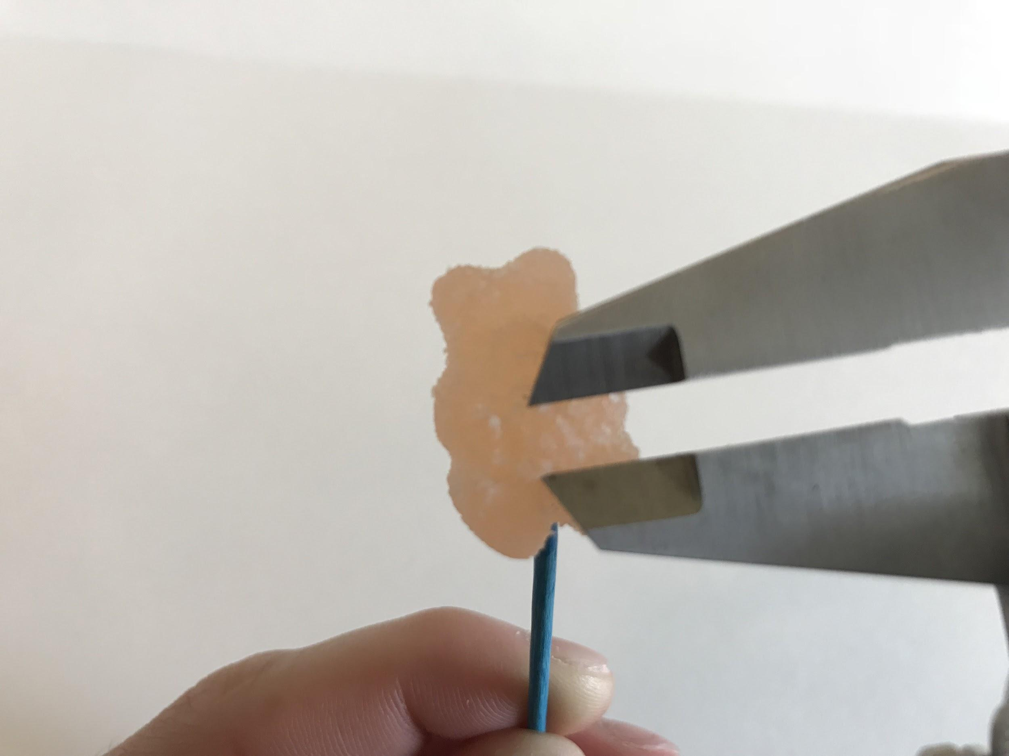

Average “A” Height: .

|  |  |  |  |  |  |  |  |  |  |
| --- | --- | --- | --- | --- | --- | --- | --- | --- | --- |
| **Bear 1** | **Bear 2** | **Bear 3** | **Bear 4** | **Bear 5** | **Bear 6** | **Bear 7** | **Bear 8** | **Bear 9** | **Bear 10** |
|  |  |  |  |  |  |  |  |  |  |

1. Write a 25 word summary of what you learned from comparing the dimensions of individual gummi bears. Use the words *dimension*, *tolerance*, *sample*, and *variation* within your summary.









