Engineering Design Process Student Activity Sheet 2.3c

Student Name: .

MSTEM Accel Car Component Dimensions
Question for Analysis
How do I account for product variation in my own MSTEM Accel Car design?
Key Concepts
- Tolerances – an allowable amount of variation of a specified quantity, especially in the dimensions of a machine or part.
- Dimensions - a numerical value expressed in appropriate units of measurement and used to define the size, location, orientation, form or other geometric characteristics of a part
Overview
In a coming lesson you will design a toy car model that can be used to explore causes of translational motion. Once you are finished designing your model it will be 3D printable and assembled, ready for an investigation into speed and acceleration. Your model will be used in several investigations throughout the course and as such must be able to have parts added to it during different investigations. Below is a list of objects that will be added to the car, and accounted for during the design process
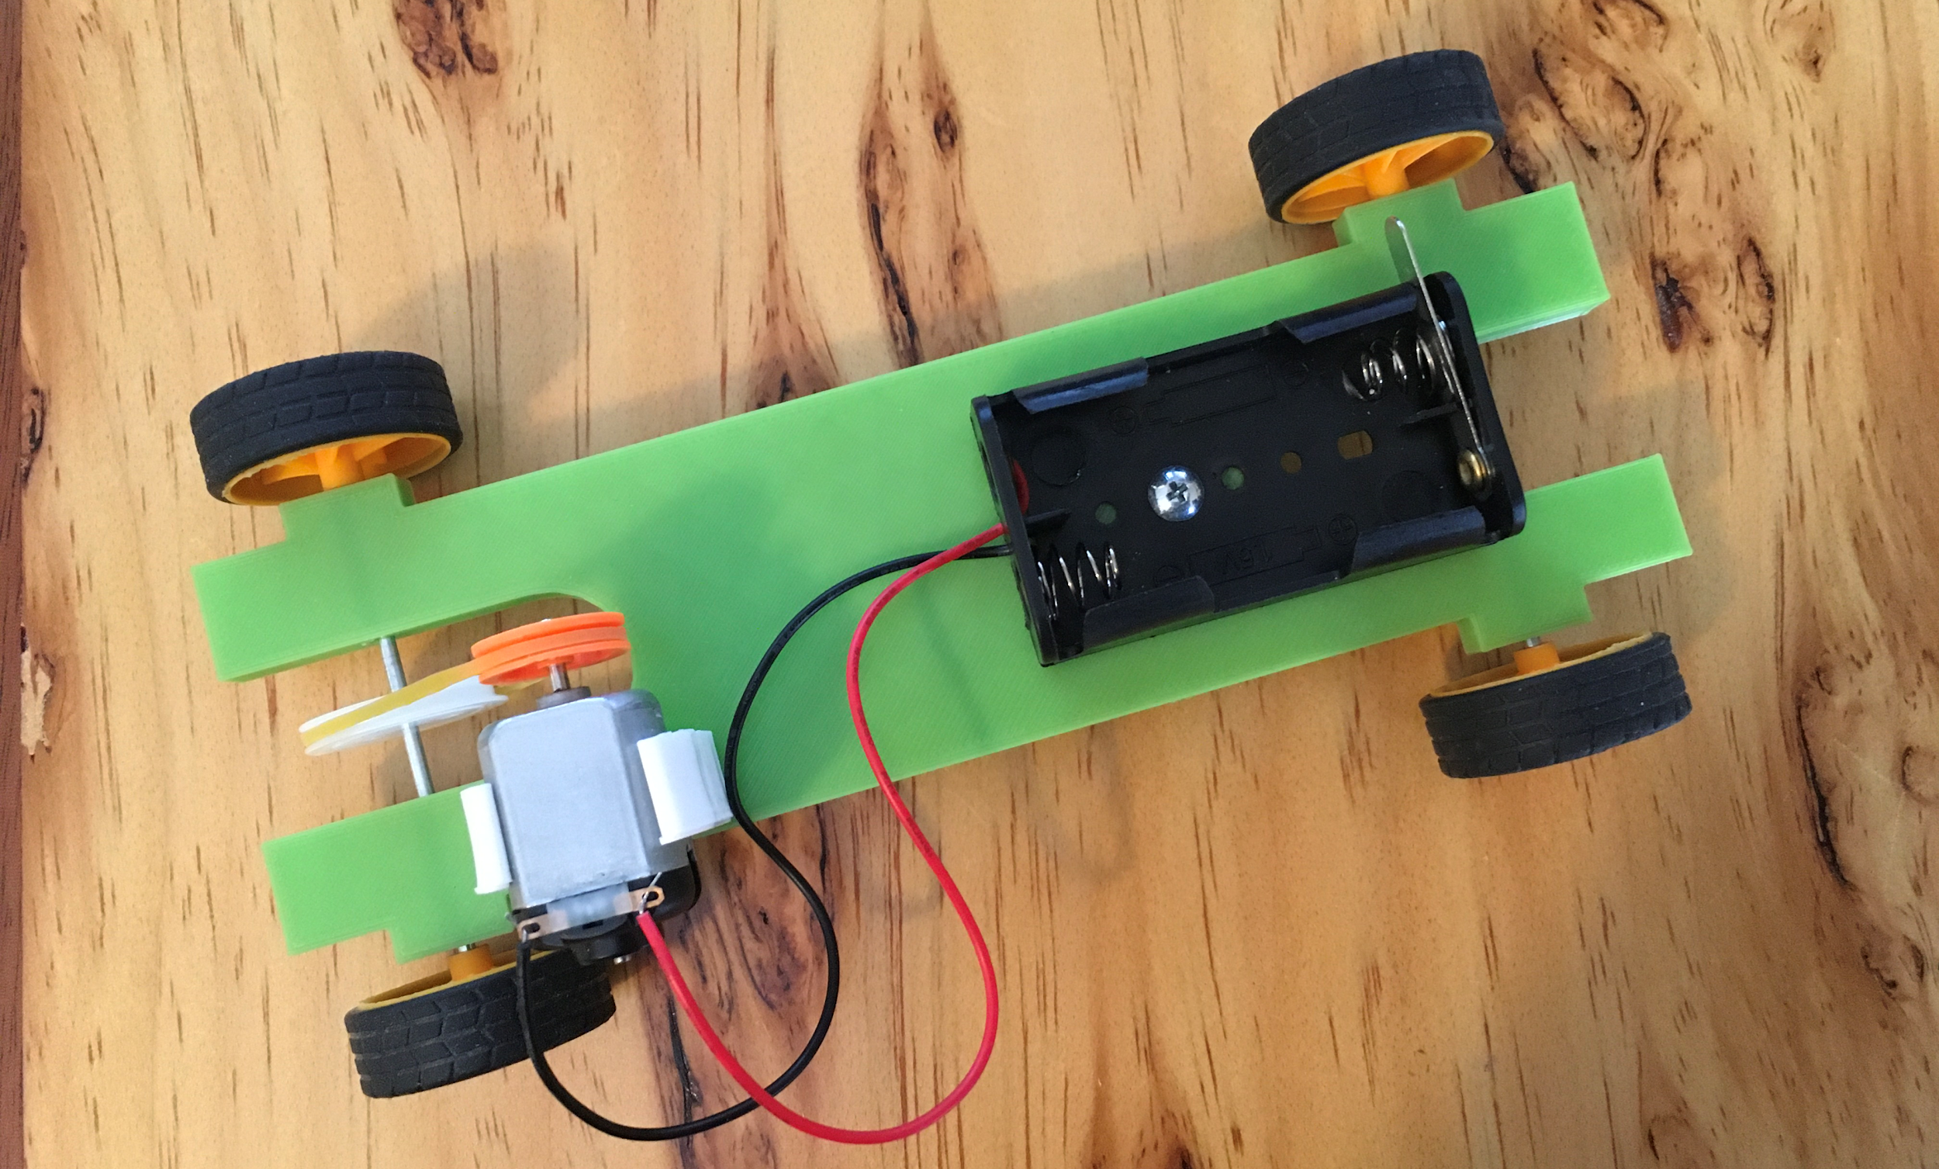
Component List
- Axle dimensions
- Pulleys - 7 different sizes
- Wheels
- Electric Motor
- Electric Motor Mount
- AA Battery Box
- Truss Machine Screws

Instructions
Use calipers and/or a tape measure to make accurate dimensions of each part. Dimensions should include a minimum of - length, width, height and be accompanied by an appropriate metric unit. (images only provided as a reference)
- Axle dimensions

- Pulleys - 7 different sizes

- Wheels

- Electric Motor

- Electric Motor Mount

- AA Battery Box

- Truss Machine Screws

