Levers and Mechanical Equilibrium
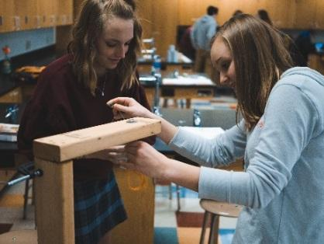
Purdue University, in partnership with Vincennes University, Ivy Tech, Indiana Next Generation Manufacturing Competitiveness Center (IN-MaC), and several Indiana High Schools, has developed a series of hands-on experiments appropriate for an introductory high school physical science course. These “Hardware Store Science” experiments are based on the premise that students will learn science content more fully by engaging in the making process of building their own investigation testing apparatus. Each experimental apparatus is constructed using hand tools and simple power tools like a drill and jigsaw. In the process, students learn how to measure, cut, and join pieces of wood and/or plastic to build their model on which to investigate a scientific phenomenon. Each of these activities provide opportunities for students to learn how to assemble a simple mechanical device using materials available from the local hardware store during the building process.
One of the major concepts that runs through physical science are the Conservation Laws. These laws state that when looking at an isolated system, certain properties of the system cannot change. These are often referred to as constants of motion. These constants of an object’s motion are said to be conserved, where the resulting conservation laws can be considered the most fundamental principle of the system. In mechanics, examples of conserved quantities include energy and momentum. One important advantage of studying motion from the basis of the law of conservation is the ability to relate that motion to energy. Since Energy is a conserved quantity, the connection between motion and the conservation laws makes it possible to follow that energy in all its various forms. Thus, a key question is to ask when studying a particular phenomenon is: Where does the energy of a system come from and where does it go.
In this lesson students will be introduced to the concept of work, which relates the gain/loss of energy to a specific type of motion. They will (i) learn how motion causes work, (ii) learn the application of the work-energy theorem when only conservative forces are involved (leading us to the conservation of energy principle) and (iii) investigate mechanical equilibrium – a concept that is transferable to other major physical processes throughout this course. Students will also learn about balanced and unbalanced forces, and how forces that move an object require work. students will develop a deeper understanding of how a lever operates as well as the concept of work. Work is one of the key concepts used throughout physical science, including mechanics, chemistry and electricity. Understanding of work is foundational, because it will be used in subsequent modules of this course.
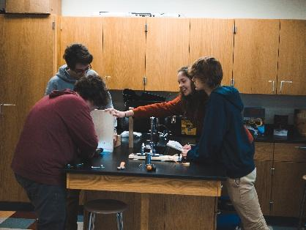
Key components of this lesson will be the hands-on build project, basic making skills, integration of all components of STEM (Science, Technology, Engineering, Math), and the application of science content to an authentic problem. The goal is to engage students with the STEM disciplines, by providing them an opportunity to apply Engineering and Technology principles to understanding a scientific concept. Mathematical analysis of collected data will be utilized to express this scientific concept in relation to balanced and unbalanced forces.
Purpose and Learning Objectives
Statement of Purpose
This is an extended lesson that will take approximately 6 days to complete. After completing first day needs and organizational issues, students begin by looking at work and how it is related to the force required to move an object, then they move on to understanding balanced and unbalanced forces. The lesson includes graphing and data analysis as well as drawing diagrams to represent story problem components. In order to introduce students to levers and lever action, students look at examples of action-reaction pairs, and how to identify them in typical story problems. Students learn about types of levers and mechanical advantage prior to their experimental investigation. Next, students participate in an investigation into how levers work and define the equilibrium rule. They will examine how a simple lever can perform work on an object by placing weights, of different mass, at various locations on a balanced board (i.e. a seesaw). Using weight and placement measurements, students will calculate the work required on one side of a balanced board to lift an object of greater mass on the other side of the balanced board. Students will use their collected data to determine the mathematical rule for equilibrium. Finally, students complete a set of practice problems to assess their understanding of inertia, balanced and unbalanced forces, action reaction pairs, mechanical advantage, and work.
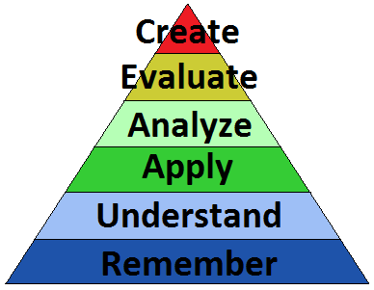
Guiding Question
How does the action of a lever demonstrate the mechanical equilibrium?
Learning Objectives (SWBAT)
Identify and explain the difference between balanced and unbalanced forces.
Demonstrate an understanding of Newton’s 3rd law by identifying action and reaction pairs.
Utilize hand tools to construct a fulcrum for investigating equilibrium and mechanical advantage of a lever.
Investigate lever action and use collected data to support the equilibrium rule.
Demonstrate an understanding of levers and the equilibrium rule by obtaining a minimum score of 70% on the Levers Practice Quiz.
Deliverables
Balanced and Unbalanced Forces
Action Reaction Pairs
Levers Investigation Data and Analysis
Levers, Work and Mechanical Advantage Practice Problems
Topics Covered
Science | Technology | Engineering | Math | Polytechnic Skills
- Balanced and unbalanced forces  - Equilibrium  - Newton’s Laws | - Hand Tools  - Measurement  - Mechanical Assembly | - Mechanical Advantage  - Building test models  - Problem Solving | - Manipulating Equations and Formulas  - $m_{1}l_{1}=m_{2}l_{2}$  - Units | - Measurement  - Design  - Physical Abilities  - System  - Technology
Lesson Timeframe
Traditional Classroom – 5 Days (45-55 minutes)

Key Concepts
- Action
- Balanced Force
- Equilibrium
- Force
- Inertia
- Interaction
- Mass
- Mechanical Advantage
- Reaction
- Unbalanced Force
- Work
Global/Local Issue
In this lesson students will engage in activities and topics related to mechanical equilibrium, as it relates to improving mechanical systems associated with manufacturing. Specifically, students will learn about the importance of recognizing balanced and unbalanced forces within mechanical systems as a way to improve efficiency and capitalize on mechanical advantage. Student teams will create a working model of a fulcrum using material from a hardware store. The use of simple hand tools during construction will set the foundation for more complicated experimental models and designs.
Enduring Understanding
Students will understand that, while the creative process is centered around defining a problem, science is about isolating a single phenomenon and testing a proposed solution and refining the experimental process until an accurate understanding emerges. Students will be aware of the fact that balanced and unbalanced forces have unique effects on an object's motion and be able to the equilibrium rule as it applies to lever action and the role levers play in developing more complicated mechanical devices. Students will understand how to apply the equilibrium rule of a lever to the use of such things as pry bars, wheelbarrows, and hand trucks. Students will understand that equilibrium is fundamental to the laws of conservation.
Required Prior Knowledge & Skills
- Basic definition of force as it relates to physical science (force is a push or pull on an object with mass that causes it to change velocity)
- Some experience with hand tools (using a hand saw, cordless drill, tape measure, etc.)
- Some experience technical drawing (using a ruler, scale, labeling, etc.)
Assessment
- Lever Investigation to assess student understanding of how a simple lever can demonstrate mechanical equilibrium, calculate the mass and distance required to balanced board, and determine the equilibrium rule for a lever.
- Levers Work and Mechanical Advantage Practice Problems to assess student learning and understanding of Newton’s laws.
- Mechanical Equilibrium Practice Quiz to assess student understanding of balanced versus unbalanced forces, calculating force, work and mechanical advantage, and Newton’s third law.
Instructional Sequence and Duration – 6 Days (Classroom duration assumed to be 45-55 minutes in length) Purchase materials for creating Lever investigation apparatus.
First Day of School: The purpose of this material is to provide guidance on utilizing the materials, methods, and procedures incorporated into the Go-Kart Science Technology & Entrepreneurship program curriculum. If you have a routine associated with how you wish to deal with note taking, warmup and wrap up activities, and overall structure of your classroom, feel free to substitute your preferred method for this section of the lesson.
Lead In: 15 – 20 minutes
- Greet Students - Prior to lesson, setup warm up activity so students are able to begin upon entering class. This will include making copies of materials or setting up a digital copy of the warm up activity and projecting that onto a screen for students to see.
- As students enter the classroom, provide them with a copy of the Lesson Log. While handing out lesson logs, use this time to greet students and gauge preparation, attitude, and attendance.
- Once class begins, instruct students to complete the warm up activity in the appropriate section of the lesson log. Take attendance as students are completing Warm Up activity.
- Bell Assignment/Affirmations/Good News/Objectives (7-10 minutes)
- Warm Up - (4-5 minutes)
  - Have students complete warmup/bell ringer activity. This could be one of the suggested warmup activities listed in the Additional Resources or one of your own choosing.
  - Affirmations/Good News (2-3 minutes) Take this time to make positive comments about student(s) Ask 1 or 2 to share “Good News” from their life – this could be birthday, birth of a sibling or cousin, success in sporting event, fun adventure they recently went on etc. The goal is to interact with students in a positive and encouraging way. If you have a routine you normally do, feel free to do that routine.
- Point out the location of the daily objective. Read the objective to students and instruct students to copy the objective into the appropriate section of the lesson log.
- Objective: Correctly identify, and calculate, balanced and unbalanced forces. This is only used as an example of an objective for the purpose of this activity. Future sessions will have a specific objective that represents the learning goal for that session. (This should be written in a prominent location within the classroom and easily identifiable by students.)
- Agenda/Activities – Take a moment to discuss the things students will be doing during the class period (agenda). Provide students with a connection between prior knowledge, the day’s objective, and list of activities. Explain what students will need to complete, and turn in, by the end of the classroom.
Activity: 25 – 30 minutes
- Classroom Discussion, Lesson Log, Take a few minutes to discuss the lesson log and the expectations for students completing the lesson log during class. You could also use a science notebook, engineering design notebook, or any number of other ways for students to take notes and complete activities.
  - Point out to students that the Lesson Notes section is for writing down important information such as terms, concepts, ideas, etc. that will allow the students to successfully complete the day’s activity(s) and accomplish the learning objective. You may wish to have students write the classroom agenda in this section as a reference.
  - Point out that the Classroom Activity section is where students will demonstrate their learning. This section can be used for completing classroom practice problems, collecting data, making observations or summarizing learning from activity.
    - Classroom Activity – Interview the student to your right or left. Ask the following questions during the interview
      - What is your name?
      - What is your favorite class in school?
      - What grade do you hope to achieve in this class?
      - What do you like to do when you are not in school?
    - Use this information (collected with Lesson Log) as part of your Affirmations/Good News for the next few days until all students have been introduced to the class.
  - Point out that the Exit Ticket section is where students will complete their daily exit ticket. This section may be graded on correctness or completion. Exit tickets are used to gauge student understanding on the day’s activity(s) and learning objective. This section can be used as a reference when prepping for the next block of learning. The goal is to determine what material needs reviewed prior to beginning the next block of learning.
- Classroom Discussion, Classroom Expectation and Procedures, Use this time to discuss that classroom expectations: grading, rules, syllabus, etc. Discuss all needed information appropriate for students to successfully complete the course. Point out to students that notes taken during this discussion should be contained in the “lesson Notes” section of their lesson log.
Wrap-up (Daily): 5 – 10 minutes
- Close and Launch – Direct student attention to the daily objective. Ask for a student volunteer to read the day’s objective. Discuss with students how they were able to meet the day’s objective. You could also invite a student to explain this as well.
- Assign any homework assignment students are expected to complete.
- Display the daily exit ticket and have students complete their exit ticket in the appropriate section of the lesson log.
- Exit Ticket/Assessment – Have student pairs answer the following questions in the Exit Ticket section of their Daily Log.
- What is the name of the people sitting to your left and right? (Answers vary)
- What is the name of the people sitting in front of and behind you? Answers vary)
- What is one rule unique to this class? (Answers vary)
- (ask an additional question or two about your specific classroom expectations and procedures)
- Collect – Lesson Log, This should contain the questions from the warmup activity, Lesson Objective, Notes taken during classroom discussion, Classroom Activity (Student Interview), and answers to the Exit Ticket. (End each lesson with a positive and encouraging statement for students to remember as they leave the classroom)
Engage: Students will learn about the causes of motion during a discussion of Newton’s 1st law of motion. During this discussion students will learn about the influence of Aristotle and Galileo on the development of Newton’s laws of motion. Students will investigate balanced and unbalanced forces as they relate to Newton’s development of his motion laws. Students will be asked to develop free-body diagrams as a means of visualizing the forces acting on an object. The accurate depiction of free-body diagrams will be the first step in determining whether all forces acting on an object are balanced or unbalanced. Students will apply their understanding of forces involved in motion by completing a series of open-ended questions. (Classroom Duration: 45-55 minutes) (ICP.3.2)
Lead In: 10 – 15 minutes
- Objective - Identify and explain the difference between balanced and unbalanced forces. (This should be written in a prominent location within the classroom and easily identifiable by students.) Provide students with a copy of the Lesson Log as they enter the classroom.
- Bell Assignment/Affirmations/Good News/Objectives (7-10 minutes)
- Warm Up - (4-5 minutes)
- ABC Chart, Vocabulary/Reading Strategy, Have students complete the ABC Chart for the term; Newton’s Laws of Motion by writing the term in the center box of the worksheet. This graphic organizer will help students brainstorm all they know about the term.
- Students complete the chart by writing a term or short phrase that starts with each letter of the alphabet. (example: A could contain the word Apple, while B could contain Balanced Forces) Once students have completed as much of the chart as possible during their warm-up activity, go around the room and have students provide the term they used for a specific letter in the alphabet.
- Display a copy of the ABC chart. Try to complete an ABC Chart while soliciting responses from students during classroom participation. (Answers vary, accept all logical answers. If you question a student’s response to a letter of the alphabet, ask them to explain their reasoning. If accurate accept answer)
- Have students write all of their unused letters in the Warm-up/Do Now section of their Daily Log. Inform students that you will verify accuracy of information prior to awarding credit for completing the activity.
- Agenda/Activities – Point out the objective and have students record this in their Lesson Log/Notes. Point out key activities that directly relate to the stated objective. Connect student prior knowledge with the day’s objective and build upon student background knowledge. Explain what students will need to complete, and turn in, by the end of the class period.
Activity: 30 – 35 minutes
- Classroom Discussion, Causes of Motion, Begin this discussion by asking a question. Ask “What is the difference between natural motion and unnatural motion?” (Answers vary, allow students to shari their thoughts. make connections between student answers and information in slides 1 and 2 of the slideshow) Have students take notes in the Classroom Notes section of their lesson log, engineering notebook, or science notebook. Use slideshow (1.3a Causes of Motion) to discuss the development of Newton’s first law of motion, by relating the works of Aristotle and Galileo to the development of Newton’s concepts of motion. Ask “What is an example of a resistive force?” (Answers vary, friction, air, etc.) Ask “What is unique about an object at rest versus an object that is not at rest?” (one is stationary, no movement whatsoever, while the other is moving in some way) Balanced and unbalanced forces are discussed as they relate to Newton’s first law and the development of force diagrams. Encourage students to make their own observations, ask questions and offer other examples from life that illustrate inertia, balanced and unbalanced forces, and examples of Newton’s first law of motion.
Discussion Note:
- Discussing Galileo’s position on motion in contrast to Newton’s is a good way to show students that knowledge and understanding changes over time as new testing methods become available. It may be helpful to review the weighted acceleration car activity if you completed the Prior Knowledge unit. If not, you may find it helpful to roll a ball down a ramp as a visual while discussing the background information of worksheet 1.3a.
- You might find it helpful for share the following video on Galileo’s study of motion called Galileo’s Inclined Plane by NOVA.
https://indiana.pbslearningmedia.org/resource/phy03.sci.phys.mfw.galileoplane/galileos-inclined-plane/
- Another helpful activity may be to create a model of Galileo’s 2-ramp system. This can be done using a 5-foot length of 1-inch PVC, 5-foot 1x4, two 6-inch pieces of 2x4, screws, and a billiard ball.
Build Procedures
- Cut the 1-inch PVC in half lengthwise. This can be done using a table saw.
- Mark the center of one length of cut PVC and a second mark 8 to 10 inches from the center.
- Drill a hole at each mark, slightly larger than a 1-inch screw.
- Mark the center of the 1x4 and additional marks 24 inches on either side.
- Use 2-inch screws to attach the 6-inch 2x4 pieces to the 1x4 at 24 inches on either side of the center mark. Ensure that both 2x4s are standing 6 inches tall on the 1x4.
- Use a 1-inch screw to attach the cut, and pre-drilled, PVC to the 1x4 so that the center marks line up. Ensure that either end of the PVC is resting on top of the 2x4 uprights, and that the rounded surface is touching the 1x4 in the center and the 2x4s at either end.
- Placing a billiard ball at one end and releasing it should allow the ball to travel along the cut edge of the PVC to the other end of your Galileo ramp model, to nearly the same height. You can change the angle by switching the screw from the center of the PVC to the hole drilled 8-10 from the center. This will create a long and short incline.
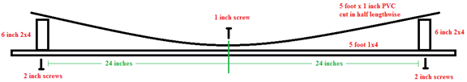
- Classroom Activity, Balanced and Unbalanced Forces, Distribute Background Information Activity Sheet for Students 1.3b. Discuss with students the question for analysis, key concepts, and review the background information. Remind students to refer to the discussion of balanced and unbalanced forces as they complete the practice problems. It may be helpful to discuss how to draw and interpret free-body diagrams while working one or two of the practice problems with students.
Wrap-up (Daily): 5 – 8 minutes
- Close and Launch – Direct student attention to the daily objective. Ask for a student volunteer to read the day’s objective and discuss how they were able to meet the day’s objective. (Take a moment to review the day’s activities and how they relate to the stated objective)
- Assignment – Balanced and Unbalanced Forces, Assign Practice Problems from Balanced and Unbalanced Forces Student Activity Sheet 1.3b students did not complete as homework.
- Exit Ticket/Assessment – Have students answer the following questions in the Exit Ticket section of their Daily Log, their engineering notebook, or their science journal/notebook. (See Module 1 Warm-up Activities and Exit Tickets)
- Define Inertia. (The property of a body to resist changes to its state of motion)
- Define Balanced Force. (Two forces acting on an object that are equal in size and opposite in directions)
- What is a free-body diagram? (Answers vary – a diagram showing all the forces acting on an object)
- Collect – Lesson Log, This should contain the questions from the warmup activity, Lesson Objective, Notes taken during classroom discussion, Classroom Activity, and answers to the Exit Ticket. (End each lesson with a positive and encouraging statement for students to remember as they leave the classroom)
Explore: Students will use their knowledge of balanced and unbalanced forces as a means of connecting with the concept of a lever. Three classes of levers will be explored, from the position of the fulcrum, an applied input force, and the resulting output force. Students will learn about mechanical advantage and how to determine the mechanical advantage of a lever. Students will demonstrate their understanding of levers and mechanical advantage by determining the mechanical advantage from an input and output force, and/or resolve a mechanical advantage into its input and output forces. (Classroom Duration: 45-55 minutes) (ICP.4.4; POE-3.3, 6.1)
Lead In: 10 – 15 minutes
- Objective - Demonstrate an understanding of Newton’s 3rd law by identifying action and reaction pairs. (This should be written in a prominent location within the classroom and easily identifiable by students.) Provide students with a copy of the Lesson Log as they enter the classroom.
- Bell Assignment/Affirmations/Good News/Objectives (7-10 minutes)
- Warm Up - (4-5 minutes)
- Mark Up The Text (MUTT) – What Is horsepower? Provide students with a copy of the article and have them Mark Up The Text (MUTT). Instruct students to circle new terms, underline definitions, place a star next to important information, place an “!” next to information they find interesting, and place a “?” next to things they don’t understand.
- Have students answer the following questions on their Daily Lesson Log, Engineering Notebook, or Science Journal once they have completed MUTTing the article:
- What did you learn from the article? (Answers vary, ensure completion)
- What is one fact that surprised you from the article? (Answers vary, ensure completion)
- What is one question you have after reading the article? (Answers vary, ensure completion)
- Agenda/Activities – Point out the objective and have students record this in their Lesson Log/Notes. Point out key activities that directly relate to the stated objective. Connect student prior knowledge with the day’s objective and build upon student background knowledge. Explain what students will need to complete, and turn in, by the end of the class period.
Activity: 30 – 35 minutes
- Classroom Discussion, Levers and Equilibrium, Use the slideshow (1.3c Levers and Equilibrium) to introduce students to levers and simple machines. Ask “What is the difference between a simple machine and a complex machine?” (Answers vary, may include size, number of pieces, etc.) Point out key terms like fulcrum, mechanical advantage, and input and output forces. Ask “What is the difference between an input force and an output force?” (input forces are the applied forces, out put forces are the resulting forces) Help students understand the formula for determining work, and how the equation can be manipulated to isolate variables. Discuss the 3 classes of levers and point out how forces come in pairs. End the discussion by relating how multiple simple machines combine to create complex machines. Ask “Why is there a difference between the ideal mechanical advantage and the actual mechanical advantage?” (actual mechanical advantage involves some sort of resistance; friction, etc.) Have students take notes in the Classroom Notes section of their lesson log, engineering notebook, or science notebook..
- Classroom Activity, Action Reaction Pairs, Discuss action-reaction pairs by providing students with the opportunity to identify action-reaction pairs in real examples. This can be done using pictures, students, and/or classroom objects. Remind students of your discussion on balanced and unbalanced forces. Provide examples of action-reaction pairs that are balanced and unbalanced. Distribute Background Information Activity Sheet for Students 1.3d. Discuss with students the question for analysis, key concepts, and Newton’s 3rd law. Help students identify action reaction pairs in a given situation. Encourage students to make their own observations, ask questions and offer other examples from life that illustrate Newton’s 3rd law. Assign students to complete the practice problems.
Discussion Note:
- The introduction of calculating force is meant to foreshadow what students will do in future lessons. There are no calculations required for the practice problems found in worksheet 1.3b but these could be manipulated to include force calculations.
Wrap-up (Daily): 5 – 8 minutes
- Close and Launch – Direct student attention to the daily objective. Ask for a student volunteer to read the day’s objective and discuss how they were able to meet the day’s objective. (Take a moment to review the day’s activities and how they relate to the stated objective)
- Assignment - Action Reaction Pairs, Assign Practice Problems from Action Reaction Pairs Student Activity Sheet 1.3d students did not complete as homework.
- Exit Ticket/Assessment – Have students answer the following questions in the Exit Ticket section of their Daily Log, their engineering notebook, or their science journal/notebook. (See Module 1 Warm-up Activities and Exit Tickets)
- What is Newton’s 3rd law? (For every action, there is an equal and opposite reaction)
- Draw a diagram showing the action reaction pair for a volleyball player spiking a ball. (Answers vary – should be two forces: player hitting the ball, ball hitting the player)
- What is meant by equal and opposite in Newton’s 3rd Law? (Answers vary – should mention something about the same magnitude of force and forces pointing in opposite directions)
- Collect – Balanced and Unbalanced Forces, Lesson Log, The lesson log should contain the questions from the warmup activity, Lesson Objective, Notes taken during classroom discussion, Classroom Activity, and answers to the Exit Ticket. (End each lesson with a positive and encouraging statement for students to remember as they leave the classroom)
Engineer: Students are organized into lab groups of 3 to 4 individuals and tasked with the creation of a fulcrum for investigating lever action in a manner that will allow them to determine the equilibrium rule for a simple lever with a fulcrum located in the center of the lever. Group members will utilize a common wood saw for cutting 2x4 material to length, a hack saw for cutting ⅛ inch aluminum the length, and a cordless drill/driver for assembling their fulcrum with screws. Groups will also design a board that can be used to easily measure the distance an object is placed from the fulcrum. Students will receive instruction on use of hand saws, cordless drill/drivers, and a standard retractable tape measure. (Classroom Duration: 90-110 minutes) (ICP.3.5, 3.7; IED-0.1, 2.6, 6.10; POE-3.2, 3.4, 3.7, 6.1, 6.6)
Investigation Build Note:
The resources required for this investigation are dependent upon which Lever Investigation model you decide to have students design and build.
Card Board Model | 3D Printer Model | Wood Model
Corrugated card board | 3D Printer with filament | 1x3 MDF board
Masking tape | Ruler or small tape measure | 2x4 lumber
Scissors or utility knife | Hex Nuts (5/16” – 18) | Screw
Tape measure | Scale | 1/8 inch flat aluminum
Wooden ruler (similar object) | Model .STL file – downloadable version of the model illustrated can be found at https://www.tinkercad.com/things/bKzOmRjJrWn | Wood cutting saw
Hex nuts (5/16” – 18) |  | Metal cutting saw (Hacksaw)
Scale |  | Electric drill
 |  | Screw driver or bit for drill
 |  | Drill bits
 |  | Tape measure
 |  | Scale
It is important to ensure that each group has access to the equipment, tools, and supplies to conduct the investigation. This does not mean each group has all equipment and tools, as these items may be shared. You will need to fabricate an example model prior to class as a reference for students when creating their design sketches.
Wood Lever Build Instructions for Educator
- You may choose to pre-cut the 1 x 3 x 8 MDF board in half creating 2 – 48-inch-long boards. Creating enough for each student group to have one board.
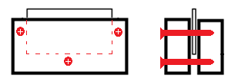
- You may choose to pre-cut 6-inch pieces of 2x4 and 4-inch pieces of the 1/8 inch flat aluminum. Create enough pieces for each group to have two 2x4 sections and 1 piece of aluminum.
- Complete the fulcrum by sandwiching the 4-inch aluminum between two 6-inch 2x4 pieces. Ensuring that the aluminum plate extends above the surface of the 2x4. Insert a 2-1/2-inch screw through the 2x4, on either side of the aluminum plate. Insert a third screw below the plate, centered in the 2x4 from left to right.
  - It is helpful to pre-drill one of the 2x4 pieces. Students may need assistance holding the 2x4 pieces together as they insert screws. It may be handy to have a number of large C-Clamps available for students having difficulty holding the 2x4s together as they drive the screws into the boards.
- It will be important to assist students in ensuring that the holes they pre-drill for are outside the dimensions of the aluminum plate. Help students accomplish this by suggesting that they trace the aluminum plate location on one of the 2x4 pieces prior to drilling pilot holes.
It is assumed that students are familiar with some sort of reporting style and format, based on their previous experience within a science classroom. This experiment can easily be turned into a formal Lab Report, mini Science Fair, Classroom Presentation, or even Journaling activity. It is encouraged however to use a rubric similar to the one included in the teacher resources as a means of assessing student learning and skill progress.
Lead In: 10 – 12 minutes
- Objective - Utilize hand tools to construct a fulcrum for investigating equilibrium and mechanical advantage of a lever. (This should be written in a prominent location within the classroom and easily identifiable by students.) Provide students with a copy of the Lesson Log as they enter the classroom.
- Bell Assignment/Affirmations/Good News/Objectives (7-10 minutes)
- Warm Up - (4-5 minutes) (See Module 1 Warm-up Activities and Exit Tickets)
- Mark Up The Text (MUTT) – Lever Investigation? Have students mark Up The Text (MUTT) the Build it Yourself and Construction Procedure sections of the Lever Investigation in preparation of making their testing apparatus. Instruct students to circle new terms, underline definitions, place a star next to important information, place an “!” next to information they find interesting, and place a “?” next to things they don’t understand.
- Have students answer the following questions on their Daily Lesson Log, Engineering Notebook, or Science Journal once they have completed MUTTing the article:
- What are you going to build? (fulcrum for balancing a board)
- What tools will you need to build your device? (wood saw, metal saw, drill, screwdriver or cordless drill/driver)
- How does your device work? (Answers vary, but should mention something about it being the point on which a lever rests or is supported and on which it pivots)
- Agenda/Activities – Point out the objective and have students record this in their Lesson Log/Notes. Point out key activities that directly relate to the stated objective. Connect student prior knowledge with the day’s objective and build upon student background knowledge. Explain what students will need to complete, and turn in, by the end of the class period.
- Ensure student pairs have adequate supplies for building their testing model.
Activity: 75 – 90 minutes
- Maker Time, Building Fulcrum and Lever, Divide students into groups of 2 or 3. Distribute Lever Investigation Data Sheet 1.2 to student groups. Take a couple minutes to discuss the Build It Yourself section with students. If students are not completing the entire build process, be sure to discuss those aspects that apply to their build process. Point out the materials available to them as well as any special instructions that relate to your classroom, and then assist students with the construction of their experimental apparatus.
- Maker Skill Development, Hand Saw Use and Safety, Before students put saw to wood, explain the following guidelines for using a hand saw. For more information on hand saws and their use see the Maker Skills document in Classroom Resources.
- Mark the cutline. Draw a line marking where you want the cut to be. The line will act as a guide to help get a straight cut.
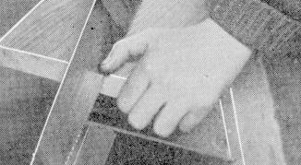
- Make the starting cut. Use your thumb or the knuckle of your thumb on the hand holding the wood as a guide to ensure they cut along the cutline.
- Start your cut with the teeth near the handle. Make a few back cuts until you get a nice kerf (opening in the wood).
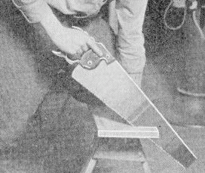
- Cut next to the line. Cut on the waste side, or side you do not want. It is always better to have a piece of wood that is a bit long, than a bit short.
- Angle the saw correctly. Angle your saw correctly to get the best cut. This is typically between 45 and 60 degrees to the cutting surface.
- Hold your elbows close to your body. This will counteract the natural tendency to angle the blade away from perpendicular.
- Grip the handle so that their forefinger extends along the side of the handle and “point” the saw along the line to ensure a more accurate cut.
- The stroke. Push the saw with an easy, free-running motion. Use long strokes so that each tooth does a fair share of the work. Short strokes make it harder to cut.
Investigation Build Note:
For some students, simply using the pencil line as their guide to cutting just doesn’t work. If students want to ensure that they get a true and square cut, have them place a small board, as a guide, along the pencil line and clamp it to the board they are cutting. The board will now act as their guide to keep the saw on the line. If available, a miter box can be another effective means of ensuring an accurate cut. If students veer from the cut line, have students stop sawing and bring their blade back to the point where they veered off and start sawing on the line again. To prevent binding, have students place a nail in their kerf. This will keep it open. Students may need to move the nail towards them as they saw.
- Maker Skill Development, Cordless Drill/Driver, A cordless drill/driver can handle all the drilling and driving needs for the projects described in this activity, and will give students all the benefits of a drill without the hassle of a power cord or the fatigue associated with a hand-held screwdriver. If students have access to a 20 to 40-piece drilling and driving accessory kit, they will have everything you need to do all projects, challenges, and investigations associated with this unit. Before students use their drill/driver, explain the following guidelines for using a cordless drill/driver. For more information on cordless drill/drivers and their use see the Maker Skills document in Classroom Resources.
- To drill a hole, select a drill bit that is appropriate for the task. If doing a pilot hole pick a drill bit a little smaller than the tip of the screw.
- To insert the drill bit into the drill/driver, hold your hand firmly around the chuck of the drill (#1 below), and keeping it still while running the drill in reverse, open the chuck (#2) or run the drill forward to close the chuck (#3).
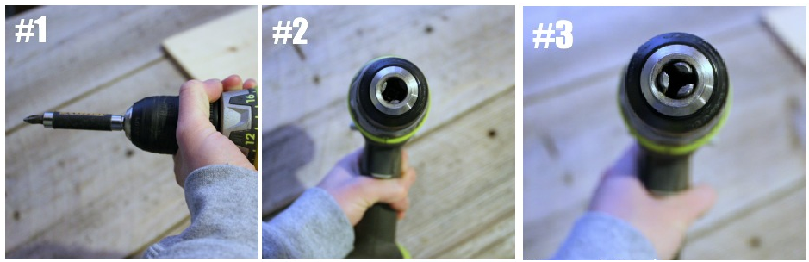
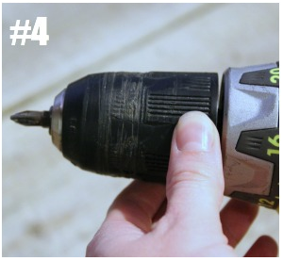
- When the chuck opening is big enough, insert the bit or driver. Do not allow the bit or driver to fall too far into the chuck opening.
- Hold your hand firmly around the chuck of the drill as you did before and run the drill in the forward motion until the drill bit or driver is secured in the drill (#4).
- Place the tip of the bit on the desired location for the hole and ensure that the drill is straight and true with respect to the board orientation.
- While pulling firmly on the trigger, use a firm and steady motion, to create your hole. There should be little pressure required to drill a vertical pilot hole within a board because the weight of the drill will do most, if not all of the work. Horizontal holes will require a firm pressure while maintaining correct orientation with the board.
- Attachment of the screwdriver bit, and driving their screw, is accomplished the same way as inserting a drill bit and drilling a pilot hole.
Investigation Build Note:
When driving screws into wood, it’s a good idea to drill a pilot hole first. Without pilot holes, screws tend to follow the grain of the wood, which results in angled screws. Thus, pilot holes ensure that students drive the screw in straight. Pilot holes also help prevent the wood from splitting as students drive in screws. For small screws, a pilot hole can be made with a small diameter drill bit. For larger sized screws and all screws in hardwood, drill a pilot hole using a drill bit with a countersinking ability. It is important to keep a watchful eye on students when using the cordless drill/driver as they often provide more torque and power than is needed. Ensure students use a screwdriver bit that matches the type of screw they are driving. Most likely, you will use a Phillip’s head drill bit but you may also choose square head and star (torx) head screws.
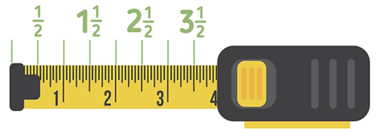
- Maker Skill Development, How to Read a Tape Measure, All activities in this course will require students to measure lengths using a standard tape measure. Students will then be taught how to convert these values into other usable units. A standard tape measure is used because it is what the majority of students will be required to use in their jobs and careers. Using a tape measure can be a quick, easy way to get needed information or obtain the needed components to a project. Knowing how to use and read a retractable measure can be a major asset to anyone working with his or her hands. Before students begin making measurements, explain the following guidelines for using a tape measure. For more information on using a tape measure see the Maker Skills document in Classroom Resources.
- Use the bigger marks between two-inch markings for half-inches. A half-inch mark is always centered between any two one-inch marks. It almost always has the second-longest marking (after the one-inch marks). There will be one half-inch mark between each one-inch mark, but it is important to remember that there are two half-inches per inch.
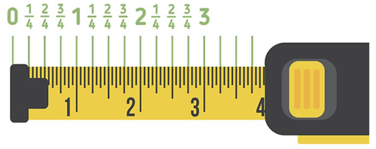
  - Note that, starting with half-inch marks, not all lines may be labeled with numbers. In this case, students will need to use the markings on either side to guide them. For example, the half-inch mark between inches three and four stands for 3 1/2 inches, even though it's not labeled.
- Use the smaller lines between half-inches for quarter-inches. These markings are smaller than half-inches but usually bigger than the 1/8 and 1/16 inch marks around them. They are evenly spaced between each half-inch mark and one inch-mark. There are four quarter-inches in one inch.
  - Note that lines marking a quarter of an inch sometimes aren't any different in size from eighth-inch marks. In this case, students will need to remember that two eighths of an inch make a quarter.
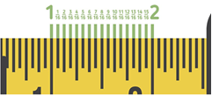
- The next smaller marks are for one-eighth-inches. These markings are centered between the inch marking and the quarter-inch marking, the quarter-inch marking and the half-inch marking, and so on. There are eight one-eighth inches per inch.
- The tiny, densely-packed marks are for sixteenths of an inch. These are the shortest lines of all on most measuring tapes are the sixteenth-inch marks.
- Catch the hooked end on one side of the object you're measuring.
- Stretch the tape across your object. You can use one hand (or a friend) to hold the end of the tape in place as you pull it back. Let tape out until it stretches all the way across the distance you're measuring.
- Read directly from the tape by looking at the point where the tape meets the end of the thing you're measuring or the desired measurement on the tape measure.
- The nearest number below the end of the tape is your number of units you're measuring and the markings between this number and the one above it correspond to fractions of the unit.
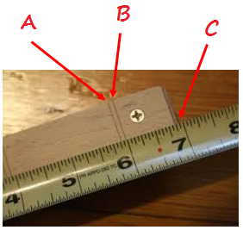
measurement A = 5 and 7/8 inches
measurement B = 6 inches
measurement C = 6 and 15/16 inches

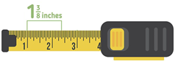
- Add the inch segments to determine total length. When you are measuring a length, getting an accurate value just means seeing where the tape lines up. Find the nearest inch before this point. Then, find the nearest half-inch before this point. Then, the nearest quarter-inch, and so on. Add up your inches and fractions of inches until you have an accurate measurement. This is a lot easier than it sounds — see below for an example.
  - Let's say that we've measured past the one-inch mark, past one quarter-inch mark, and past one eighth-inch mark. To find our measurement, we need to add:
1 (our inches) + 1/4 (our quarter-inches) + 1/8 (our eighth-inches).
  - Since there are two eighth-inches in a quarter-inch, we can rewrite this as:
1 + 2/8 + 1/8 = 1 3/8 inches.
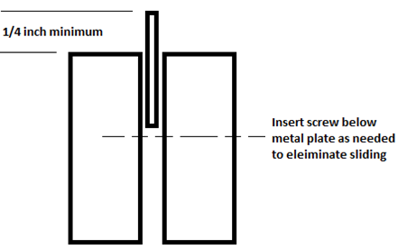
  - Students may need assistance with adding fractions like 1/2, 1/4, 1/8, as they can be tricky for some students.
Investigation Build Note:
- When students are assembling their fulcrum, ensure that the piece of aluminum rises above the surface of the fulcrum by a minimum of ¼ inch.
- To help with keeping the metal strip from slipping further down into the fulcrum it may be helpful to have students place a screw through the fulcrum, below the bottom of the metal strip.
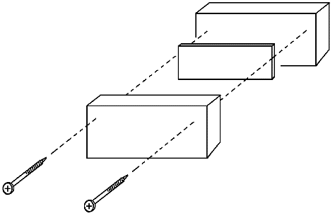
- Fulcrum Build, Lever Investigation, Have students use the tape measure to accurately measure 36 inches of 1x3 MDF board then use their hand saw to cut the MDF board to length. remind students that they must ensure the accuracy of their cut. If cut correctly the board will balance when centered on the stationary fulcrum. Next, have students create their fulcrum by cutting two pieces of 2x4 that are at least 8 inches long and a piece of 1/8 inch flat aluminum that is a maximum of 5 inches long. Assist students in assembly of their fulcrum. Students should place the aluminum between the 2x4 pieces centered within the length dimension. There should be a minimum of 1 inch between the edge of the aluminum and the edge of the 2x4 material and extend at least ½ inch above the surface of the 2x4 pieces. Have students secure the plate aluminum in place using screws. Have students measure the 1x3 MDF board’s overall length and determine the center, then scribe a line to clearly mark this center point. Place lighter marks across the 1x3 MDF board every 1 inch from the center line, until you reach either end, similar to the image below.
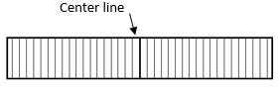
Wrap-up: 5 – 8 minutes
- Close and Launch – Direct student attention to the daily objective. Ask for a student volunteer to read the day’s objective and discuss how they were able to meet the day’s objective. (Take a moment to review the day’s activities and how they relate to the stated objective)
- Assignment - Lever Investigation Background Information, Assign students to read the Background information from the Levers Exploration Investigation Activity Sheet 1.2a as homework. Inform students they will be quizzed over the information prior to conducting their investigations .
- Exit Ticket/Assessment – Have students answer the following questions in the Exit Ticket section of their Daily Log, their engineering notebook, or their science journal/notebook. (See Module 1 Warm-up Activities and Exit Tickets)
- What aspect of building your fulcrum did you find the most difficult? (Answers vary)
- What aspect of building your fulcrum did you find the easiest? (Answers vary)
- Collect – Lesson Log, This should contain the questions from the warmup activity, Lesson Objective, Notes taken during classroom discussion, Classroom Activity, and answers to the Exit Ticket. (End each lesson with a positive and encouraging statement for students to remember as they leave the classroom)
Explain: After collecting data during an investigation into how a simple lever can demonstrate mechanical equilibrium, groups share their findings. Data will be collected from placing weights, of different mass, at various locations on a balanced board (i.e. a seesaw). Using weight and placement measurements, students will calculate the force distance ratio required on one side of a balanced board to lift an object of greater mass on the other side of the balanced board. Students will also determine the mathematical rule for equilibrium. Students will share their findings with their peers and evaluate the success of each group's investigation based on how accurately a group determines similar equilibrium rules. (Classroom Duration: 45-55 minutes) (ICP.3.2, 4.4; POE-3.2, 6.1, 6.4)
Investigation Note:
It is important to ensure that each group has access to the supplies to conduct the investigation. provide groups with a container of hex bolts for conducting their investigation.
Lead In: 10 – 12 minutes
- Objectives - Demonstrate an understanding of work by solving story problems involving work and mechanical advantage. (This should be written in a prominent location within the classroom and easily identifiable by students.) Provide students with a copy of the Lesson Log as they enter the classroom.
- Bell Assignment/Affirmations/Good News/Objectives (7-10 minutes)
- Warm Up - (4-5 minutes) (See Module 1 Warm-up Activities and Exit Tickets)
- Levers Background Information Quiz, Establish 4-5 questions that will gauge whether students have read, and understand, the material in the background section of the Lever Investigation activity. This can be handed out as students enter the classroom or in a more formal manner after class has begun. You may choose to use the following: What is required to make an object move? What are the three requirements for work to take place? What is mechanical advantage? What is the formula for calculating work? What is the equation for equilibrium and what does it tell us about a given situation?
- Have students answer the following questions in the Warm-up/Do Now section of their daily lesson log, their engineering notebook, or their science journal/notebook.
- What is required to make an object move? (a force)
- What are the three requirements for work to take place? (Answers vary - force, movement (or equivalently the displacement), and cause)
- What is the formula for calculating work? ($w=F×d$)
- What is the equation for equilibrium and what does it tell us about a given situation? ($M_{1}A=M_{2}B$)
- Agenda/Activities – Point out the objective and have students record this in their Lesson Log/Notes. Point out key activities that directly relate to the stated objective. Connect student prior knowledge with the day’s objective and build upon student background knowledge. Explain what students will need to complete, and turn in, by the end of the class period.
Activity: 30 – 35 minutes
- Data Collection, Lever Investigation, Ensure that each student has a cop of the Investigation Activity Sheet 1.2a. Assist groups in investigating how a simple lever can perform work on an object. Groups will accomplish this by placing weights, of different mass, at various locations on a balanced board (i.e. a seesaw). Using weight and placement measurements, students will calculate the force distance ratio required on one side of a balanced board to lift an object of greater mass on the other side of the balanced board. Students will also determine the mathematical rule for equilibrium.
- Have groups complete the first experiment from this activity. Take a couple minutes to explain the information in the Background Information section of their packet and data collection. Then, move around the classroom and assist students as needed. Ensure students are collecting data that is consistent between trials.
- Once students have collected their data, have them calculate the
- $m×l$ value on each side of the fulcrum. Assist groups with these calculations as needed.
- Assign groups to complete the data analysis section of their investigation data sheet and any exploration activities you deem appropriate. This can be done by having student pairs complete all exploration activities or dividing the activities among the classroom groups. At this point, you may collect their packets or have them complete a more formal lab report. If a report is collected, you may consider grading it using the scoring rubric, which accompanies this unit. Always grade for accuracy of answers, use of collected data, and supporting evidence.
- Optional Classroom Presentation, Allow students to present their findings with class members using a poster board/science fair format.
Wrap-up: 5 – 8 minutes
- Close and Launch – Direct student attention to the daily objective. Ask for a student volunteer to read the day’s objective and discuss how they were able to meet the day’s objective. (Take a moment to review the day’s activities and how they relate to the stated objective)
- Assignment - Lever Investigation, Assign Data Analysis question from the Lever Experimental Investigation Activity Sheet 1.2 students did not complete as homework.
- Exit Ticket/Assessment – Have students answer the following questions in the Exit Ticket section of their Daily Log, their engineering notebook, or their science journal/notebook. (See Module 1 Warm-up Activities and Exit Tickets)
- What was done during the Levers Investigation? (Answers vary, should mention something about determining the equilibrium rule for a board balanced on a fulcrum)
- What did you learn from doing the Levers Investigation today? (Answers vary)
- Collect – Copy of Levers Investigation Data, Lesson Log, This should contain the questions from the warmup activity, Lesson Objective, Notes taken during classroom discussion, Data from lever investigation written in the Classroom Activity section, and answers to the Exit Ticket. (End each lesson with a positive and encouraging statement for students to remember as they leave the classroom)
Evaluate: Students will participate in a review discussion on causes of motion, balanced and unbalanced forces, action reaction pairs, the equilibrium rule and mechanical advantage. They will be introduced to the concept of work as a prelude to future investigations and be assessed on the module learning objectives and activities. The practice quiz assessment will cover balanced and unbalanced forces, lever equilibrium, and action reaction pairs. (Classroom Duration: 45-55 minutes) (ICP.3.2, 4.4; POE-3.2, 6.1, 6.4)
Lead In: 10 – 12 minutes
- Objectives - Demonstrate an understanding of levers and the equilibrium rule by obtaining a minimum score of 70% on the evGrand Prix Rules Practice Quiz. (This should be written in a prominent location within the classroom and easily identifiable by students.) Provide students with a copy of the Lesson Log as they enter the classroom.
- Bell Assignment/Affirmations/Good News/Objectives (7-10 minutes)
- Warm Up - (4-5 minutes) (Have students complete this activity in the Warm-up/Do Now section of their daily lesson log, their engineering notebook, or their science journal/notebook.)
- Word Web, Vocabulary/Reading Strategy – Levers, Have students create a Word Web for the term Levers. Students should include all the information they can recall from the past lessons to create connections between concepts, equations, and experimental data.
- Agenda/Activities – Point out the objective and have students record this in their Lesson Log/Notes. Point out key activities that directly relate to the stated objective. Connect student prior knowledge with the day’s objective and build upon student background knowledge. Explain what students will need to complete, and turn in, by the end of the class period.
Activity: 30 – 35 minutes
- PowerPoint Presentation, Work, Review with students the principle of work. Review the concept of work by discussing input and output force. Address how to manipulate the work equation to determine force and distance. Utilize the PowerPoint slideshow to review student understanding of work from lesson 3. Be sure to point out the work equation and the units associated with each quantity. Students should be able to calculate the input force, output force, distance from the fulcrum to forces, and the mechanical advantage.
- Classroom Practice, Levers Work and Mechanical Advantage, Distribute Practice Problems Student Activity Sheet 1.4. Have students complete the practice problems. This may be collected and graded for accuracy.
- Assessment, Levers Practice Quiz, If time permits, you may wish to have students complete the unit quiz as their exit ticket for the day. This quiz is 7 questions long and has students work problems from the previous lessons. The quantities for each question changed, however the wording and method for solving the problems remains the same.
Wrap-up: 5 – 8 minutes
- Close and Launch – Direct student attention to the daily objective. Ask for a student volunteer to read the day’s objective and discuss how they were able to meet the day’s objective. (Take a moment to review the day’s activities and how they relate to the stated objective)
- Exit Ticket/Assessment – Have students complete the Levers Practice Quiz for the exit ticket. Ensure students have 10-15 minutes to complete the quiz. This quiz contains 7 questions covering the information contained in this module. If you have a quiz that you think would work better; online or otherwise, feel free to utilize that assessment. It is important to note that the quiz is available as a word document, and easily manipulated to meet the classroom needs.
- Collect – Levers Work and Mechanical Advantage, Lesson Log, This should contain the questions from the warmup activity, Lesson Objective, Notes taken during classroom discussion, Classroom Activity, and answers to the Exit Ticket.(End each lesson with a positive and encouraging statement for students to remember as they leave the classroom)
Tools / Materials / Equipment: Required tools, materials, and equipment to fully utilize the lesson plan.
- Chalkboard or Overhead Projector
- Computers with Internet access
- 1x3 MDF board (8 foot, $3.69 @ Menards)
- 2x4 (8-foot framing lumber, $2.49 @ Menards)
- Screw (1-pound box of #7 x 2” Construction Screws, $3.79 @ Menards)
- 1/8-inch flat aluminum (1/8 x 2 x 36 Hillman solid flat aluminum, $10.65 @ Menards)
- Hex Nuts (Midwest Fastener ® 3/4" - 10 Zinc Grade 2 Course Thread Hex Nut – 87 Count, $23.61 @ Menards)
- Hand Saw with Miter Box base (MasterForce® 14” Hand Back Saw with Miter Box, $7.98 @ Menards)
- Metal cutting saw (Hacksaw) (Tool Shop ® 12” Plastic Dipped Steel Handle Adjustable Hacksaw Frame, $4.82 @ Menards)
- Electric drill/driver (Black & Decker ® 20 V Max Lithium-Ion Cordless 3/8” Drill/Driver Kit, $39.99 @ Menards)
- Screw driver (6-in-1 Screw Driver, $2.97 @ Menards)
- Drill bits (7/64”) (Tool Shop ® Titanium Twist Drill Bit Set - 21 Piece, $9.99 @ Menards)
- Tape measure (Performax 12 foot, $4.99 @ Menards)
- Scale (Mainstays Slim Digital Scale, $14.86 @ Walmart)
Resources (Student, Teacher, & Assessment): List of assessment tools, worksheets, or other teacher resources needed to assess the work done by students.
- Documents
  - Daily Lesson Log
  - ABC Vocabulary Reading Strategy
  - Balanced and Unbalanced Forces Student Activity Sheet 1.3b
  - Action Reaction Pairs Student Activity Sheet 1.3d
  - Levers Investigation Experimental Investigation Data sheet 1.2
  - Levers, Work and Mechanical Advantage Practice Problems 1.4a
  - Levers Practice Quiz 1.6a
  - Practice Problems Answer Key 1.5a
- Slideshow Presentations
  - Cause of Motion 1.3a
  - Levers and Equilibrium 1.3c
  - Work 1.3e
- Additional Resources
  - U1L1 Warm-Up Activities and Exit Tickets 1.5d
  - What is Horsepower 1.5b
Vocabulary: List of necessary, and unique, vocabulary for this lesson.
- Action – the force acting in one direction
- Balanced forces – two forces acting in opposite directions on an object, and equal in size
- equilibrium – The condition of equal balance between opposing forces
- Force – any interaction that, when unopposed, will change the motion of an object
- Inertia – the resistance an object has to change in its state of motion
- Interaction – reciprocal action or influence
- Mass – the quantity of matter in a body regardless of its volume or of any forces acting on it.
- Newton’s 1st Law of Motion – An object at rest stays at rest and an object in motion stays in motion with the same speed and in the same direction unless acted upon by an unbalanced force.
- Newton’s 3rd Law of Motion – For every action, there is an equal and opposite reaction.
- Reaction – the force acting in the opposite direction.
- Unbalanced forces – two forces acting in opposite directions on an object, and not equal in size
Indiana Academic Standards
- Science and Engineering Process Standards:
  - SEPS.1 Posing questions and defining problems
  - SEPS.2 Developing and using models and tools
  - SEPS.3 Constructing and performing investigations
  - SEPS.4 Analyzing and interpreting data
- Literacy in Science/Technical Subjects: Grades 9-10:
  - LST.1 Read and Comprehend science and technical texts independently and proficiently and write effectively for a variety of discipline-specific tasks, purposes, and audiences
  - LST.3 Build understanding of science and technical texts, using knowledge of structural organization and author’s purpose and message.
  - LST.4 Build understanding of science and technical texts by synthesizing and connecting ideas and evaluating specific claims.
- Integrated Chemistry and Physics (ICP)
  - ICP.3.2 Construct force diagrams and combine forces to determine the equivalent single net force acting on the object when more than one force is acting on the object.
  - ICP.3.5 Qualitatively describe and quantitatively determine the magnitude and direction of forces from observing the motion of an object of known mass.
  - ICP.3.7 Develop pictorial and graphical representations which show that when two objects interact, the forces occur in pairs according to Newton’s third law and that the change in motion of each object is dependent on the mass of each object.
  - ICP.4.4 Qualitatively and quantitatively analyze various scenarios to describe how energy may be transferred into or out of a system by doing work through an external force or adding or removing heat.
- Math Process Standards
  - PS.1 Make sense of problems and persevere in solving them.
  - PS.3 Construct viable arguments and critique the reasoning of others.
  - PS.4 Model with mathematics.
  - PS.5 Use appropriate tools strategically.
  - PS.6 Attend to precision
- Introduction to Engineering Design Standards
  - IED-0.1 Students will exhibit appropriate safety practices while working with tools and equipment.
  - IED-2.6 Students will produce industry standard sketches and drawings to allow for universal communication.
  - IED-6.10 Students create designs using a variety of modeling techniques to communicate information.
- Principles of Engineering non-PLTW Standards:
  - POE-3 Students will perform various analyses of systems or products with the purpose of developing appropriate improvements
  - POE-6 Students evaluate simple machines for the purpose of solving a wide range of design and application problems.
Additional Resources: Go Kart Science & Technology Program Introduction

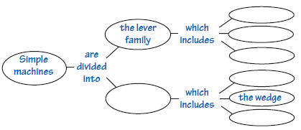
Reading Strategies
These reading tools will help students learn the material in this unit: Science Terms, Mathematical Language, and Concept maps. These are just a few suggestions that might be used to assist students in learning the material of this unit. They could be used as bell ringers, exit tickets, homework, or in class activities.
Science Terms, Many words used in science are familiar words from everyday speech. However, when these words are used in science, their meanings are often different from or are more precise than the everyday meanings. As students pay attention to the definitions of these words their correct use of them in scientific contexts will improve. Have students set up a table in their scientific/engineering notebooks with three columns as seen below. As students are introduced to vocabulary, have them complete the table for the new term. Terms for this unit include inertia, unbalanced force, equilibrium and others.
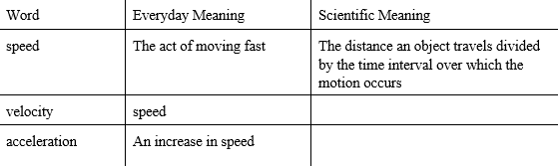
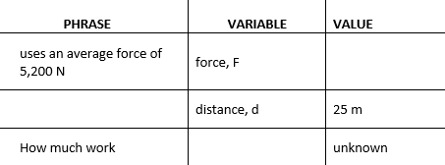
Mathematical Language Word problems describe science or math problems in words. To solve a word problem, you need to translate the language of words to the language of equations, mathematical symbols, variables, and numbers. Students would complete a table like the one below for the following word problem. A crane uses an average force of 5,200 N to lift a girder 25 m. How much work does the crane do on the girder?
Concept Maps, A concept map is a diagram that helps you see relationships between the key ideas and categories of a topic. To construct a concept map, do the following: Select a main concept for the map. List all of the other related concepts. Build the map by arranging the concepts according to their importance under the main concept. Add linking words to give meaning to the arrangement of concepts.
Printable Resources
The following resources are found in the additional teacher resources file shared with this module.
Science Content – Levers
Daily Lesson Log
Educator Practice Problems Answer key
Maker Skills
ABC Chart
General Scoring Rubric: Experiments Assigning grades on a percentage scale may not work with all experiments. The following rubric describes six levels of student performance associated with all experiments students conduct. To use this 4-point scale, read the description of each level and decide which description most accurately reflects each experiment you grade. A helpful strategy may be to create a file of past papers that you feel exemplifies each level of the rubric. These could be scanned and kept as a digital file or hard copy, whichever works best for you. You would then be able to make this file available to students as a guideline.
Online Resources
The following resources are found online, and can be accessed through their individual websites or in a word document version at the Hardware Store Science website. One advantage of using the word document version of this article is that educators are able to download and edit the document with questions, writing prompts or other student suggestions.
What is Horsepower? – This article was written by Sara Chodosh, May 10, 2018. It can be found the Popular Science website at https://www.popsci.com/what-is-horsepower or a word document of this article, without the ads and other distractors, can be found at hardwarestorescience.org
Online Resources
http://cmse.tamu.edu/documents/LittlegreenBookletv3.pdf
http://www.physicsclassroom.com/class/newtlaws/Lesson-2/Types-of-Forces
https://www.physicsclassroom.com/class/energy/Lesson-1/Definition-and-Mathematics-of-Work

