Summary: This reference outlines how to access the SuccessFactors Mobile App.

Access SuccessFactors from OneCampus

Step 1 | Access Employee LaunchPad from OneCampus.  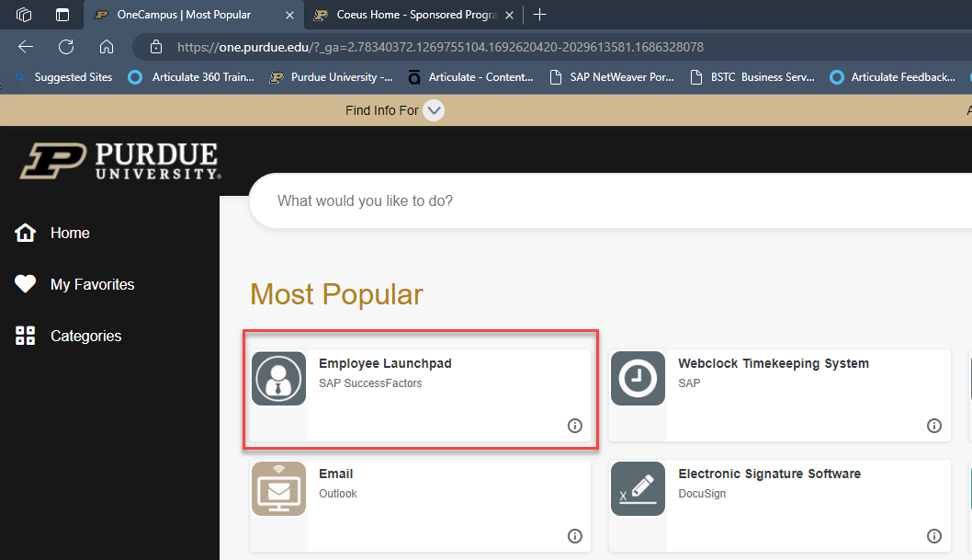
Step 2 | Click Mobile Activation Quick Actions tile.  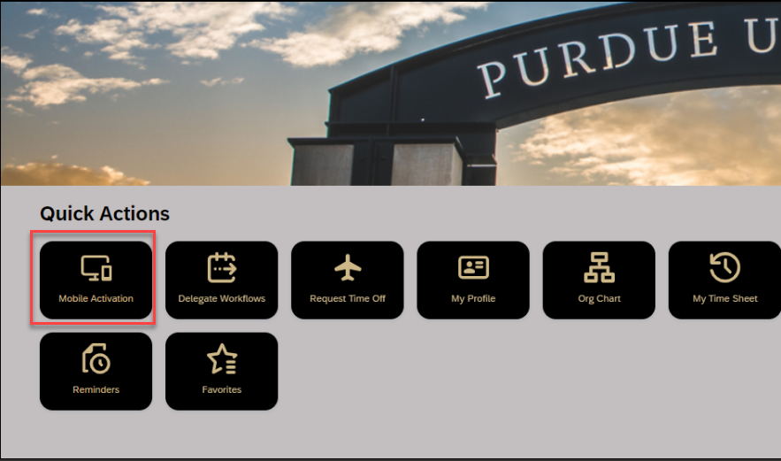
Step 3 | Best Practice: Send the Setup instructions to your email address.  Email example:  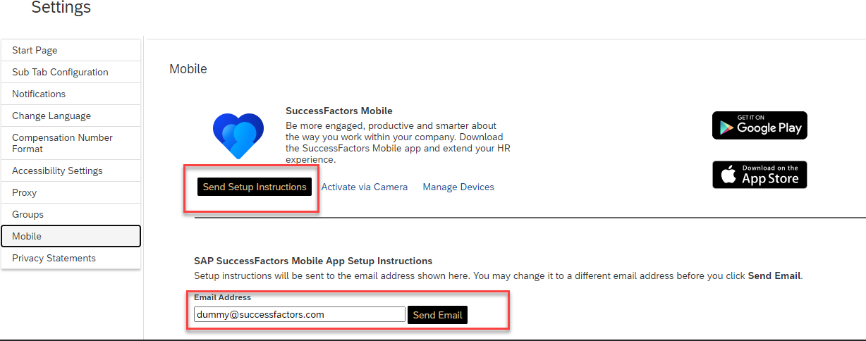  If you choose to Activate via Camera, consider downloading the app first.  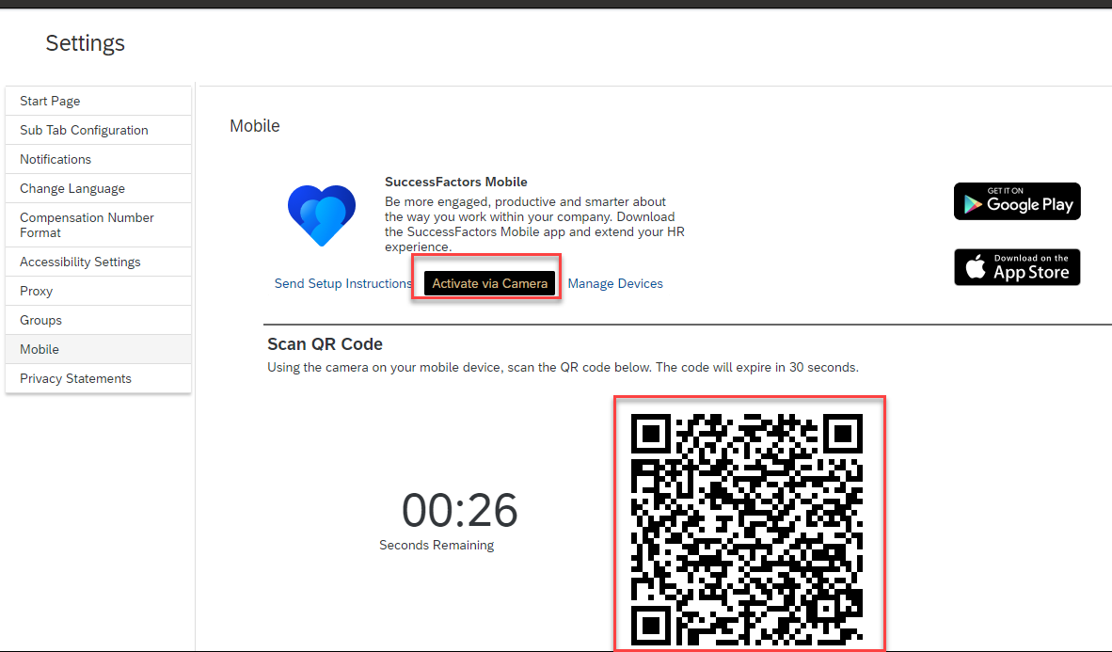
Step 4 | Manage Devices (Provides ability to delete a device when no longer needed.)  