Summary: This reference outlines how to access and review the SuccessFactors Talent Profile within the Employee Profile. The Talent Profile allows employes to review Development Objectives, Performance Trends, Job History and Learning accomplishments. These elements are populated from other modules within SuccessFactors.
Eventually, the Talent Profile becomes the building block to career path planning and succession planning.

Access and View
Step 1 | Access Employee LaunchPad from OneCampus.  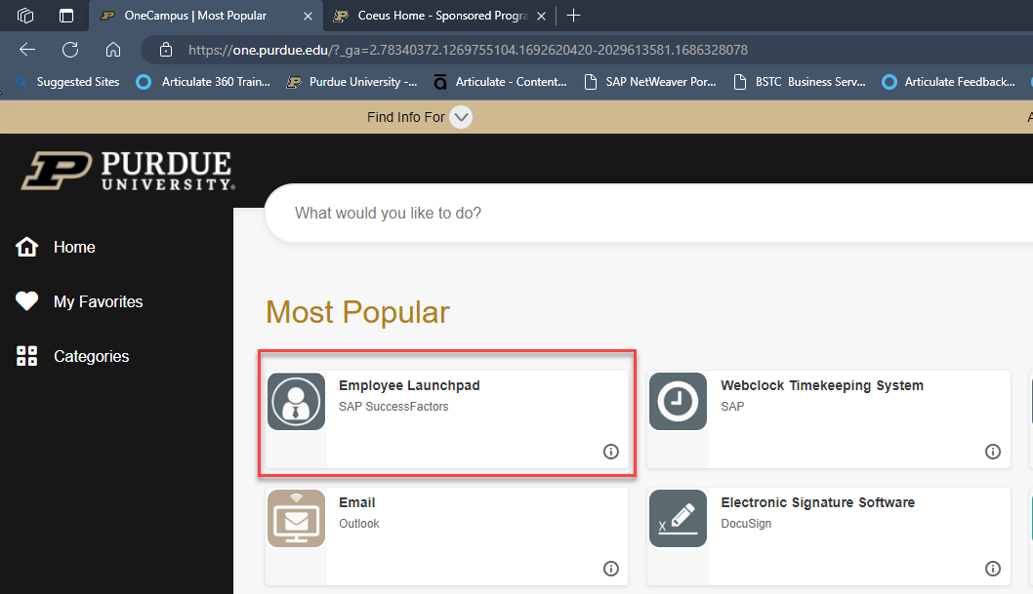
Step 2 | Click My Profile Quick Action Tile.  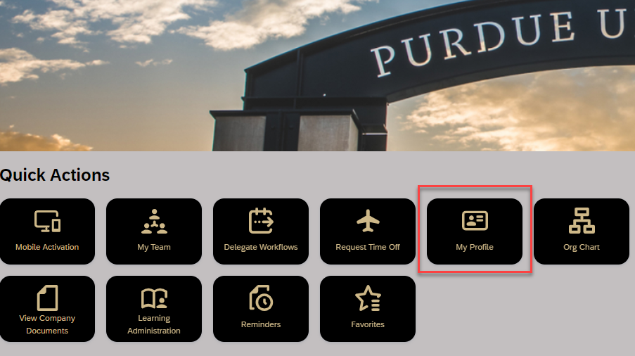
Step 3 | Notice Talent, Career and Learning are now viewable menu options.  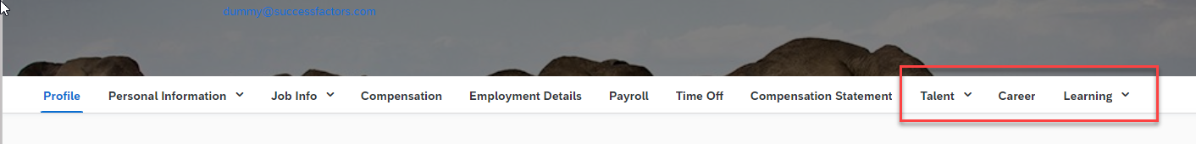
Step 4 | Talent contains Development Objectives, Objective Ratings, Competencies and History. (You can also scroll to see these.)  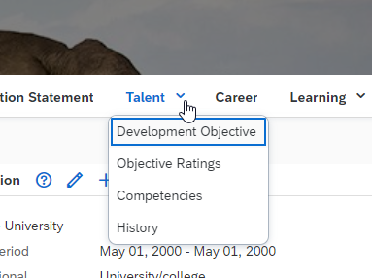
Reviewing Information
Development | - Development Objectives are imported from the Development Plan. (Development plans are often used to create and acknowledge additional skill development.)  - Select Development from the Home drop-down menu or click Development Plan from the Organizational Updates section.  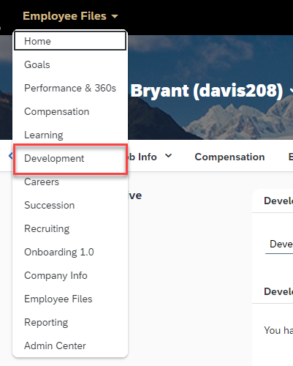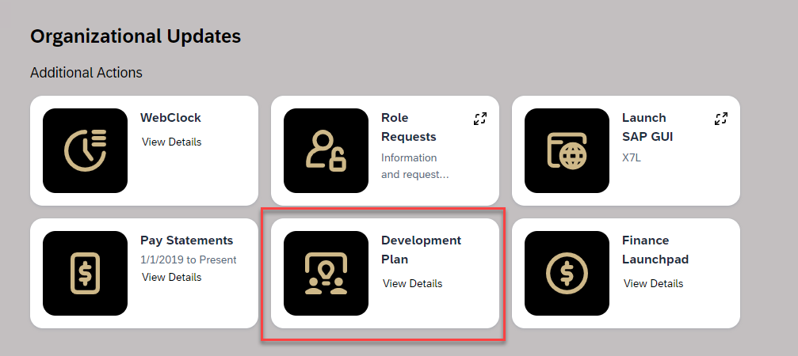  Edit or view Development goals.  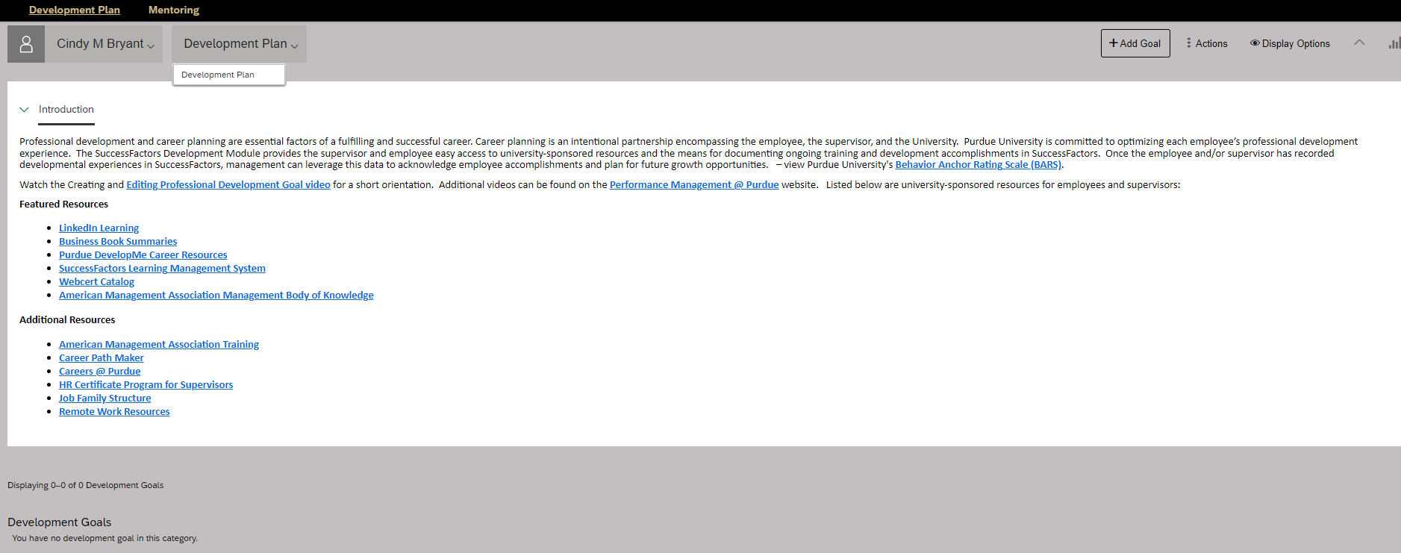
Competencies,  Performance Trend, History | Competencies, Performance Trends and History are imported from Performance & 360.  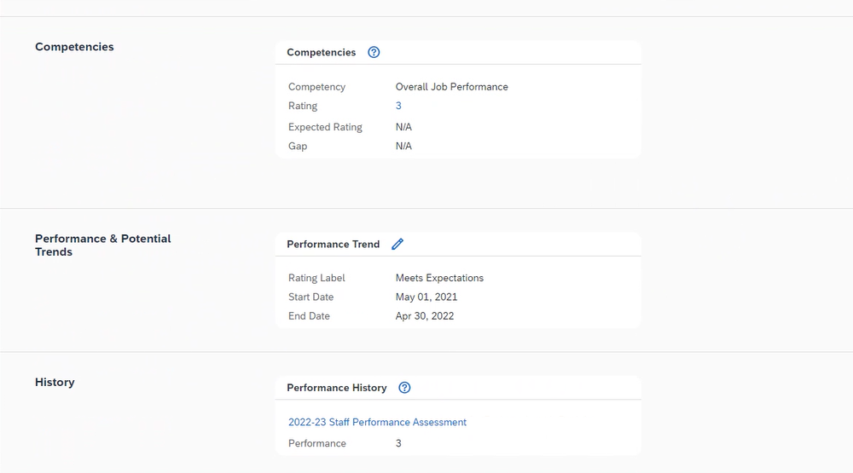
Career | Career displays recent actions, such as transfers, promotions, etc.  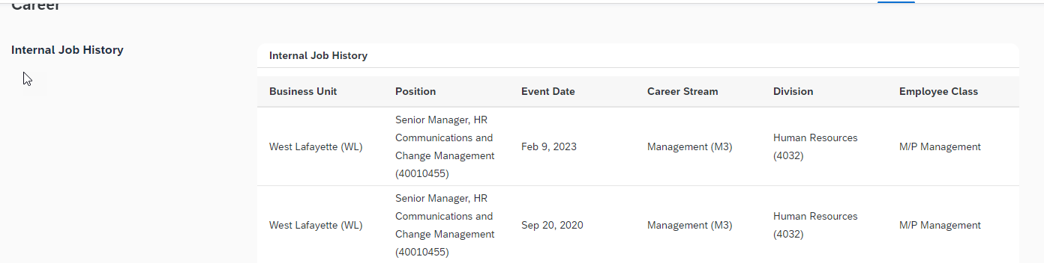
Learning | Learning displays your completed courses and recorded outside courses/certifications from Learning. Click go to Learning History to view Completed Work, when applicable.  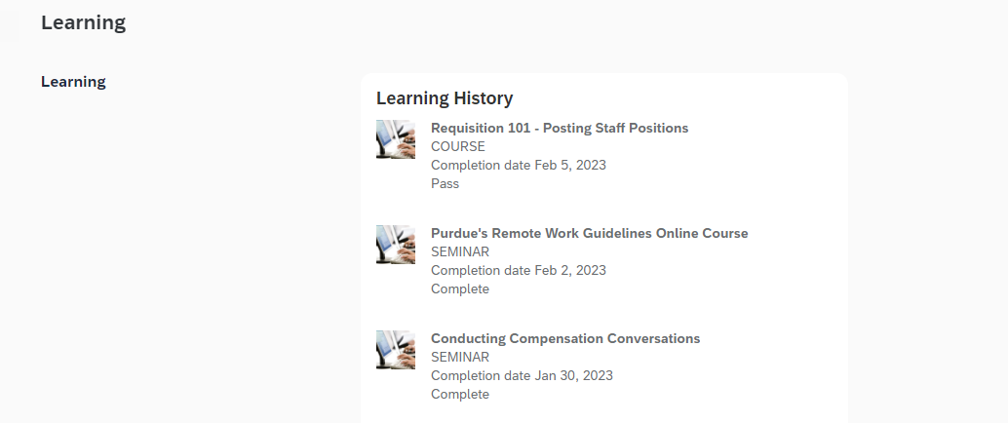
Skills and Certificates | Skills and Certificates is a free-form allowing the opportunity to add certifications or skills simliar to Education, when first hired.  - Those that hold certifications with specific timeframes, will find completing the effective and expiraton dates beneficial.  - As you complete the coursework to renew certifications, remember you can acknowledge those courses in SuccessFactors Learning as external learning.  