Last Updated: 11/11/2019
Use this QRG to view the roles assigned to a position.

Launch IDM and View My Roles
From the OneCampus portal (https://one.purdue.edu/), launch Employee Launchpad – SuccessFactors.  Login with your Career Account and BoilerKey. | 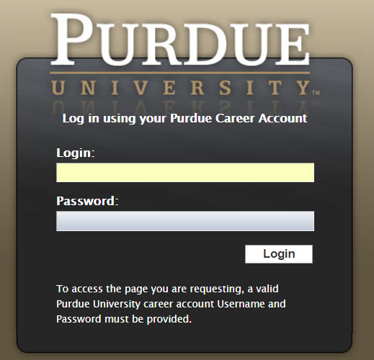
Under My Info on the SuccessFactors Home screen, click the IDM Login tile. | 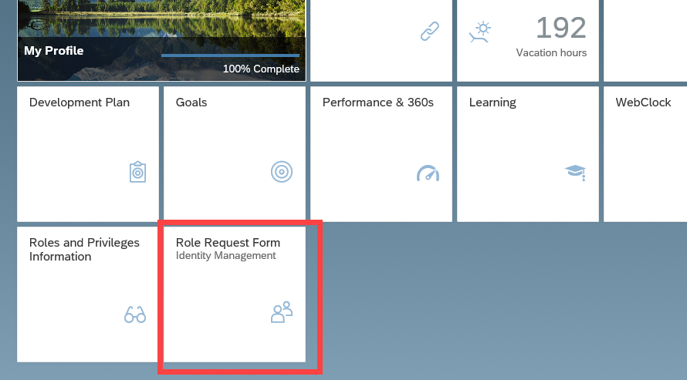
The request is displayed.  - Click Select, next to Position to search for employee’s position.  - Enter position number in the Find text entry  When searching, use the asterisk (*) before and after the term to perform a more accurate search.  Click Search | 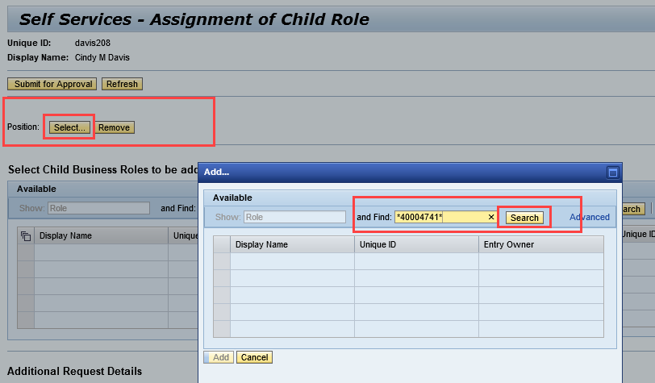
Click to select the desired position and click Add. | 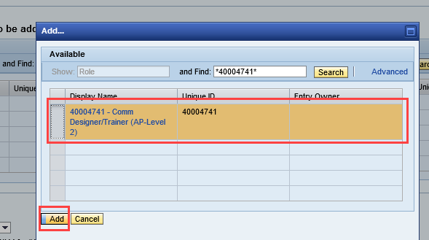
Click Position link | 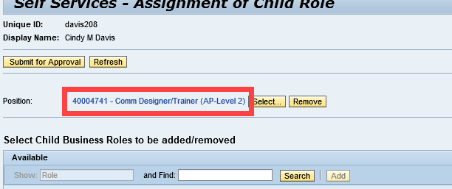
Display Assignment opens with General Attributes, click Assigned Roles to view roles | 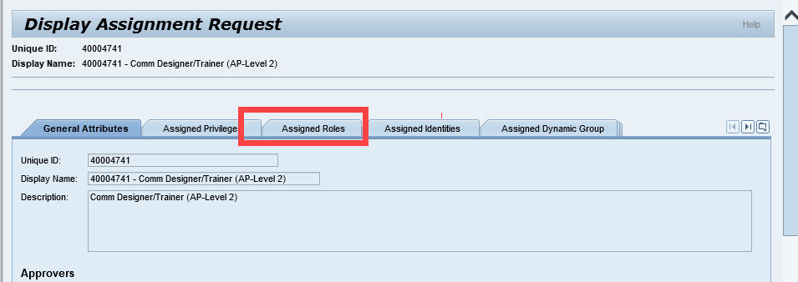
- Click Search to populate Roles. | 