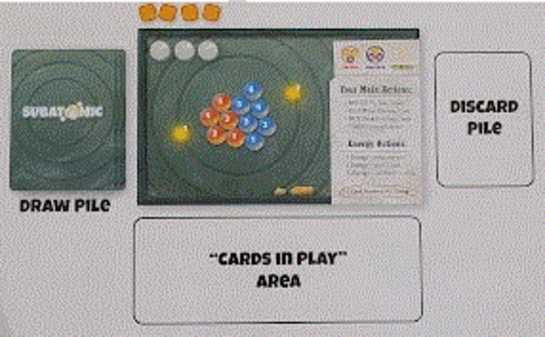
PLAYER STARTING MATERIALS:
(1) Quick Start Guide
(1) Player Mat
(4) Goal Marker cubes
(3) glass Particle Markers
Starter Card Deck: (4) Up Quark cards,
(4) Down Quark cards, (3) Photon/Gamma Ray cards

PLAYER STARTING MATERIALS:
(1) Quick Start Guide
(1) Player Mat
(4) Goal Marker cubes
(3) glass Particle Markers
Starter Card Deck: (4) Up Quark cards,
(4) Down Quark cards, (3) Photon/Gamma Ray cards

PLAYER STARTING MATERIALS:
(1) Quick Start Guide
(1) Player Mat
(4) Goal Marker cubes
(3) glass Particle Markers
Starter Card Deck: (4) Up Quark cards,
(4) Down Quark cards, (3) Photon/Gamma Ray cards

PLAYER STARTING MATERIALS:
(1) Quick Start Guide
(1) Player Mat
(4) Goal Marker cubes
(3) glass Particle Markers
Starter Card Deck: (4) Up Quark cards,
(4) Down Quark cards, (3) Photon/Gamma Ray cards

PLAYER STARTING MATERIALS:
(1) Quick Start Guide
(1) Player Mat
(4) Goal Marker cubes
(3) glass Particle Markers
Starter Card Deck: (4) Up Quark cards,
(4) Down Quark cards, (3) Photon/Gamma Ray cards

