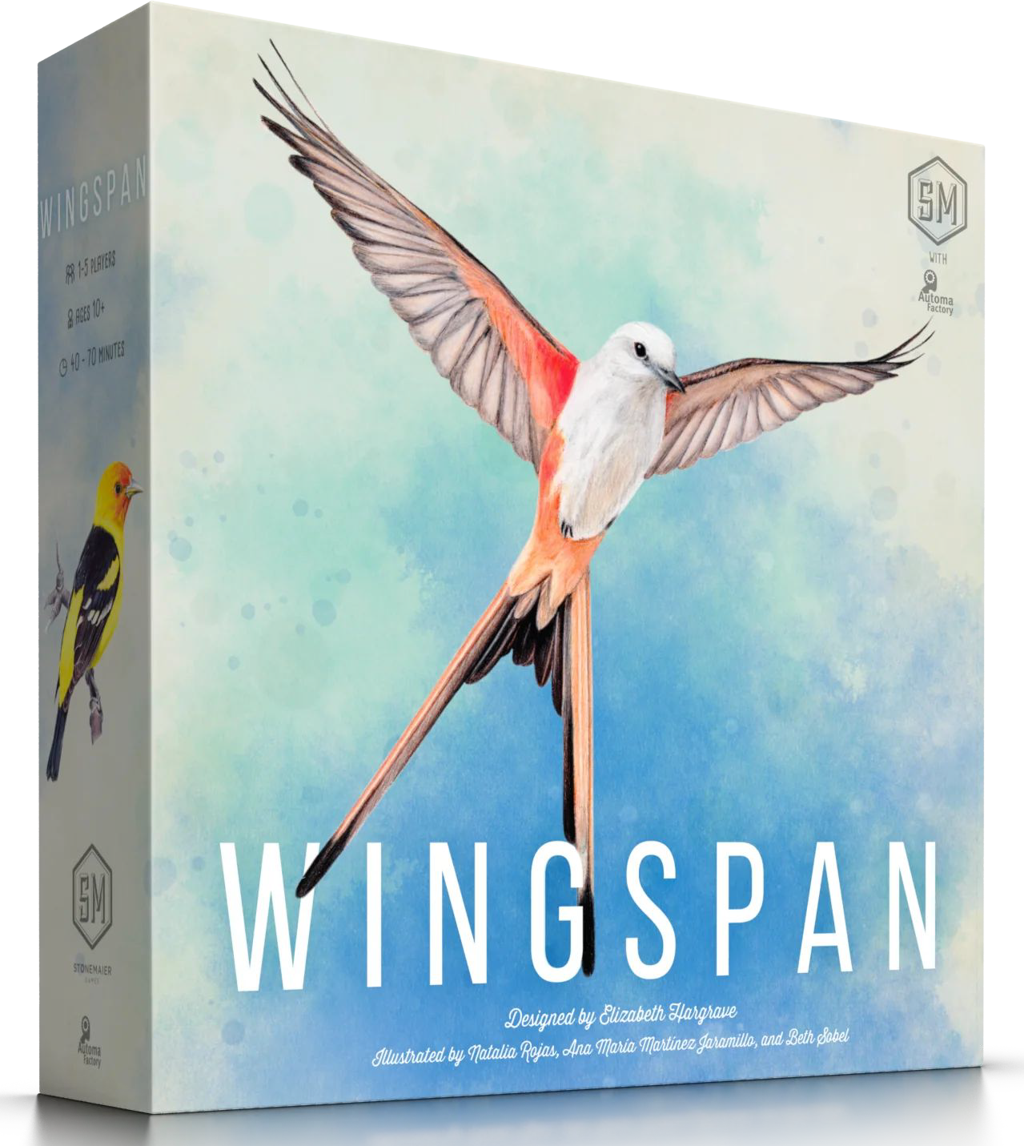
Wingspan: The Classroom Adaptation

Each group should have the following:
- (1) Player Board
- (7) Bird Cards
- (4) Eggs
- (5 total) 1 Token of Each Food Type
- (8) Action Cubes

Place 4 of the 7 Bird Cards on the Mat.
  - Note: you must fill each ecosystem from left to right.
  - Each Bird Card may only go in the Ecosystem that is indicated in the upper left box of the card.
  - Keep the other 3 cards in your hand. (it does not need to kept secret)

Place the 4 eggs on your cards
  - You may not go over the number of eggs that each card may hold.

When it is your teams turn, do one of the following actions:
  - Play a bird from their hand (this is located at the top left of the game mat and does not activate any card powers).
  - Gain food and activate forest powers
  - Lay eggs and activate grassland powers
  - Draw bird cards and activate wetland powers

After all teams have gone, the last team draws an Environmental Card and everyone carries out the action on the card if applicable.
  - If an environmental card takes away or adds a bird, it must be on the far right and if the bird has eggs in the nest they are lost too.
  - If an environmental card lets you gain a bird, you may only gain it if there is room on your board.
  - If an environmental card removes a bird from your board, it is discarded.
  - If a card you are lying down has when played effect do that when playing the card.

After 8 total turns, the game is over and the team with the most points wins.
  - Add up all the Bird card points (the number beside the feather icon on each card)
  - Add up the number of eggs on you board. (1 pt ea)
  - Add up the number of food tokens on the board. (1 pt ea)
  - Add up the number of cards tucked behind Bird cards. (1 pt ea)

