The “Charging Sun” Team Norms

Introduction
When you walk into a library, how are you supposed to behave? What do you say when you answer a telephone or end a phone call? If you want to ask the teacher a question in the middle of a lecture, what do you do? All of these scenarios should bring about similar, if not identical, responses from everyone in the class. Each of these scenarios would result in a behavioral response that follows guidelines, protocols, or rules of acceptable behavior, also known as norms. Norms regulate proper and acceptable behavior by and among individuals.

Teams develop and agree upon norms through consensus to ensure efficiency and to avoid potential conflicts. Acceptable and preferred communication protocols, decision-making rules, and methods of conflict resolution are only a few examples of team norms.

Equipment
- Engineering notebook

Procedure
In this activity you and your teammates will formulate team norms that will serve to guide your actions throughout your design challenge.

Using email, instant message, web cam, telephone, or some other means of appropriate communication, you and your virtual teammate will brainstorm ideas for team norms that address the following topics one at a time. Use your engineering notebook as a repository for your ideas.
- Code of conduct
    - Business like and professional
- Standard communication method(s)
- Frequency of communication
- File management structure
    - Google Drive (Team Drive)
    - USB (thumb) drive
- File revision management
- Process for making design decisions
- Process for dealing with differences of opinion and conflict

Analyze the ideas for each topic and discuss their impact on the team and the overall goal.

Identify key norms that you and your teammate can come to consensus on and finalize them as formal statements in your engineering notebook.

Establish consequences (what will happen) for each norm should they be broken by either teammate. Write these consequences after each norm in your engineering notebook.

In your engineering notebook, create a project timeline in the form of a Gantt chart. The Gantt chart will reflect all of the phases of the design process that you are using to guide your efforts in the design challenge.
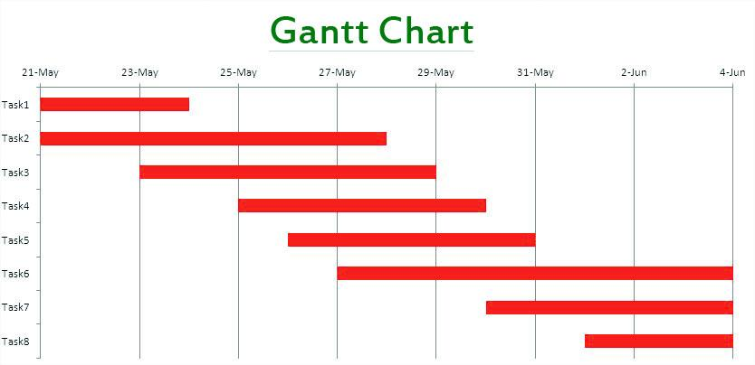

Re-create the design brief for your design challenge. Construct the Gantt chart using the draw tools. List the team norms and violation consequences that you and your teammate have agreed to. At the bottom of the second page, you will include three sentences for teammate and teacher signatures. The first two sentences are to be signed by the teammates. The last sentence is to be signed by both students’ teachers after they have reviewed your document.
- Read, understood, and agreed to by ________________ on ___________.
- Read, understood, and agreed to by ________________ on ___________.
- Read, understood, and agreed to by ________________ on ___________.
- Read, understood, and agreed to by ________________ on ___________.
- Accepted by _________________ and __________________.

*Important*
Have every student sign this Team Norm contract and also have your teacher sign it.

