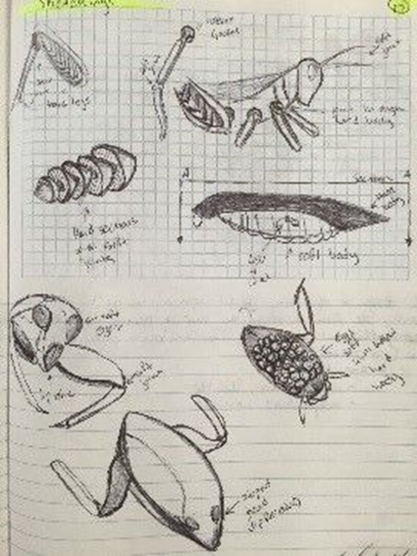
Lesson Overview:
Using principles of ecosystem interactions and buoyancy, students will design and 3D print real fishing lures that imitate the behaviors of aquatic insects.

Age Level or Subject:
- Ages 15-18
- Subjects: Biology, Physics, Technology Education

Lesson or Unit Objectives:
Students will be able to:
- Observe biological processes and organisms as a source of design inspiration.
- Form testable hypotheses about which aquatic insects are likely fish prey and their important features.
- Create a decision matrix to select the best features that meet the need of the client.
- Predict buoyancy of 3D printed prototypes using mathematics before printing the final design.
- Create prototype using 3D printer and parametric modeling software and test predictions.

This project is supported by the National Science Foundation, award # DRL – 1513248
Any opinions, and findings expressed in this material are the authors and do not necessarily reflect the views of NSF.

