# 

# Age Levels:

* Grades 9-12
* Engineering design
* Biology
* Environmental Science

# Total Time Required:

### Lesson 1: Water Health (4 days)

### Lesson 2: Topography & Water Flow (5 days)

### Lesson 3: Design a Riparian Zone (10 days)

# Prepared by:

* Aaron Blount & Shelbi Fortner, Frankfort High School, Frankfort, Indiana
* June 3, 2019

# Unit Objectives:

Students will be able to:

* predict how different ground covers affect the rates of water erosion and identify how topography influences water movement
* establish a connection between erosion and water health.
* observe biological processes and organisms as a source of design inspiration and form testable hypotheses about which aquatic insects are likely fish prey and their important features.
* design and construct a bio-mimicked “riparian zone” that minimizes erosion and protects biodiversity.
* evaluate the impact of a bio-mimicked “riparian zone” in minimizing erosion and protecting biodiversity based on student-designed and constructed models.

# Science Standards and Standards for Technology Literacy:

***Content specific***

**B.3.2** Design, evaluate, and refine a model which shows how human activities and natural phenomena can change the flow of matter and energy in an ecosystem and how those changes impact the environment and biodiversity of populations in ecosystems of different scales, as well as, how these human impacts can be reduced.

**B.3.3** Evaluate the claims, evidence, and reasoning that the complex interactions in ecosystems maintain relatively consistent numbers and types of organisms in stable conditions, and identify the impact of changing conditions or introducing non-native species into that ecosystem.

***Science & Engineering Process Standards***

**SEPS.2 Developing and using models and tools -** A practice of both science and engineering is to use and construct conceptual models that illustrate ideas and explanations. Models are used to develop questions, predictions and explanations; analyze and identify flaws in systems; build and revise scientific explanations and proposed engineered systems; and communicate ideas.

**SEPS.3 Constructing and performing investigations** - Scientists and engineers are constructing and performing investigations in the field or laboratory, working collaboratively as well as individually. They evaluate to make changes to modify and repeat the investigation if necessary.

***Standards for Technological Literacy***

**3** - Students will develop an understanding of the relationships among technologies and the connections between technology and other fields of study.

**5** - Students will develop an understanding of the effects of technology on the environment.

**G**. Humans can devise technologies to conserve water, soil, and energy through such techniques as reusing, reducing, and recycling. For example, water treatment and filtering technologies can facilitate the reuse of water; wind and water erosion can be reduced by no-till farming; and aluminum containers can be recycled.

**J**. The alignment of technological processes with natural processes maximizes performance and reduces negative impacts on the environment. For example, buildings can be strategically oriented to the sun to maximize solar gain, and biodegradable materials can be used as compost to make the soil more productive.

**K**. Humans devise technologies to reduce the negative consequences of other technologies. Examples include scrubbers for coal burning generation facilities, fuels that burn more cleanly and, materials separation processes that aid in the recycling process.

# Recommended Instructor Preparation

* AR Sandbox facilitation - <https://arsandbox.ucdavis.edu/wp-content/uploads/2016/11/Shaping-Watersheds-AR-Sandbox-Facilitation-Guide.pdf>
* Testable 3d printed topography idea - <https://makezine.com/2017/12/18/science-simulation-3d-printing/>
* Erosion Table ideas -
  + <https://www.youtube.com/watch?v=wUaswZHk6ps>
  + <https://www.youtube.com/watch?v=5bqJo5ze3Bk>

Lesson 1: Water Health

# Lesson Focus:

Students will be able to assess the health of a body of water by the type and number of aquatic insects sampled from the waterway.

# Total Time Required:

* Four 70-minute class sessions

# Lesson Objectives:

Students will be able to:

* observe biological processes and organisms as a source of design inspiration.
* form testable hypotheses about which aquatic insects are likely fish prey and their important features.
* understand how some insects are adapted to breathe, move, feed, and hide underwater.

# Equipment and Materials:Special Notes on Materials:

Cut bottom out of 5 gal bucket before starting. Bottom and lid are not needed.

Fill vials approx. 80% full with hand sanitizer. Each group of student will have 1–2 vials to preserve insects.

Clear plastic containers are used to observe aquatic insects. They should be very transparent. Ice cube trays are for sorting insects.

During field observations, students may work in teams with one transparent container for observation per team.

**Lesson Procedures:**

1. Brief lecture on the main aquatic insect groups and how they live. Focus on adaptations that allow them to breathe underwater, move, feed, and hide.
2. Discuss scientific inquiries. Main topics will be observation, hypotheses to explain observations, falsifiability and repeatability, predictions and testing, refining hypotheses.
3. Discuss which types of insects are likely prey for fish. What are the reasons for choices—what are the important features of these insects? How could we test these hypotheses? Given unlimited time and resources, how could we test these hypotheses?

Field observation: observe insects and those of adaptations.

a. Travel as a group to a nearby safe shallow body of water

b. Press bottomless five-gallon bucket into substrate in ~1 foot of water

c. Stir water in bucket to dislodge insects from bottom, rocks, plants

d. Sweep aquarium net several times through the water

e. Drop insects into separate clear plastic container half full of pond/stream water

f. Repeat in different habitats, ex.: different substrates, depths, plants, etc.

g. Cover clear plastic container and observe insects. It may be easier to observe some insects if they are moved with the dip net to a basin in the ice cube tray. Based upon their body shape, what do you think they eat? How do they move? Use the Insect Body Adaptations table (appendix F) to help guide this activity.

4. Optional Activity: Biological Indicators

a. Students will divide into groups and collect their own samples.

b. Use biological indicator flash cards to determine water quality as indicated by insects (See Appendix E).

Special Materials Notes and Comments

Cut bottom out of 5 gal bucket before starting. Bottom and lid are not needed.

Fill vials approx. 80% full with hand sanitizer. Each group of student will have 1–2 vials to preserve insects.

Clear plastic containers are used to observe aquatic insects. They should be very transparent. Ice cube trays are for sorting insects.

During field observations, students may work in teams with one transparent container for observation per team.

What can insects tell us about water health?

Option for class activity if step #4 Field Observation not possible:

If this field component is not possible (e.g., no accessible or safe body of water available), the instructor may use the tools and materials to collect insect samples beforehand and bring these to the class. Changes in water temperature and depleting oxygen mean that some insects will not live long so as soon before class time as possible is best. In class, use an aquarium net to remove

one type of insect from the larger bucket and place in smaller clear plastic container or one section of an ice cube tray. Use live insects in containers to pass around class if containers are small and sealable, or to have students come to view at a break in the class.

*Note:* 1. Aquatic insects have adapted their bodies and behaviors to meet several challenges: breathing and moving underwater, feeding, and avoiding being eaten.

2. The shape of insect’s body parts such as the mouthparts and legs give clues as to where and how these species live.

3. To fool a fish, a lure should look and behave like an insect that would be found in that

particular habitat, and at the correct time and season.

# Student Resources:

Activity Extensions:

Will it float: <http://www.abc.net.au/science/surfingscientist/pdf/lesson_plan14.pdf>

Web Resources:

Fishing down the food chain: <http://britishseafishing.co.uk/fishing-down-the-food-chain/>

How to make an observation like a scientist: <http://ideas.time.com/2012/05/02/how-to-incease-your-powers-of-observation/>

Other Resources:

Background reading on aquatic entomology: Chapter 10 of Gulan, P.J. and P.S. Cranston. 2014.

The Insects: An Outline of Entomology, 5th Ed. Wiley–Blackwell.

Lesson 2: Topography and Water Flow

# Lesson Focus:

The students will see where erosion would happen in a landscape through 3D printing a custom topographical map. They will also test how different ground covers affect erosion through studying water turbidity.

# Total Time Required:

* Five 70-minute class sessions

# Lesson Objectives:

Students will be able to:

* predict how different ground covers affect the rates of water erosion.
* identify how topography influences water movement through an AR sandbox.
* construct a 3D model of a waterway that is important to them.
* use a 3D model to identify where erosion happens in a waterway.
* establish a connection between erosion and water health.

# Equipment and Materials:Special Notes on Materials:

Augmented Reality (AR) Sandbox will be constructed or procured prior to the beginning of the lesson.

Erosion table will be constructed or procured prior to the beginning of the lesson

1L plastic bottles should be cut in half along the long axis.

Any soil and groundcover will be acceptable for the groundcover lesson

**Lesson Procedures:**

1st 70-minute class period: Students complete the Soil Erosion Lab in their research groups. They will cover each bottle of dirt with a different groundcover and assess how well each worked.

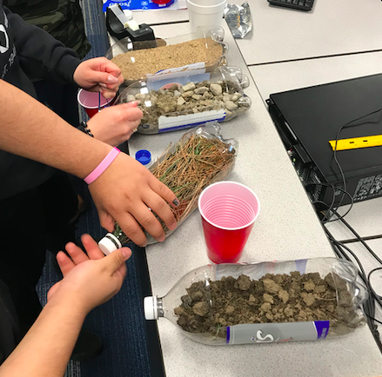

How to test groundcover

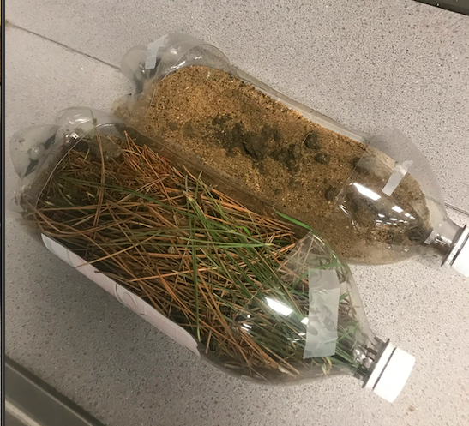

Samples of different ground covers

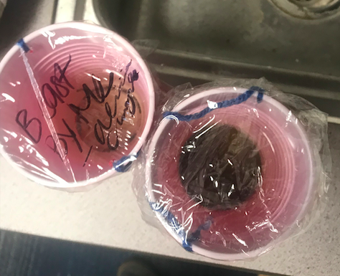

The amount of sediment in the water that flows from the differently covered bottles of soil is how to assess the effectiveness of each groundcover method

Soil Erosion Lab - <https://www.dropbox.com/s/eez96ksluzn66zu/Soil%20Erosion%20Lab.docx?dl=0>

2nd 70-minute class period: Students complete the following portions of the “Shaping Watersheds” Augmented Reality Sandbox Facilitation Guide:

a. Topography and Contour Maps – Primary Activities

b. Landforms and Geomorphology – Extension Activities

c. Hydrology – Primary Activities & Extension Activities

<https://arsandbox.ucdavis.edu/wp-content/uploads/2016/11/Shaping-Watersheds-AR-Sandbox-Facilitation-Guide.pdf>

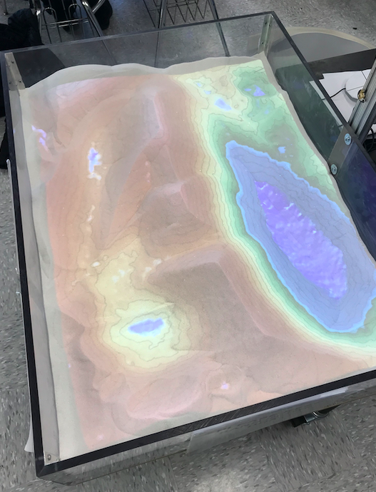

An AR Sandbox with the ability to create rainwater and see how topography and water flow can go together.

3rd & 4th 70-minute class period: Teacher demonstrates the movement of water through a pre-constructed 3D model of a waterway. Discuss where erosion is most likely to occur based on this water movement. Students work in small groups to design and print a 3D model of a section of a local waterway that is important to them. Use the 3D Topo-map Lab and instructional videos. They can make a negative from something water soluble and watch it erode as the water flows over their model.

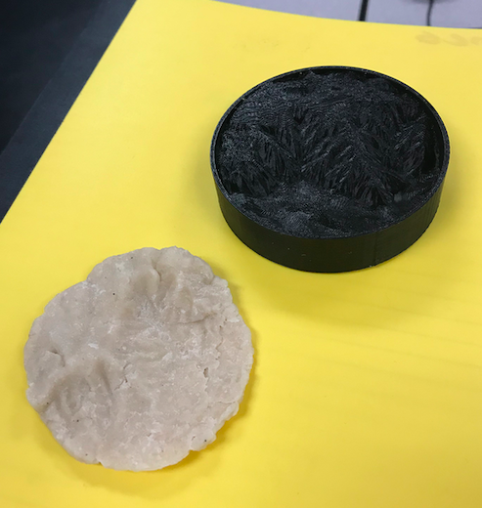

A 3D printed negative of a selected landscape and the soluble model made from cornstarch

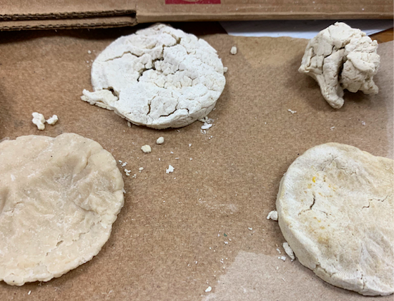

How water flow eroded the landscape models

Topography Prototyping Lab - <https://www.dropbox.com/s/semtcpnrglnvwpv/Topography%20Erosion%20Lab.docx?dl=0>

5th 70-minute class period: Students use this model to observe water movement through this portion of their landscape.

<https://makezine.com/2017/12/18/science-simulation-3d-printing/>

*Note:* If the students have problems converting the USGS topography to a 3-dimensional model, there are many models of landscapes available to download. The idea of erosion can be seen on any landscape and does not necessarily have to be a custom landscape.

# Student Resources:

Web Resources:

Testable 3D printed topography - <https://makezine.com/2017/12/18/science-simulation-3d-printing/>

USGS – <http://usgs.gov>

Other Resources:

Erosion Table -

<https://www.youtube.com/watch?v=wUaswZHk6ps>

<https://www.youtube.com/watch?v=5bqJo5ze3Bk>

Lesson 3: Design a Riparian Zone

# Lesson Focus:

The students will design a replacement mechanism to biomommic a natural riparian zone. They will 3D print a testable riparian zone replacement model and plan a real-life implementation of their designed model.

# Total Time Required:

* Ten 70-minute class sessions

# Lesson Objectives:

Students will be able to:

* design and construct a bio-mimicked “riparian zone” that minimizes erosion and protects biodiversity.
* evaluate the impact of a bio-mimicked “riparian zone” in minimizing erosion and protecting biodiversity
* based on student-designed and constructed models.
* refine and construct a model of a bio-mimicked “riparian zone” to improve success in minimizing
* erosion and protecting biodiversity.

# Equipment and Materials:

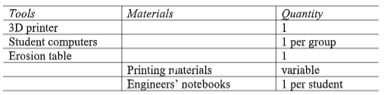

# Special Notes on Materials:

Erosion table will be constructed or procured prior to the beginning of the lesson

**Lesson Procedures:**

The students will follow the class design process to design a 3D-printed testable model riparian zone. They will test them to see how well they could mitigate erosion

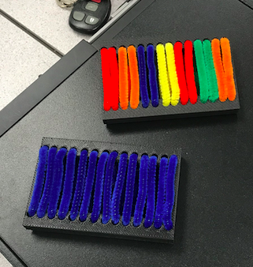

A sample of a Biomimicry model of a riparian zone

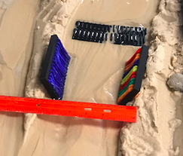

The riparian zone medel being tested in a water flow table for erosion

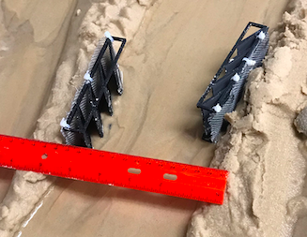

Evaluating the design based on the amount of erosion that happens

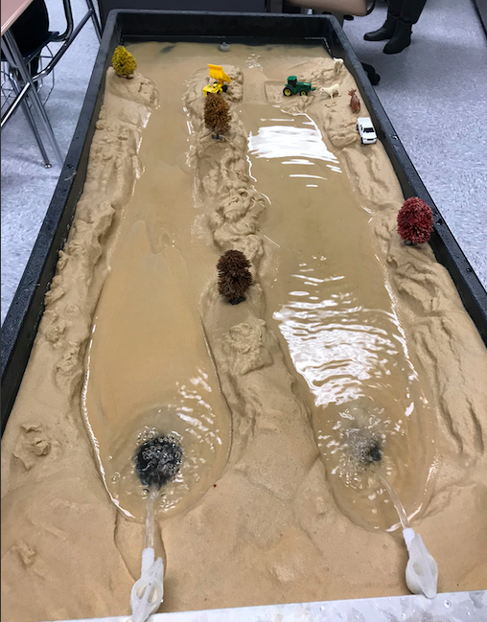

A sample of a basic erosion waterflow table.

Riparian Zone Design Brief -

<https://www.dropbox.com/s/ld1eeupp5qnnumv/Riparian%20Zone%20Replacement%20-%20Design%20Brief.docx?dl=0>

Enrichment and Guiding Questions:

How have humans impacted the banks of waterways?

How does nature mitigate the effects of erosion?

Use the following tools to gently maneuver student conversations and motivation toward developing a biomimicked riparian zone.

|  |  |
| --- | --- |
| Guiding Questions:  What happens to our waterways when riparian zones are allowed to grow?  What happens to our waterways when riparian zones are eliminated?  What are the impacts/effects of large riparian zones? What happens to the rest of the ecosystem?  What are the impacts/effects of small riparian zones? What happens to the rest of the ecosystem?  What do humans do to control the erosion of waterway banks?  What happens when human solutions to erosion of waterway banks fail?  What are the benefits of a natural solution?  What are the draw-backs of a natural solution? (encourage students to consider asthetics)  How might we use biomimicry to design a natural solution? | Resources:  Biomimicry: A Tool for Innovation  Hoosier RiverWatch website |

Continue to guide student conversation and collaboration until students have identified a

potential biomimicked solution that can be 3D printed as a testable prototype.

Students will work in their small design teams to design a testable prototype, print their

prototype, and use the erosion table to test their prototype then redesign and retest.

Students should be encouraged to include additional biomimicry connections during the redesign process.

Students should present their prototype and a plan to use what they’ve learned to an authentic audience (homeowners, farmers, local legislators, etc.) based on the specific area of the waterway they chose to study. The presentation should include a plan to scale their prototype to relevant working implementation.

*Note:* There are many ways to test and evaluate how well the design can mitigate erosion. The photos show just one way to test their designs.

# Student Resources:

Ag NRCS programs -

<https://www.nrcs.usda.gov/wps/portal/nrcs/in/home/>

<https://www.nrcs.usda.gov/Internet/FSE_DOCUMENTS/nrcs142p2_022756.pdf>

<https://www.fsa.usda.gov/Assets/USDA-FSA-Public/usdafiles/FactSheets/2015/CRPProgramsandInitiatives/Practice_CP22_Riparian_Buffer.pdf>

Indiana Riparian Zone Laws -

<http://schneidercorp.com/resources/blog/march-2015/indiana-riparian-rights-and-water-boundaries/#.Wx51btVKjIV>

Web Resources:

Hoosier RiverWatch website - <http://www.hoosierriverwatch.com/>

Testable 3d printed topography - <https://makezine.com/2017/12/18/science-simulation-3d-printing/>

USGS – <http://usgs.gov>

Biomimicry and waterways resources - <https://asknature.org/collections/managing-water/#.Wx51sdVKjIV>

Natural Erosion Control - <https://www.cardnonativeplantnursery.com/erosion-stormwater-control/erosion-control>

Other Resources:

Erosion Table -

<https://www.youtube.com/watch?v=wUaswZHk6ps>

<https://www.youtube.com/watch?v=5bqJo5ze3Bk>



This project is supported by the National Science Foundation, award # DRL – 1513248

Any opinions, and findings expressed in this material are the authors and do not necessarily reflect the views of NSF.