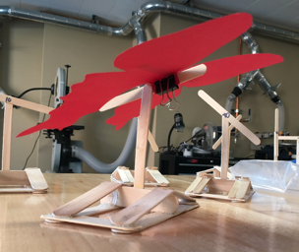

Age Levels:

9-12: Biology, Physics, Engineering

Total Time Required:

9 one and a half hour long lessons

Prepared by:
- Morgan Toby and Cameron Nunan
- 2017

Unit Objectives:
Students will be able to:
- Create an ornithopter using biomimicry inspired wings
- Collaborate using 21st century skills (creativity, collaboration, communication, and critical thinking)
- Analyze the efficiency of self-created designs

Science Standards and Standards for Technology Literacy:
Below is a list of academic standards in this unit

Biology:
- B.5.1 Evaluate anatomical and molecular evidence to provide an explanation of how organisms are classified and named based on their evolutionary relationships into taxonomic categories.
- B.5.1 Evaluate anatomical and molecular evidence to provide an explanation of how organisms are classified and named based on their evolutionary relationships into taxonomic categories.

Physics:
- PI.4.1 Evaluate the translational kinetic, gravitational potential, and elastic potential energies in simple situations using the mathematical definitions of these quantities and mathematically relate the initial and final values of the translational kinetic, gravitational potential, and elastic potential energies in the absence of a net external force.

Engineering:
- IED-1.2 Identify and describe the steps in the design process

Recommended Instructor Preparation
- Bus to transport to Purdue will be needed or have someone come and talk about entomology/biomimicry
- Lesson 3: The teacher could create the butterfly stands ahead of time to save on time, keeping in mind that this takes away the design element for students of measuring the angles.
- Lessons 5 and 6: Students will be creating wings on inventor, students will need more or less time to work with the program depending upon whether or not they have had experience. However, the lessons were designed for students who have had no experience with inventor.

Lesson Plan 1: Science Inquiry Investigation: Guiding Question – How does the wing shape of insects impact flight?

Lesson Focus:
Students will be introduced to the project

Total Time Required:
- 30 min.

Lesson Objectives:
Students will be able to:
- Describe the project and the expectations

Equipment and Materials
Tools and Materials | Quantity Needed
Projector | 1 / class
Design brief | 1 / student
Permission slips | 1 / student

Special Notes on Materials:
The permission slips are for a field trip to Purdue to learn about entomology. This can be replaced in future lessons with a guest speaker or teacher presentation.

Lesson Procedures:
- Show the hummingbird video to introduce looking at nature to “solve” design issues (not an introduction to biomimicry, that is later). Humming bird video: https://www.curiositymachine.org/challenges/22/
- Pass out the design brief and explain what the students are going to be tasked with doing. The design brief is linked to the Student Resources section below.
- Show the rubric and let students know what groups they will be in.
- Pass out the field trip form. This MUST be turned in in order to go on the field trip.
- Ask students if they have any questions. Remind students that they will be meeting, promptly, at 8:05 to go on the field trip.

Note: The permission slips are for a field trip to Purdue to learn about entomology. This can be replaced in future lessons with a guest speaker or teacher presentation.

Student Resources:
Ticket to Fly Design Brief

Student Worksheets:
None are needed

Lesson Plan 2: Field Trip to Purdue

Lesson Focus:
Students will learn about insects and insect collecting.

Total Time Required:
- 1.5 hours

Lesson Objectives:
Students will be able to:
- Understand what a formal insect collection looks like
- Understand what a formal insect collection is used for
- Describe unusual insects

Equipment and Materials
Tools and Materials | Quantity Needed
Permission slips | 1 / student
Bus | 1 / class

Special Notes on Materials:
The field trip to Purdue to learn about entomology. This can be replaced in future lessons with a guest speaker or teacher presentation. Individuals to contact at Purdue: Dr. Jeff Holland (Entomology) and Dr. Gwen Pearson (Outreach Coordinator).
Lesson Procedures:
  - Go to Purdue and Meet with Dr. Holland. He has a room reserved to a 45 min talk on insects.
  - Students were split into two groups. One went with Dr. Pearson and one with Dr. Holland. Students visited Purdue’s insect collection and the Boiler Barn with live, unusual arthropods.
  - After about 20 minutes, groups of students switch locations so both groups get to see both areas.

Student Resources:
None needed

Student Worksheets:
None needed

Lesson Plan 3: Biomimicry and Butterflies

Lesson Focus:
[Description of the lesson]

Total Time Required:
- 1.5 hours

Lesson Objectives:
Students will be able to:
- Explore who wing shape impacts lift
- Be able to define lift

Equipment and Materials
Tools and Materials | Quantity Needed
Projector | 1 / class
Electronic balance | 1 / group
Weight | 1 / group
Cardstock | 1 / group
Scissor | 1 / group
Binder clip | 1 / group
Pre-made stands | 1 / group at each angle
Fans | 1 / group
Different types of wings printed. Download butterfly templates here: http://www.sciencebuddies.org/Files/5120/5/butterfly-outlines.pdf | 1 type of wing / group
Meter stick | 1 / group

Special Notes on Materials:
Before teaching the lesson, the teacher will need to build the stands that the butterfly wings will be tested on. Teacher will need to attach the angled popsicle sticks at the angles listed in the table below. (This is optional to help save on time or have students create the stands with the angled popsicle sticks attached.) Teacher will also need to create a google slide document in order to share data tables with students so that data is all in one place.

Lesson Procedures:
- Show videos on butterfly wings.
- https://www.youtube.com/watch?v=CoInyfsySD0 (3 minutes 30 seconds)

- How butterfly wings are being used in nature- biomimicry (2 minutes)
https://www.insidescience.org/video/butterfly-wings-may-improve-airplane-wings
- Students will need to be split into groups so that different wing shapes can be tested. Each group will be given a different type of wing: Glasswing, Monarch, Glasswing (small), Four Bar Swordtail, small Monarch, Orange Aeroplane.
- Students will need to trace wing onto a piece of cardstock and cut out the wings.
- Students will begin testing.
- The stand needs to be placed approximately 1 meter from the fan.
- A weight of some sort will need to be place on the base of the stand. After placing the weights on the stand, the scale will need to be zeroed out.
- Students fill in the data table. This is linked to the Student Resource section of this lesson.
- Students will analyze data by creating line graphs in order to determine which angle the wing worked the best on (X= angle, Y=lift).
- Students will create a small (8.5 inch by 11 inch) poster showing the shape of the wing and the angle that the lift was the greatest. The posters will be put up around the room in order to aide in the brainstorming process to happen later.
- Once the data has been gathered, students will share the data slide with the teacher to be projected on to the screen for all students to see. Students should have one slide of a google slides sheet in order to compile all data into one place so that students can reference the data later on
- Discuss what had the most influence on the butterfly wing lift and why students think so. Discuss how this can be applied to creating wings on an airplane.

Student Resources:
Wings Testing Data Table

Student Worksheets:
None Needed

Lesson Plan 4: Introduction to Inventor

Lesson Focus:
Students will brainstorm ideas for wings shapes. Students will learn the basics of using Inventor software and create a sketch of a wing shape.

Total Time Required:
- 1.5 hours. Time will vary depending on how familiar students are with the 3D CAD software

Lesson Objectives:
Students will be able to:
- Brainstorm ideas for wings shapes
- Learn the basics of using Inventor software
- Create a sketch of a wing shape

Equipment and Materials
Tools and Materials | Quantity Needed
Projector | 1 / class
Computer with Inventor software | 1/ group

Lesson Procedures:
- Review the video about brainstorming ideas. Ask the class, what stood out, what worked, what didn’t work, how is this helpful. Video: https://www.youtube.com/watch?v=cmoWCSyujPY
- Split the class into their groups and begin brainstorming wing shape ideas. They should use engineering notebooks or draw on the dry erase boards and take a picture of their results
- Give them 10 minutes and a goal of 10 different ideas.
- Have at least one group member open up Autodesk Inventor (or as many kids as possible, depending on available computers). As they work, make sure they know the importance of dimensions.
- Discuss the general rules for how Inventor works: drawing complete two dimensional shapes, then extruding them into 3D.
- Demonstrate how to create a 2D sketch and how to sketch from the origin.
- Show how to create a line and dimension if for reference. The maximum length of a wing should be ~4 inches.
- Demonstrate line, spline, circles, and rectangles.
- After a shape is completed, finish sketch in the top right corner.
- Click Extrude in the top left, then click the shape. Make a very thin extrusion.
- Now show how you can place a sketch on existing surface and project the outline.
- Students can now add an additional sketch and draw in extra support structure like veins in wings or the bones in a bat wing.
- Show how to Fillet and manipulate the size.
- Demonstrate how to mirror the wing to the other side.
- If students want each side printed separately, hit “Save As” twice. Save it once as side one and again as side two. Now open each file, cut away one half, then open the other and cut away the other half.
- Possible Example:
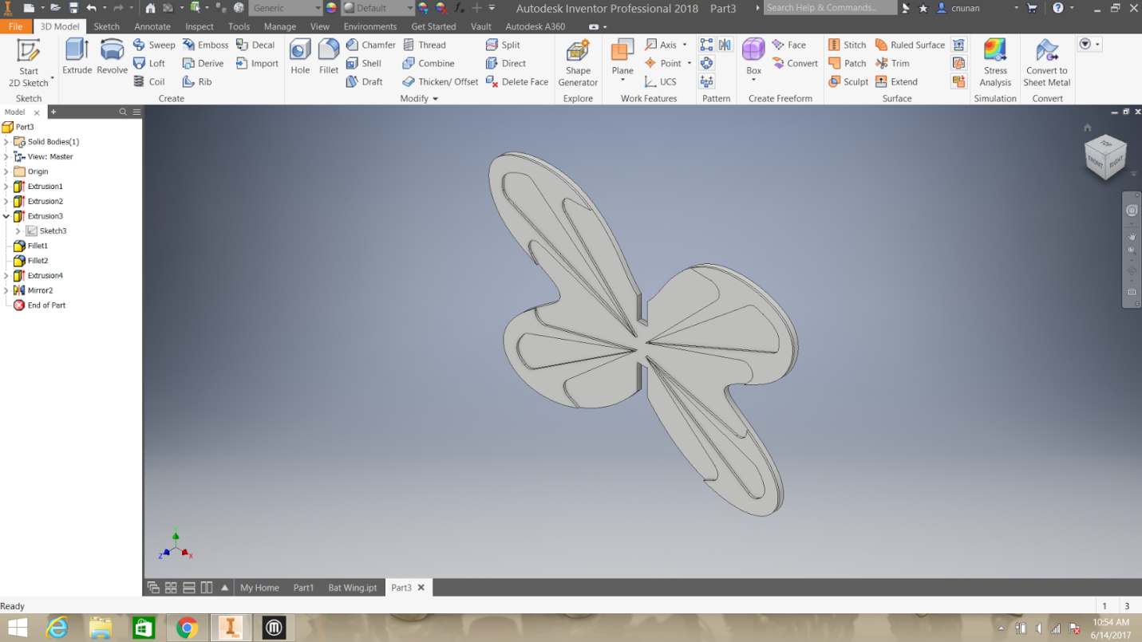
- Discuss rapid prototyping: What is it? Pros vs cons?
- Set the students free to build their own.
- Each group is to design three different wing files.
- Cycle around the room as they work, encourage them to help each other.
- Make sure that they are using realistic dimensions. No wing should extend more than 4 inches in any direction.
- Students should be working for the rest of the class period and will have some time next week to finish. However, it will be best to finish as soon as possible. Encourage them to come back and work on their own time if they can. By next class period, you will want to have as many sets printed as you can.
- Students must create a public post on Google Classroom reflecting on today’s lesson. What were the pros and cons of brainstorming? What was the hardest part about Inventor? What went really well? [Due by next week’s class]

Student Resources:
Students will need access to Inventor 3D CAD software

Student Worksheets:
None needed

Lesson Plan 5: Design Process

Lesson Focus:
Students will use the design process to construct an ornithopter to test their wing designs.

Total Time Required:
- 1.5 hours]

Lesson Objectives:
Students will be able to:
- Describe the design process
- Build an ornithopter
- Test an ornithopter

Equipment and Materials
Tools and Materials | Quantity Needed
Small motor powered flapping mechanism | 1 / group
Computer with Inventor software | 1 / group
PLA filament for 3D printing | 1 kg spool / class
Anemometer https://www.amazon.com/dp/B01MU5V05B?psc=1 | 1 / group?  1 / class if groups take turns
3D printer | 1 or more / class

Special Notes on Materials:
Create a small motor powered flapping mechanism (VEX, Fischerteknik, or Lego). Wings will be attached to the end and used to measure air speed.

Lesson Procedures:
- Ask the class if they have heard of or have ever used a Design Process. What did that process look like? What steps did they follow? Was it helpful?
- Introduce the TRAILS Design Process. Talk through each step and what it means. TRAILS Design Process Diagram is linked below in the Student Resource section of this lesson.
- Right now, we have already covered the first two steps. What do we do next and why?
- Make sure they talk about the importance of testing, failure, and the significance of the circular nature.
- If a group has already finished and printed all three sets of their wings, have them continue to step three.
- Attach wing segments to robotic wing flapper and measure air speed with Anemometer.
- Students will create a chart documenting the results for each wing set.
- Students will put these results into their portfolio. Make sure they identify and reflect on which wing set achieved the highest speed and why.
- Students will report out their best design and everyone will write the best results up on the board. This lesson will finish up during the first half hour of lesson 6.

Student Resources:
TRAILS Design Process Diagram

Student Worksheets:
None needed

Lesson Plan 6: 3Build an Ornithopter

Lesson Focus:
Student build an ornithopter with their designed wings.

Total Time Required:
- 1.5 hours

Lesson Objectives:
Students will be able to:
- Use the design process to design an ornithopter
- Begin building the ornithopter

Equipment and Materials
Tools and Materials | Quantity Needed
“Tips from the Experts”  http://www.ornithopter.org/teacherguide.2.pdf | 1 / student
Light weight material for wings such as: lightweight plastic, tissue paper, or disposable drop cloth https://www.harborfreight.com/9-ft-x-12-ft-disposable-drop-cloth-95142.html | Enough for several builds per group to allow for redesign
Gyrophon Blue Bird Plus Modeling Kit: http://www.birdkit.com/models.starter.html | 1 / group

Special Notes on Materials:
The website moved the “Tips for Experts.” The link given is the Teacher Guide. Teachers may want to use excerpts from this instead of the whole document.

Lesson Procedures:
- Beginning of lesson will be allocated to finishing up lesson 5. Then begin with lesson 6.
- Show students a working example of a robot that flies similar to a bird. https://www.youtube.com/watch?v=4l0xavWi7kU
- Students will then see examples of ornithopters in order to see how they will be taking what they have learned about wing shape and angle to apply to the ornithopters. https://www.youtube.com/watch?v=8o5H1Wo9o3w (show the first 30 seconds)
- Pass out a paper with “Tips from the Experts” and have students go through that before they start building. Have students look at the website that is provided on the sheet as well (link to teacher’s guide is in the materials).
- Discuss whether or not students see anything that stands out and what they should consider. Ask if they have something else that they think should be added to the list.
- Have students brainstorm what they want the wings to look like on their ornithopters and why.
- Students will share their ideas with everyone and ask for suggestions.
- Students will begin building.
  - The only part of the modeling kit that students will not be using is the plastic wing material. Do NOT give students the plastic that is from the kits as this is a set design.
  - Teacher will need to have a set material to use for the wings, it is suggested to use a lightweight plastic or tissue paper (disposable drop cloth).

- Have students discuss what is working well and what they are going to need to fix/improve upon during the next session.

Student Resources:
None needed except the printed “tips” sheet mentioned in materials

Student Worksheets:
None needed

Lesson Plan 7: Continue Building Ornithopter

Lesson Focus:
Students finish building their ornithopters.

Total Time Required:
- 1.5 hours

Lesson Objectives:
Students will be able to:
- Use the design process to design an ornithopter
- Finish building the ornithopter

Equipment and Materials
Tools and Materials | Quantity Needed
Light weight material for wings such as: lightweight plastic, tissue paper, or disposable drop cloth https://www.harborfreight.com/9-ft-x-12-ft-disposable-drop-cloth-95142.html | Enough for several builds per group to allow for redesign
Gyrophon Blue Bird Plus Modeling Kit: http://www.birdkit.com/models.starter.html | 1 / group

Lesson Procedures:
- Have students share their goals and plan of attack for the day. They must do this in 45 seconds or less. Using only 45 seconds will require students to only share the most important information.
- Students will work on designing their ornithopters. Their goal is to see how long they can keep it in the air in order to fulfill the design brief.
- Students will continue to make improvements and test their designs.
- About halfway through, have students stop and discuss with one another what is working and what they have been doing in order to share ideas. This should not take longer than 10 minutes. Briefly discuss friction how it may be a hindrance.
- Have students wrap up and let them know that they need to have a working design by the start of the next class
- Due to testing of designs, students will be working until the bell. Therefore, students will need to answer the following question on google classroom: How did your group, specifically, use the design process while working on your model today? You must answer using specific terms from the design process and specific examples from your group today.

Student Resources:
None needed

Student Worksheets:
None needed

Lesson Plan 8: Presentations

Lesson Focus:
Creating a PowerPoint presentation.

Total Time Required:
- 1.5 hours or more

Lesson Objectives:
Students will be able to:
- Describe what makes a good PowerPoint
- Create a PowerPoint presenting their project and what they learned

Equipment and Materials
Tools and Materials | Quantity Needed
Light weight material for wings such as: lightweight plastic, tissue paper, or disposable drop cloth https://www.harborfreight.com/9-ft-x-12-ft-disposable-drop-cloth-95142.html | Enough for several builds per group to allow for redesign
Gyrophon Blue Bird Plus Modeling Kit: http://www.birdkit.com/models.starter.html | 1 / group
Tips for making a good PowerPoint: https://edu.gcfglobal.org/en/powerpoint-tips/simple-rules-for-better-powerpoint-presentations/1/ | 1 / class
Projector | 1 / class
Computer with Internet access | 1 / group or student

Special Notes on Materials:
The designing teacher did not attach their presentation for PowerPoints. The attached link is a website with good suggestions. Teachers can present this or create their own individualized PowerPoint.

Lesson Procedures:
- Ask students what makes a good presentation. Brainstorm a list of ideas on the board as a group.
- Students will be shown the PowerPoint on what makes a good presentation.
- Students will be given the presentation rubric and reminded of the components of the communication column on the 4c’s rubric.
- Students will do a review of the 21st century rubric
- Students will break out into groups and begin working on presentations
- Students will end the unit with presenting their final presentations and ornithopters.

Student Resources:
None Needed

Student Worksheets:
None needed

This project is supported by the National Science Foundation, award # DRL – 1513248
Any opinions, and findings expressed in this material are the authors and do not necessarily reflect the views of NSF.

