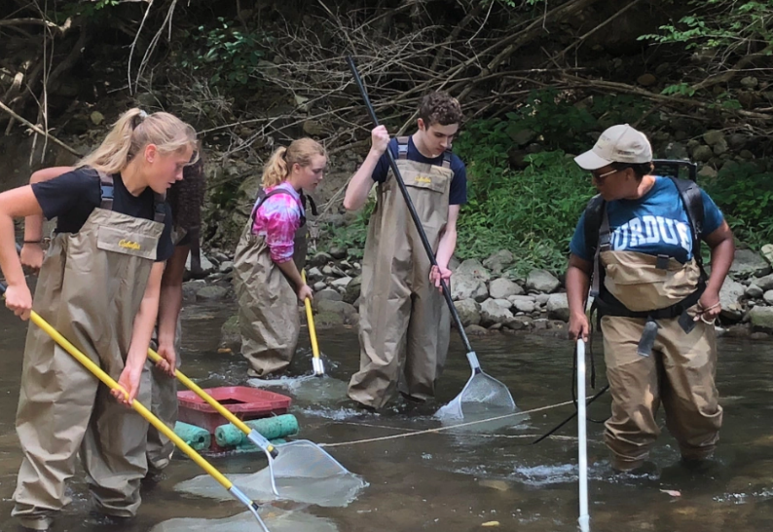Lesson Plan 1: Water Quality Assessment

# Lesson Focus:

AP Biology students will work with Purdue extension outreach coordinator to gather fish in a local stream/creek in order to assess population (of fish), water quality. The Index of Biological Integrity assessment is used for statistical analysis of species population.

# Age Levels:

* AP Biology (11-12)

# Total Time Required:

* Two to three, 50 minutes periods

# Lesson Objectives:

Students will be able to:

* Assess water quality of a local stream using electrofishing equipment provided by Purdue University, outreach coordinator.
* Assess water quality using Index of Biological Integrity to give local stream a ‘score’
* Use a coliform detection broth and Indole to identify the presence of coliforms in the stream

# Equipment and Materials

| Tools and Materials | Quantity Needed |
| --- | --- |
| Electrofishing Apparatus, nets, waders, buckets | 8 for entire class/provided by outreach coordinator |
| Coliform Detection Broth/Indole Indicator | 1 bottle for each class |
| Specimen jars (various sizes) | 1-3 per students |

## Special Notes on Materials:

**This exercise is not possible w/o the help of Purdue FNR Outreach Coordinator, Megan Gunn. She is eager to work with HS in Indiana, please contact her @ [mlgunn@purdue.edu](mailto:mlgunn@purdue.edu).

Lesson Procedures:

Day 1:

1. Have students don themselves with protective gear provided by Purdue.
2. Students will be divided into 3 groups:
   1. On land water assessment
   2. In water (need waders), collecting with PU coordinator
   3. In water (need waders), gathering in the pooled areas.
3. Collection takes the entire class period (especially if most-all students want to actively participate).
4. Store samples in an appropriate place (fish tank in classroom, temperate regulated greenhouse,

Day 2:

1. Using identification tables provided by PU to ID/count specimens.
   1. This could take 30-45 minutes dependent on # of specimens and interest level of students.

Day 3:

1. Using the Index of Biological Integrity
2. Megan Gunn will lecture over what the # means AND the importance of this information in water health, water sheds, etc.

# Student Resources:

Students will take this knowledge and apply it to design of the lure.



This project is supported by the National Science Foundation, award # DRL – 1513248

Any opinions, and findings expressed in this material are the authors and do not necessarily reflect the views of NSF.