Ornithopter Design Brief

The engineers at Boeing have made amazing strides in aeronautical engineering, but after studying animals, insects, and biomimicry, they want to learn more about how animal flight works. You and your team of designers must create a better ornithopter than your competitors. Boeing will be looking for the design that stays in the air the longest. The winning design will be awarded a grand prize.

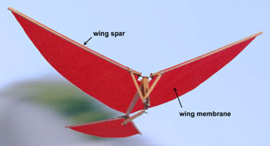

Constraints
- Manipulate one wingless ornithopter kit (you make the wings)
- Stay in the air longer than competitors
- Only use provided materials:

  - Ornithopter kit
  - Paper
  - Scissors
  - Glue
  - Tape
  - Utility blade
  - Pliers

When finished, reflect on these questions: Was your ornithopter successful? Why or why not? Did the airspeed (measured previously) correlate with the flight time? Ask other groups, did their results match yours?

Tips from the Professionals
The basics of ornithopter modeling.

- Use a utility knife to cut the balsa wood
- Use needle-nose pliers
- Decrease friction wherever possible
- Center of gravity
- Lubricate the rubber band (ideal to use commercial but can use vegetable oil)
- Weight reduction

For more tips check out: http://www.ornithopter.org/index.shtml

