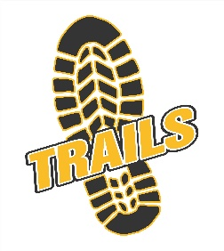
Design Activity – Dbait

Student Resource

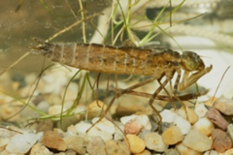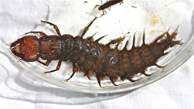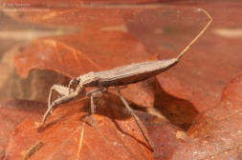Scenario: You are working for a fishing outfitter company- DBait and your job is to help the company create a new line of fishing lures. DBait market researchers have determined that there are a limited number of artificial baits that represent insects that become food sources for fish.
Your Task: Your team must create a fishing lure that mimics an aquatic insect to attract fish.
Constraints:
  - Use parametric modeling to create a design to be 3D printed
  - The lure must be castable using a basic spinning rod – (not fly fishing)
Criteria:
  - Lure design must mimic nature
  - Biomimicry designs will consider function as a design feature (neutral buoyancy), consider other functions

