Fusion 360 Slicing Tips
- Create a new Print setting (copy it from one you already have) and save it to your Cloud
  - This will enable you to access it anywhere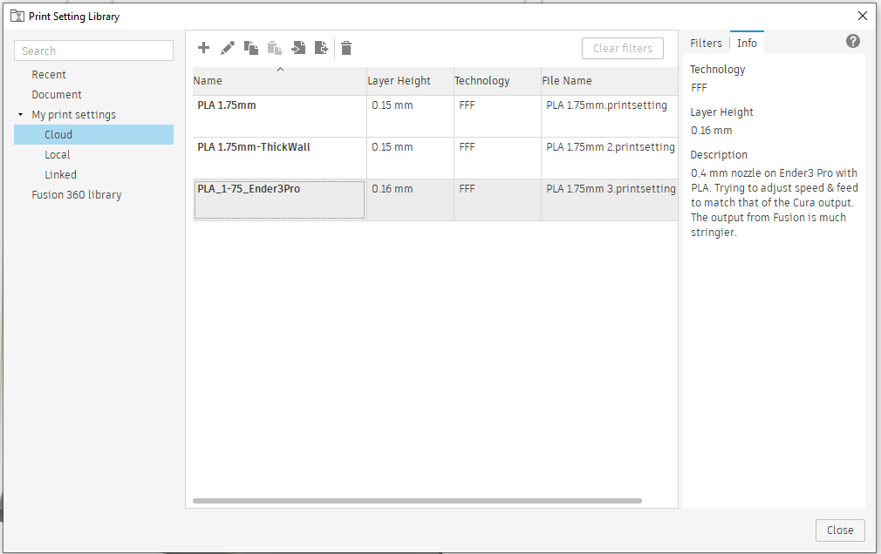

- Edit the Manufacturing Model to ensure you are only printing what you want to print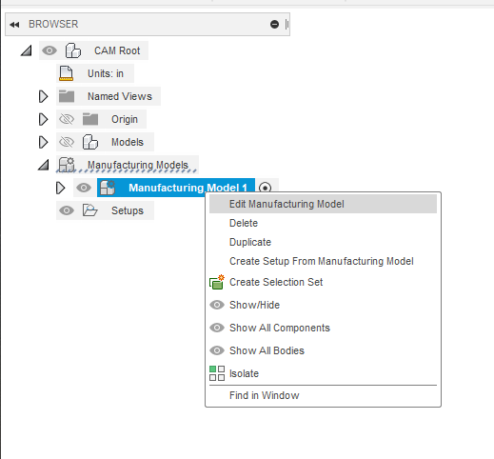

- If prints are stringy, try:
  - Reducing extrusion temperature
  - Increasing retract length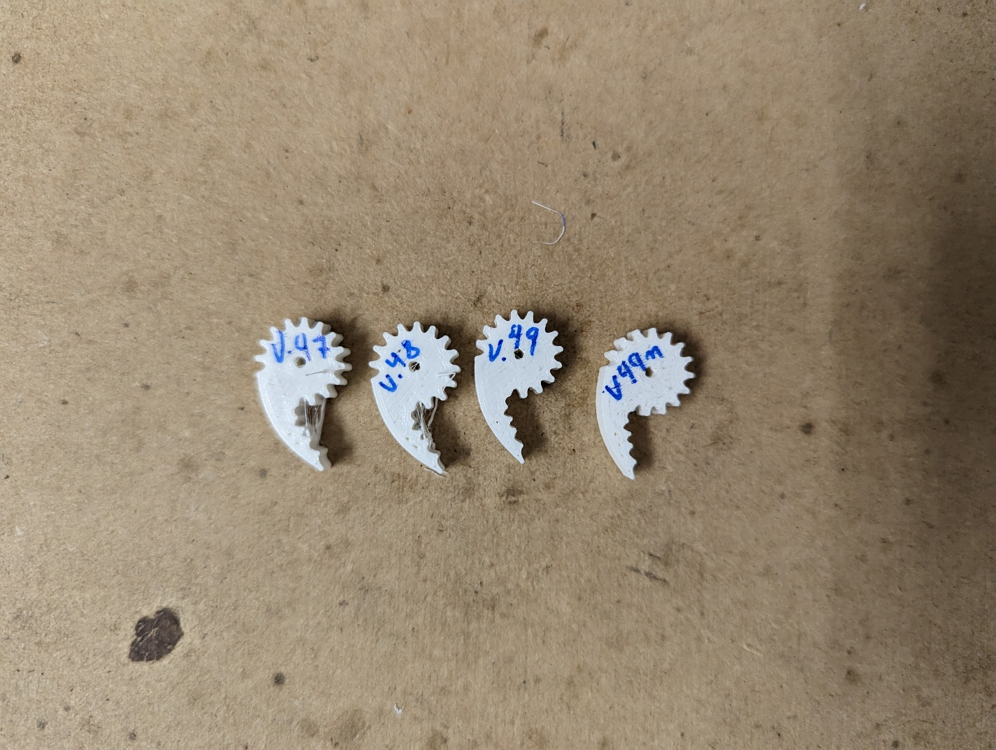

- If prints are too weak
  - Increase infill percentage
  - Increase shell thickness (more layers on perimeter, top, & bottom)
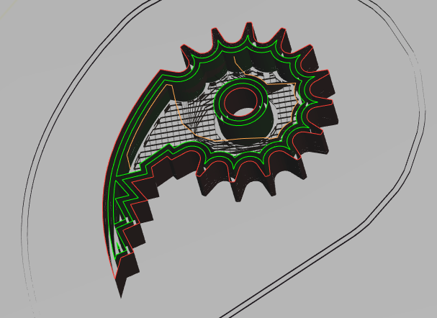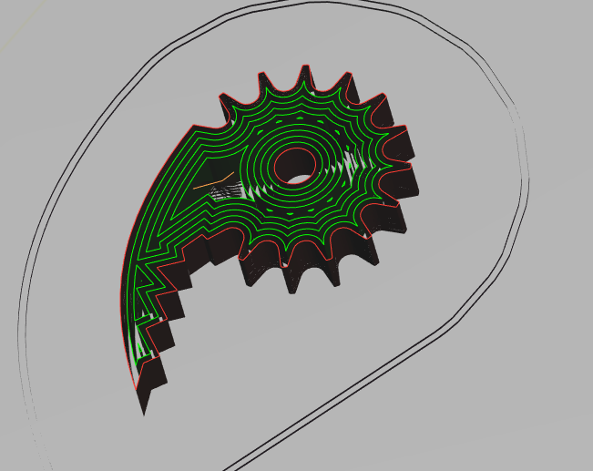

- If parts fail without support
  - Try reorienting the part
  - Try adding supports (ensure to add them where they will be easy to remove) 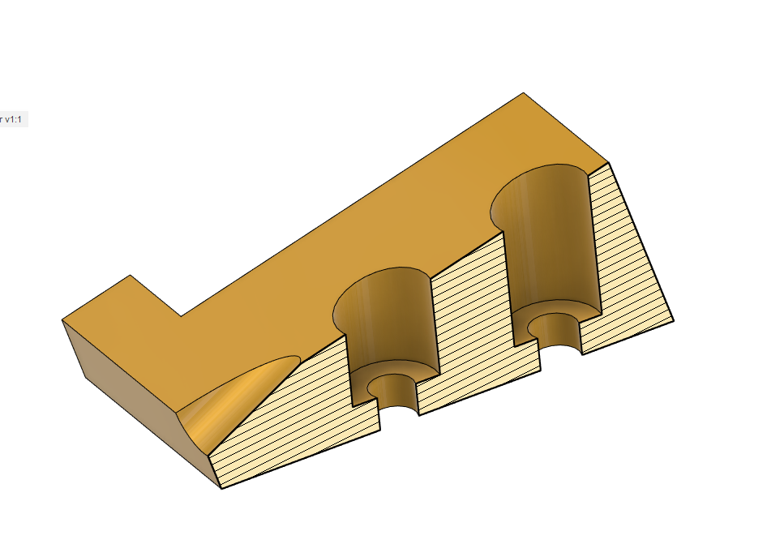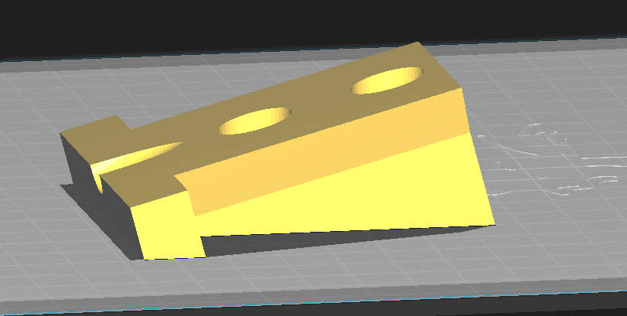

- If prints do not stick on the first layer
  - Check bed temperature
  - Check bed leveling
  - Try different Print Bed Adhesion settings (listed in order of strength)
    - Skirt is a thin ring around, but no connected to, the part(s)
    - Brim is a thin plate under the part(s)
    - Raft is a thick plate under the part(s)
- Remove the blob at the end of a print by reducing the final extrusion setting in the last G1 move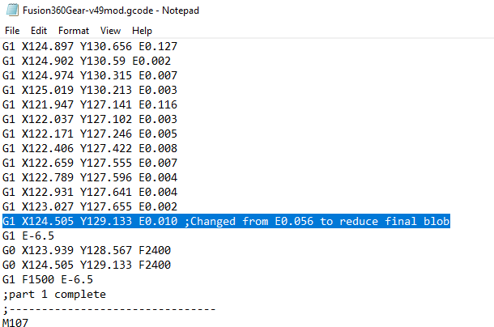
- Modify final lines of gcode to make printing faster