ABSTRACT SUBMISSION VIA OURConnect

A HOW-TO GUIDE

FALL UNDERGRADUATE
RESEARCH EXPO

Last Updated: August 2026
Purdue University Office of Undergraduate Research

OURConnect is the abstract submission and approval platform. This guide will share functionalities of the conference portal to submit an abstract.
Go to: purdue.edu/undergrad-research/ourconnect/
STEP 1: LOGIN OR CREATE AN ACCOUNT
Click “Login” and either sign in with BoilerKey or create an account to login. If you have an @purdue.edu email, login with that.
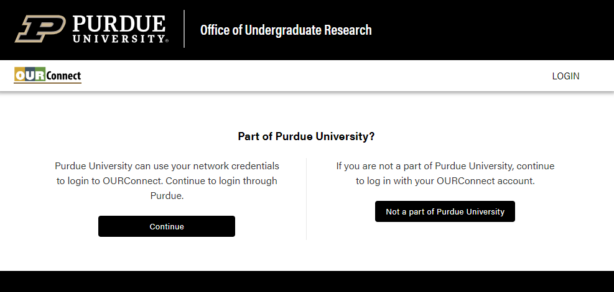

STEP 2: ENTER THE CONFERENCE PORTAL
Click “Conference” and then “New Abstract for 2026 Fall Expo -WL”. Saved or submitted abstracts are found under “My Abstracts.”
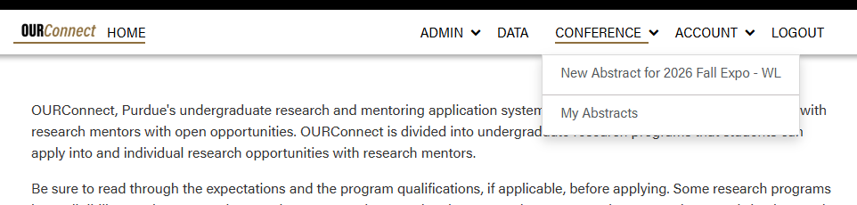

STEP 3: SUBMIT A NEW ABSTRACT
Fields with a red asterisk are required. Confirm information with your research mentor and team, especially availability, before submitting.
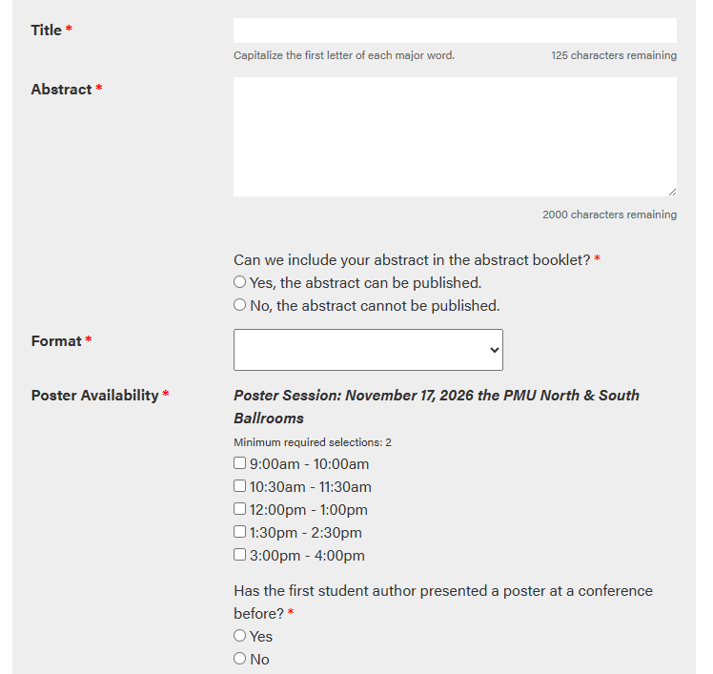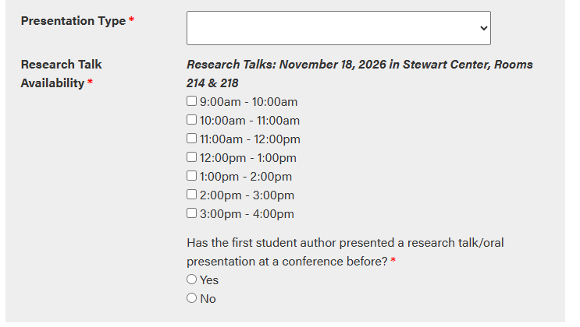
in-person presentations are considered as posters. authors can select be considered for a research talk.
in-person & virtual formats available
Check IF the Abstract CAN be available on the EXPO website. If not, the abstract will be redacted.
Title: 125-character limit
abstract: 2,000-character limit

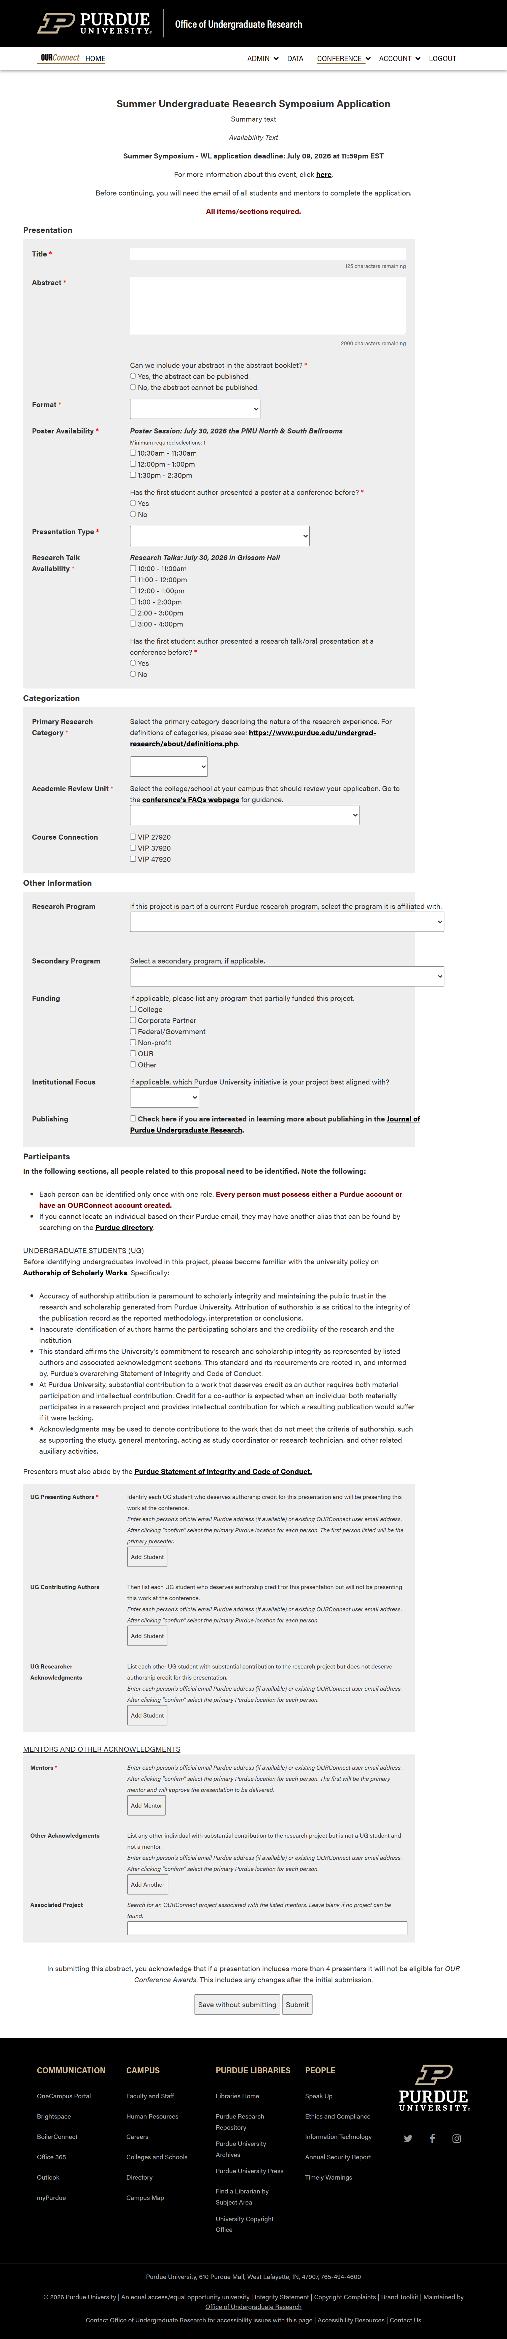
These items are optional & may not be relevant

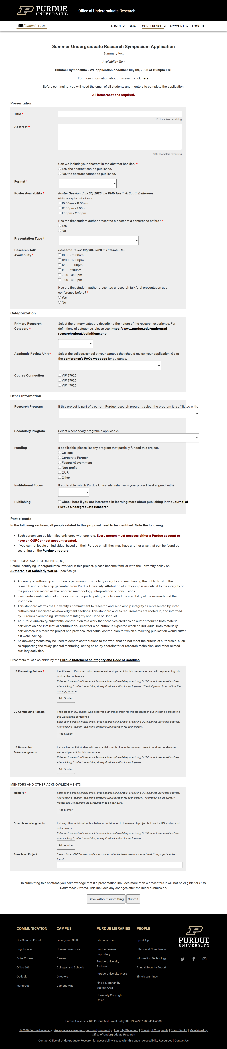
to “lock in” a name, click “confirm”
enter email then confirm the location
participants without a purdue email must create an account first
is a valid purdue email not found? check the directory for the “alias”
submit & send confirmation emails.
save your abstract to come back. is not submitted and is still “pending.”

UPDATING ABSTRACTS
Primary authors and mentors can update abstracts until the approval deadline.
Student updates to the title, abstract, keywords, and participants after approval will require mentor approval again to ensure awareness.

STEP 4: REVIEW “MY ABSTRACTS”
A saved-only abstract is only visible to the individual who started it.
Note the “Pending” status (circled) indicating it has not been submitted.
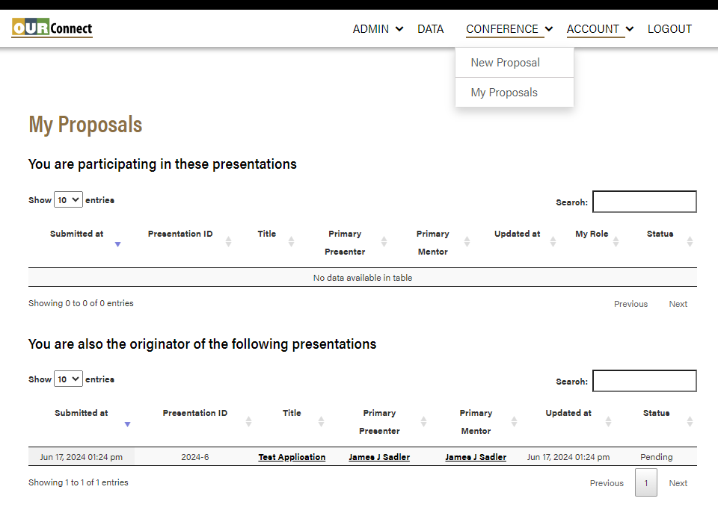
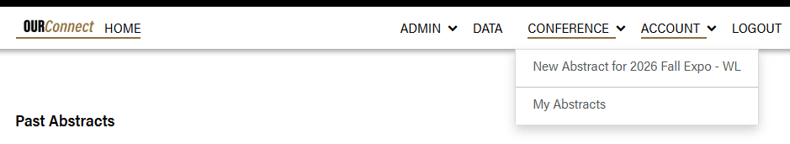

Column TitleS for submitted presentations
“Submitted at”: When the abstract was first saved/submitted.
“Conference”: Which conference your abstract is submitted to.
“Presentation ID”: System-generated unique identifier used for references.
“Title”: Title of the presentation; click to update the submission.
“Primary Presenter”: Lead author of the presentation; can update.
“Primary Mentor”: Lead mentor (faculty/staff); can update and approve.
“Updated at”: When the abstract submission was last updated.
“My Role”: Your contribution for the presentation.

AVAILABLE STATUSES FOR ABSTRACTS
A submitted abstract is visible on OURConnect to all individuals with a role. These individuals can determine where in the process of being approved under the “Status” header.
Pending
Saved, but not officially submitted for review.
(Only seen by application initiators who have not submitted the proposal.)
Submitted
Initially submitted for mentor review.
Mentor approved
Presentation is approved by the primary mentor to be delivered.
Presenter updated
Abstract was updated by primary author for mentor review.
Not approved
Primary mentor selected the presentation is not approved to be delivered.
Withdrawn
Student has withdrawn the abstract from the event.

