ABSTRACT APPROVAL VIA OURConnect

A HOW-TO GUIDE FOR MENTORS

SUMMER UNDERGRADUATE
RESEARCH SYMPOSIUM

Last Updated: June 2026
Purdue University Office of Undergraduate Research
OURConnect is the abstract submission and approval platform. This guide will share functionalities of the conference portal to submit an abstract.
Go to: purdue.edu/undergrad-research/ourconnect/
STEP 1: LOGIN OR CREATE AN ACCOUNT
Click “Login” and either sign in with BoilerKey or create an account to login. If you have an @purdue.edu email, login with that.
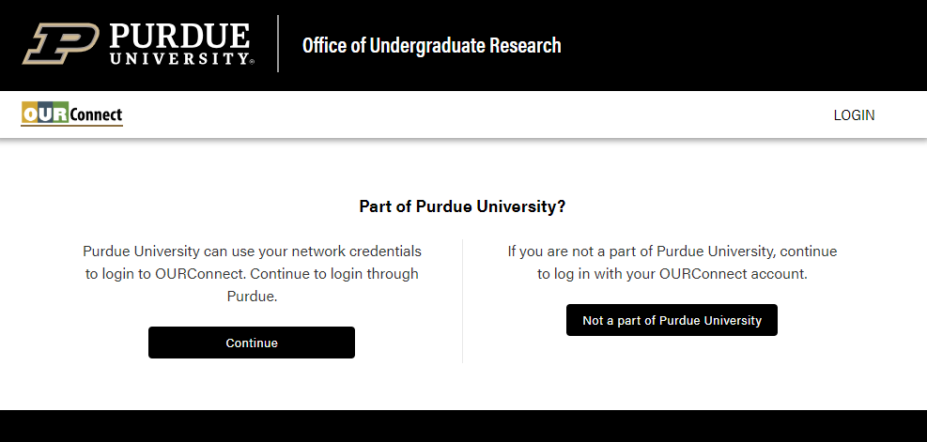

STEP 2: ENTER CONFERENCE PORTAL TO VIEW ABSTRACT
Click “Conference” and then “My Abstracts.”
New abstracts are submitted through the “New Abstract” links.
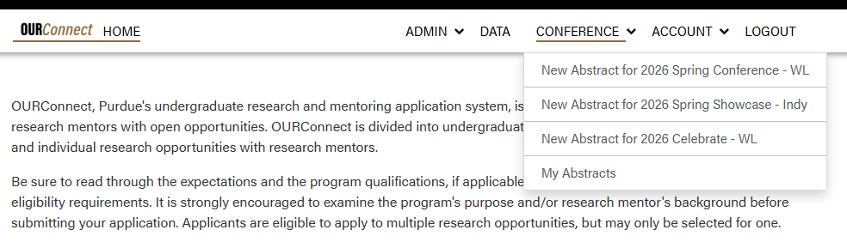

STEP 3: REVIEW “MY ABSTRACTS”
Submitted abstracts are visible on OURConnect to all individuals with a role. Click on the Title to review, update, and approve. Click on a name to send them an email. Only the primary mentor can approve presentability.
Note the “Test Application” below has the same person as the primary presenter and mentor with the “My Role” column indicating this, too. This is not possible with the current system.
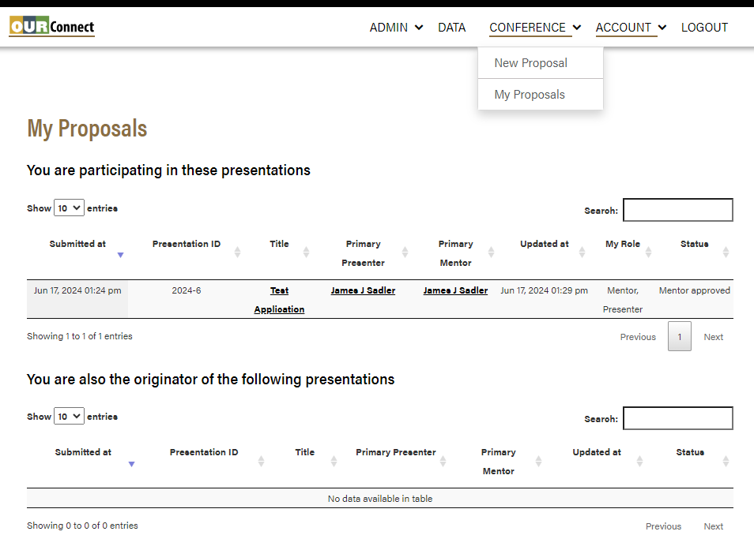

STEP 3: REVIEW “MY ABSTRACTS”
research mentor and team, especially availabilities, before submitting.

Column TitleS for submitted presentations
“Submitted at”: When the abstract was first saved/submitted.
“Conference”: Which conference your abstract is submitted to.
“Presentation ID”: System-generated unique identifier used for references.
“Title”: Title of the presentation; click to update the submission.
“Primary Presenter”: Lead author of the presentation; can update.
“Primary Mentor”: Lead mentor (faculty/staff); can update information; only one who can approve the presentation to be delivered.
“Updated at”: When the abstract submission was last updated.
“My Role”: Your contribution for the presentation.
“Status”: The current status of the abstract. Can filter based on those that need action such as “Submitted” and “Presenter updated” statuses.
STEP 4: REVIEW SUBMITTED ABSTRACT PROPOSALS
Review and update information. Fields with a red asterisk are required.
Do not update format or availabilities without confirming with the presenters as this affects the information we use to schedule the presentations.
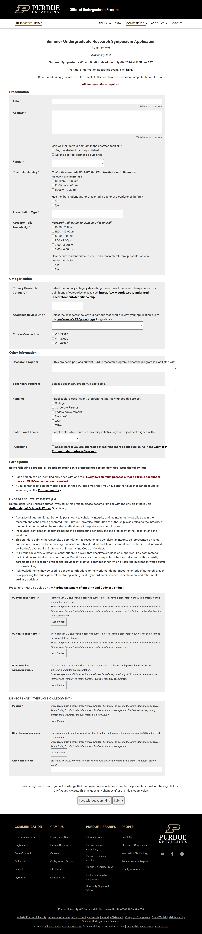
UPDATE STUDENT AVAILABILITY AFTER SPEAKING WITH THEM
in-person & virtual formats available
Title: 125-character limit
abstract: 2,000-character limit

Check IF the Abstract CAN be available on the conference website. If not, the abstract will be redacted.
in-person presentations are considered as posters. authors can select be considered for a research talk.

These items are optional & may not be relevant

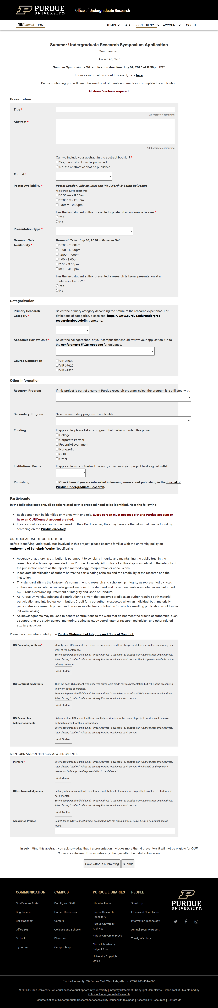
to “lock in” a name, click “confirm”
enter email then confirm the location
participants without a purdue email must create an account first
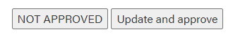
is a valid purdue email not found? check the directory for the “alias”
UPDATE ANY CHANGES AND APPROVE FOR PRESENTING.
DO NOT APPROVE THE ABSTRACT TO BE PRESENTED. IF ERRORS, FIX AND APPROVE.

UPDATING ABSTRACTS
Primary authors and mentors can update abstracts until the approval deadline.
Student updates to the title, abstract, keywords, and participants after approval will require mentor approval again to ensure awareness.

STEP 5: CONFIRM “MY ABSTRACTS” STATUSES
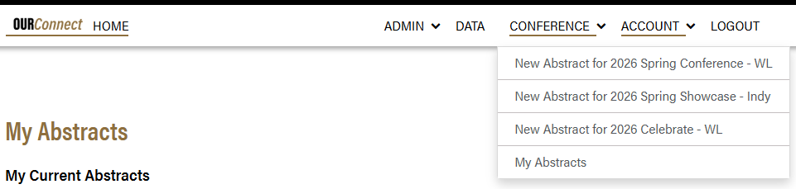
Confirm statuses of all abstracts you are primary mentor for are either “Mentor approved” or “Not approved.”
Note the “Mentor approved” status (circled below) indicates it was reviewed and approved. This is required for all presentations.

AVAILABLE STATUSES FOR AN ABSTRACT
Pending
Not officially submitted for review. (Only seen by application initiators.)
Submitted
Initially submitted for mentor review.
Mentor approved
Presentation is approved to be delivered.
Presenter updated
Abstract was updated by primary author for mentor review.
Not approved
Presentation is not approved to be delivered.
Withdrawn
Student has withdrawn the abstract from the event.

