How to apply to a project:

Go to https://www.purdue.edu/undergrad-research/ourconnect/

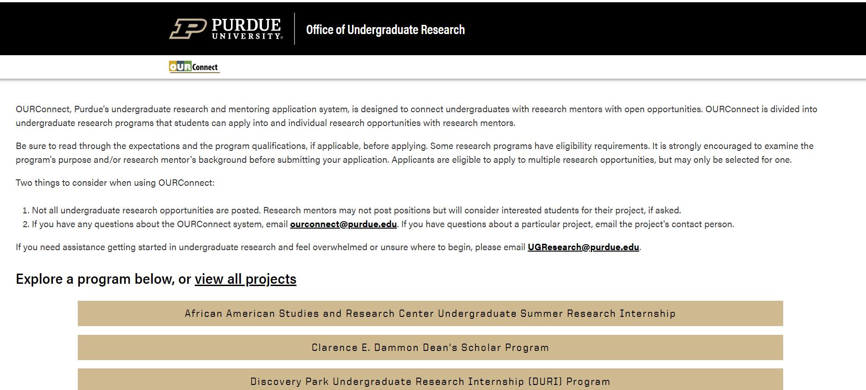

Select the Program tile that best fits your project. Here we’ve selected the “Discovery Park Undergraduate Research Internship (DIURI) Program”: 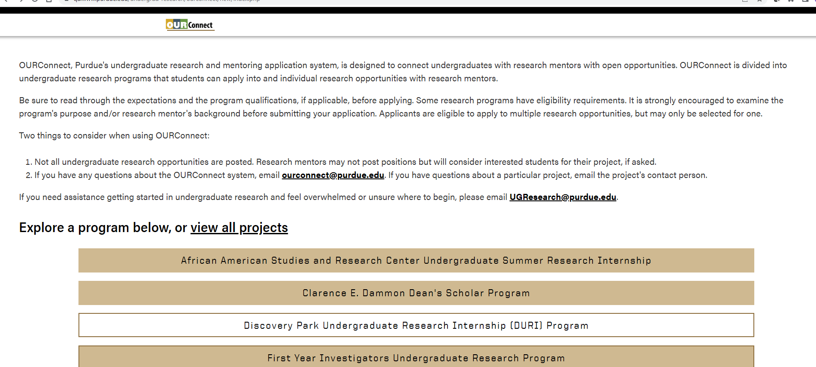
You’ll see this screen: 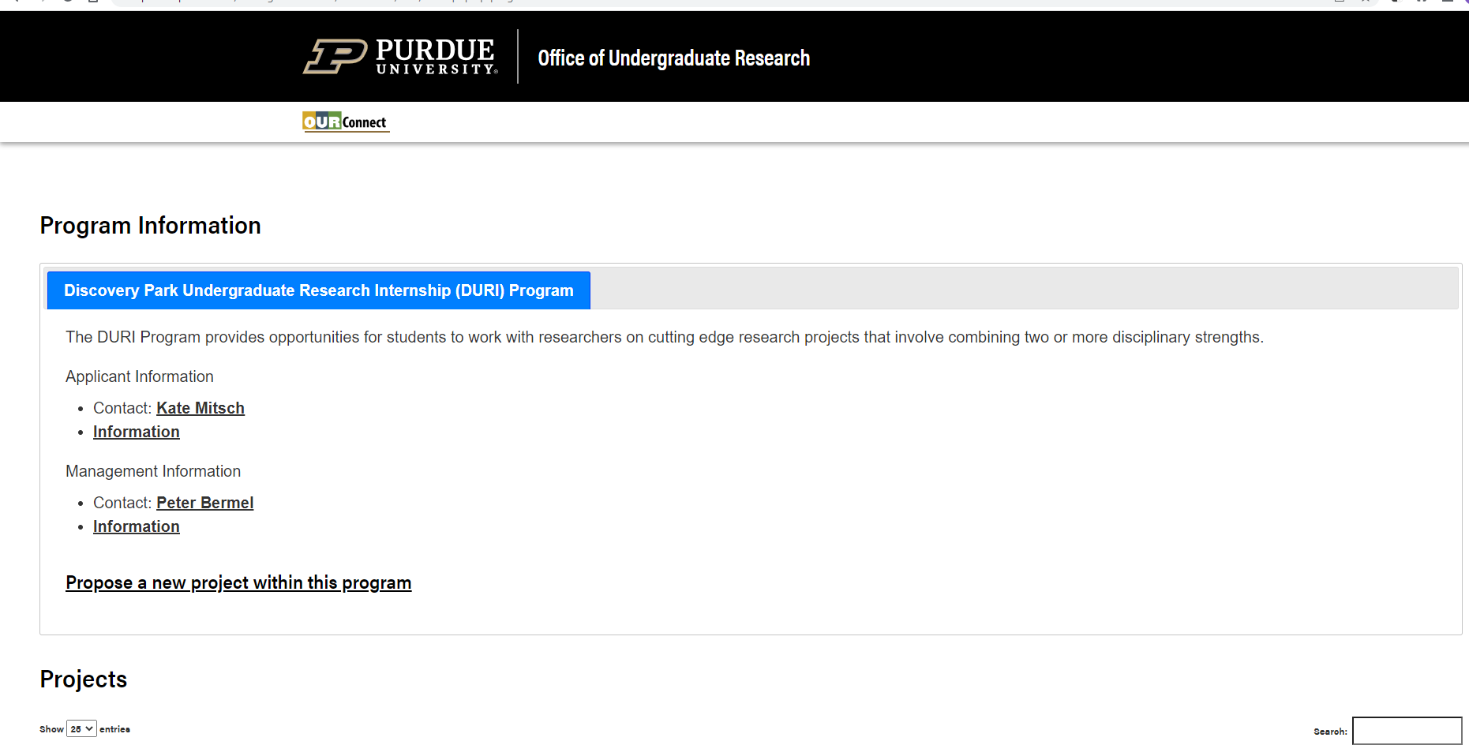

Scroll to see all projects. Select a project you would like to view and/or apply to. Here we’ve selected “Climate change and emerging infectious diseases of wildlife and” by Wendy Beauvais: 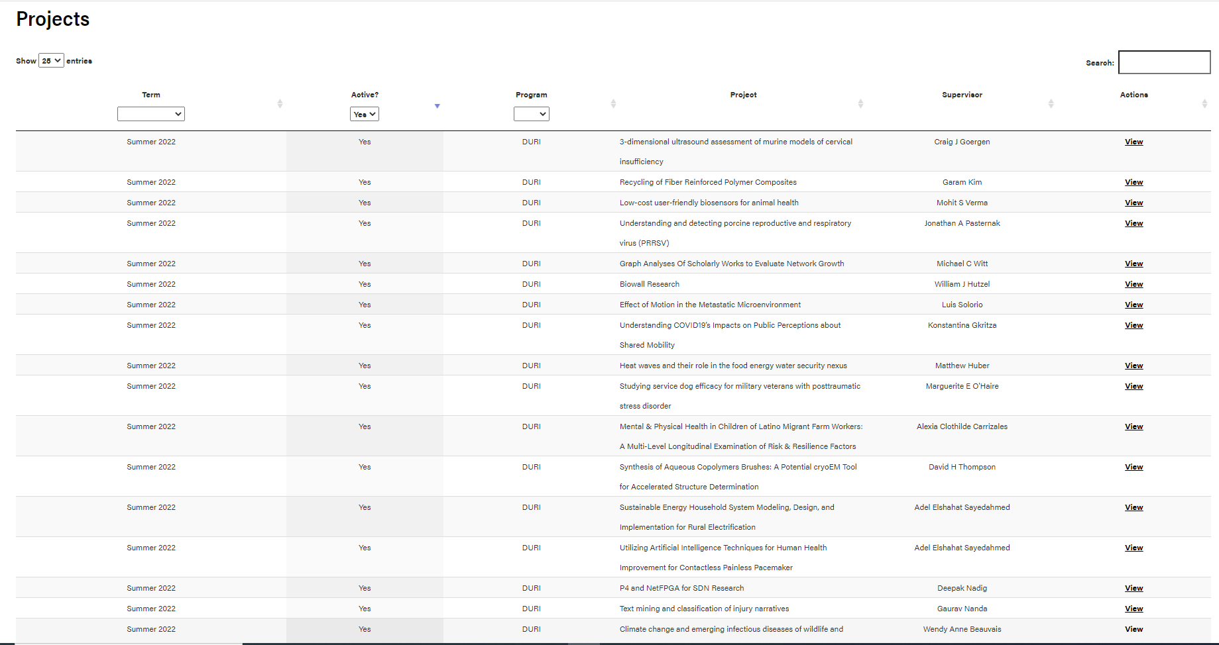

Now you are able to view detailed information about this project. If interested, you will select the “Apply for …” button at the bottom left: 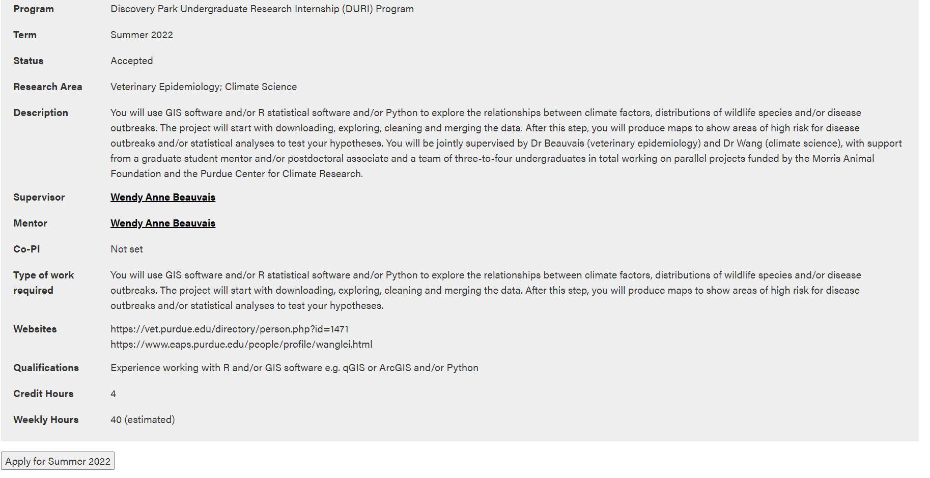
The BoilerKey login screen will appear: 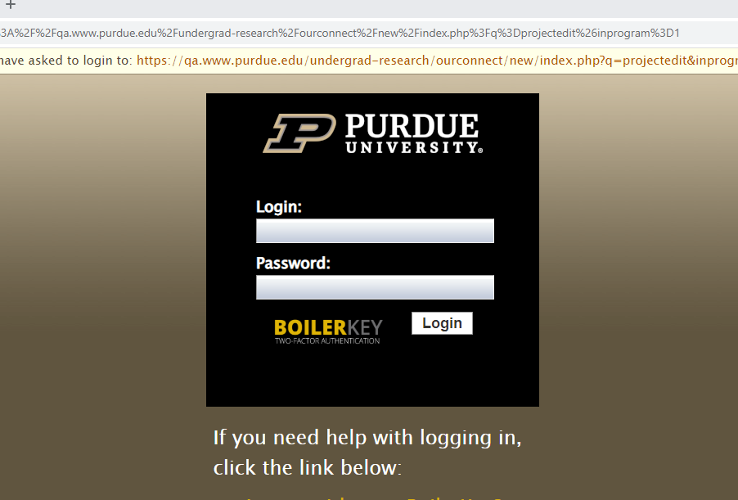
Enter your career account information:
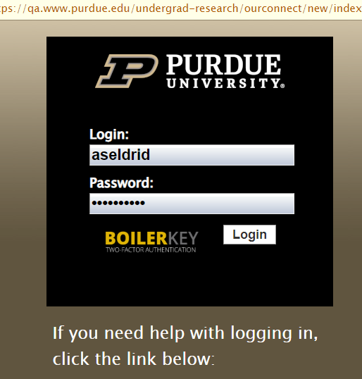

This screen will appear and be prefilled if you already have a profile in the system. (It will appear blank if you need to create a profile): 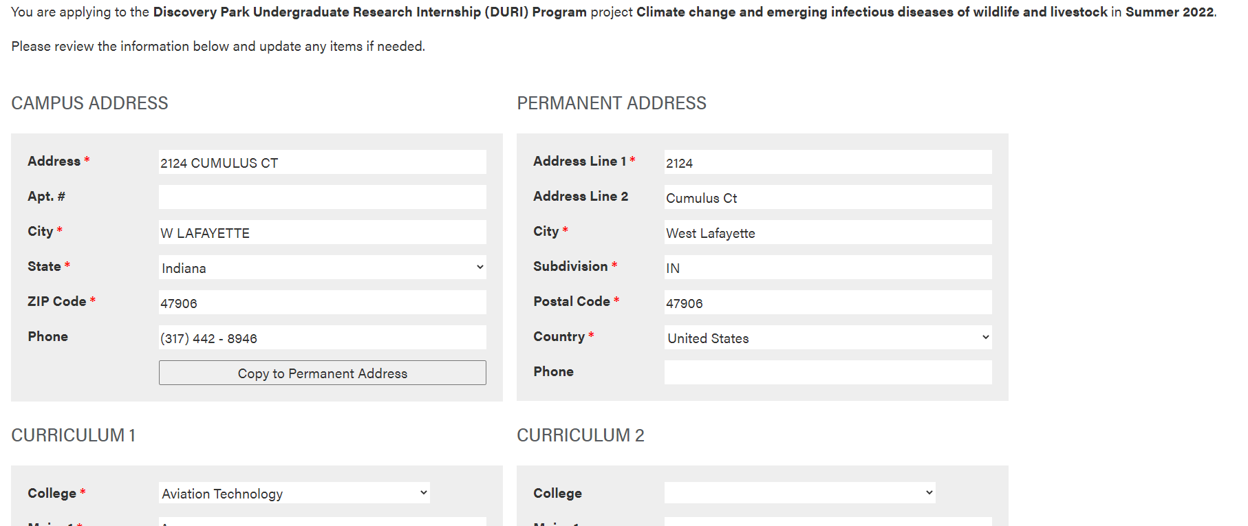
Upon completion of your application, you will select the “Complete application” button at the bottom left: 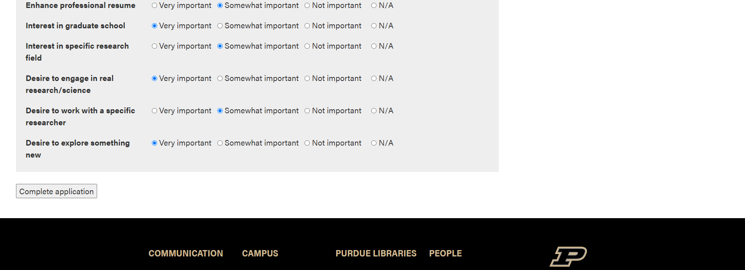
You will then see this screen: 