How to review and select students for your project:
Go to https://www.purdue.edu/undergrad-research/ourconnect/ and select the login button in the upper far right corner:
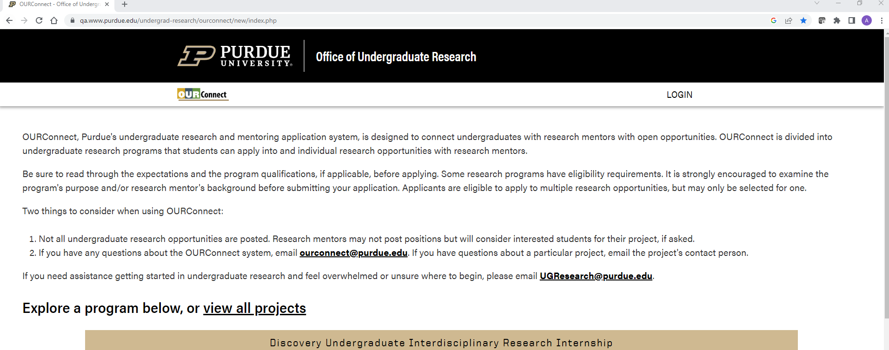

The BoilerKey login screen will appear: 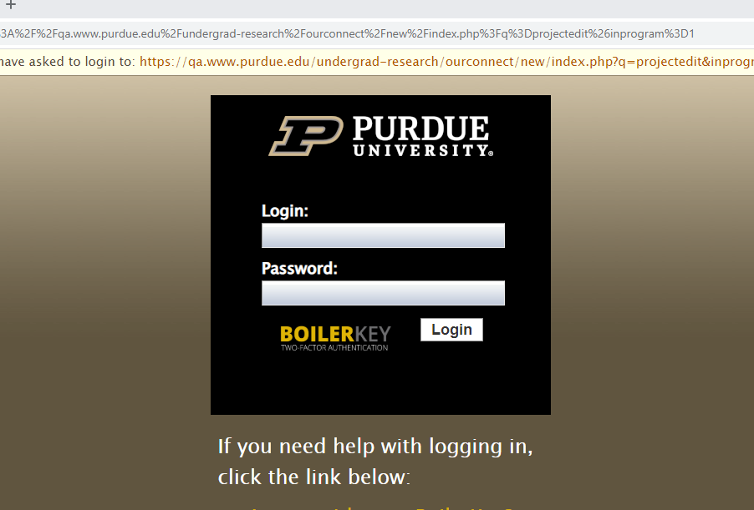
Enter your career account information:
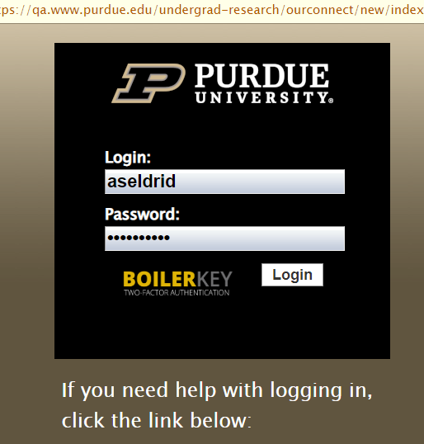
Now, on the far right, under the Account Tab, when you click the caret, you will see “My Profile” and
My Projects”, select “My Projects”:
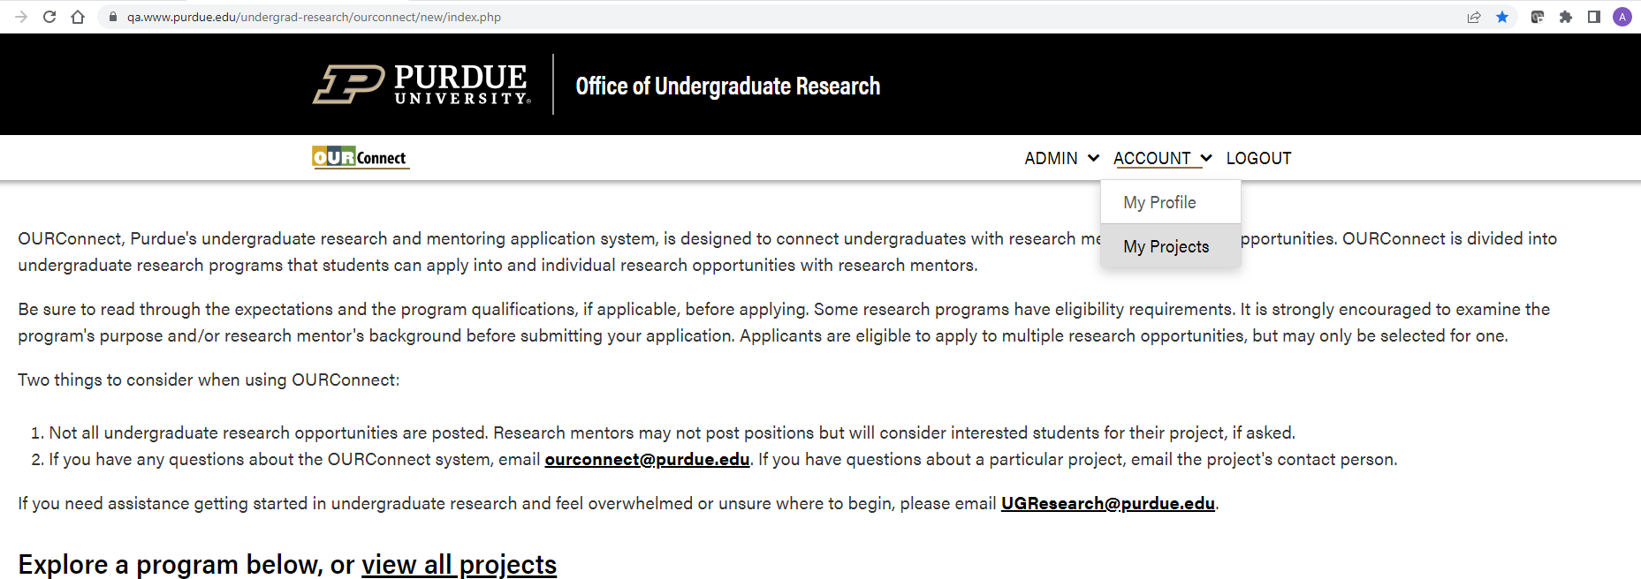
You are then shown all projects you manage and any projects you may have applied to. For the project you would like to review, select the “Manage” tab on the far right:
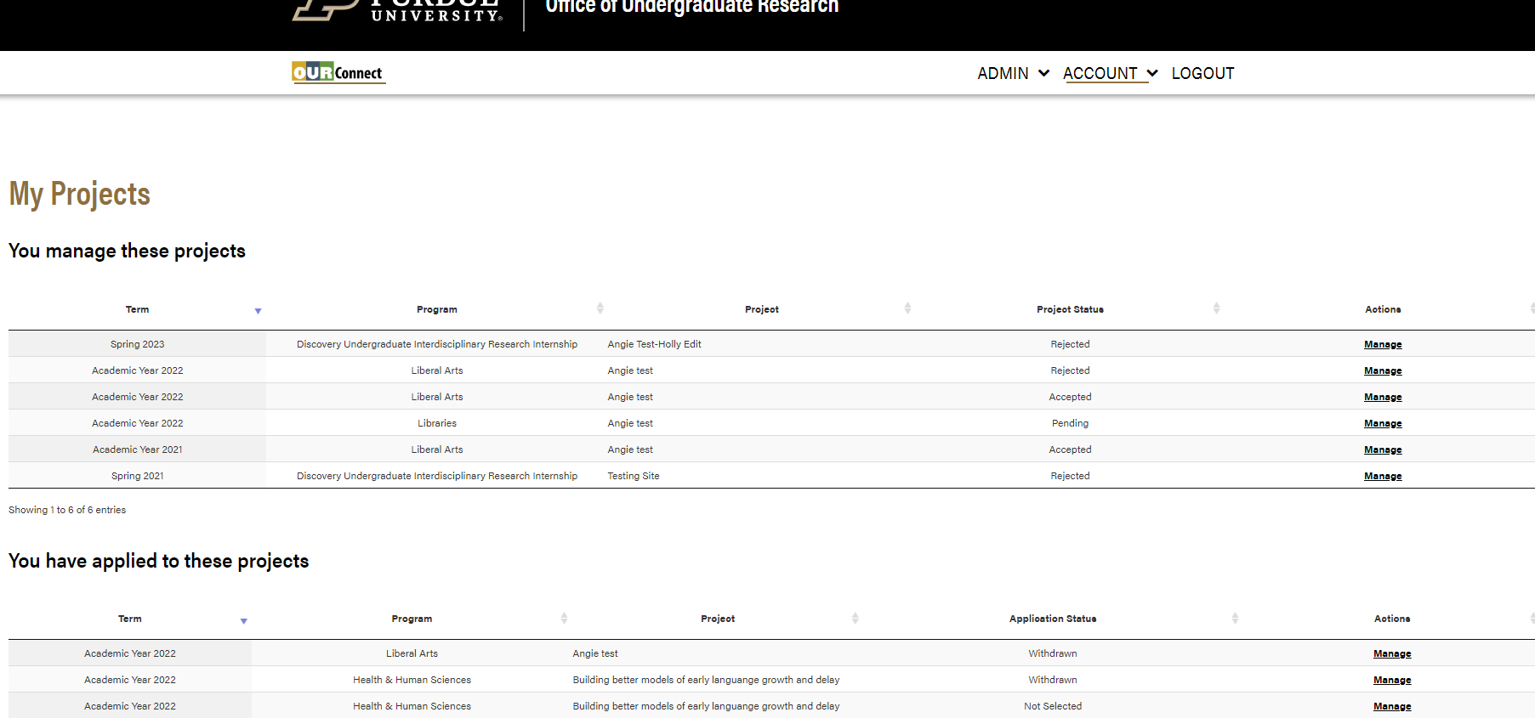
The selected project will appear and show the tabs titled “Details”, “Applications” and “Status. Select the “Applications” tab to see all applications:
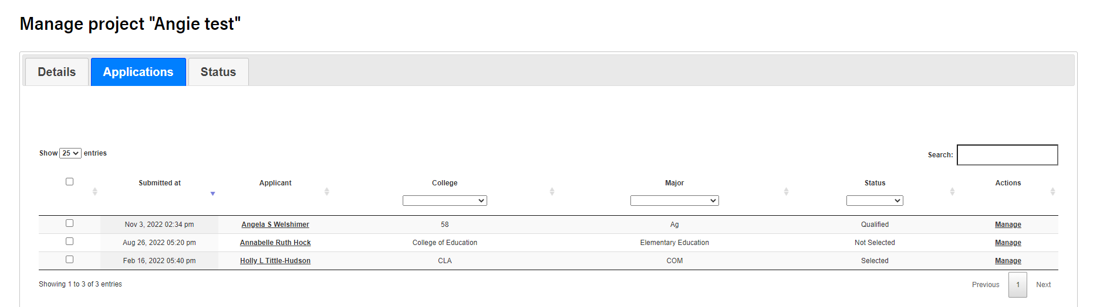

For this example, the top application for Angie Welshimer shows as “Qualified”. Please select the “Manage” tab to review it. This screen will appear with multiple tabs for you to select from:
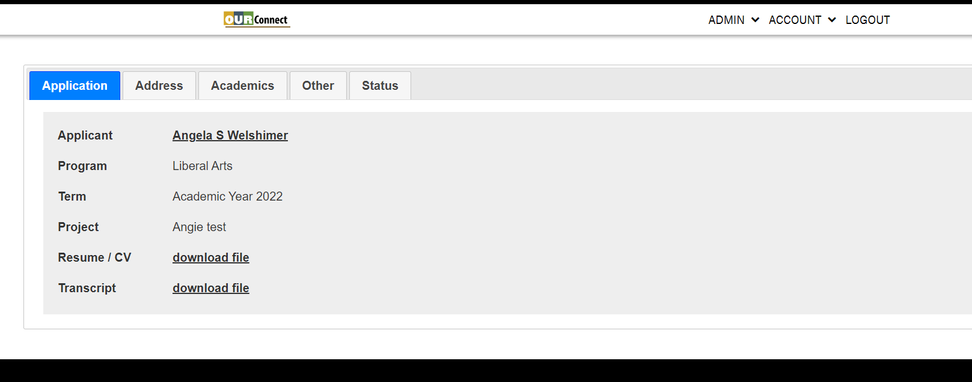
After reviewing the information under each tab, the final tab “Status” will allow you to select the applicant if that is your decision:
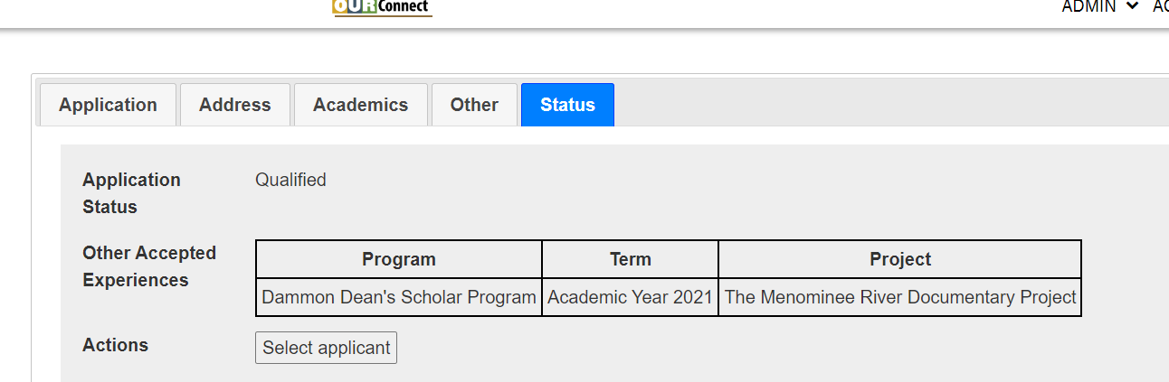
Once you have selected an applicant, an automated email will be sent to the applicant notifying them of the change. They can then either “accept” or “decline” the offer.

