How to submit a project:

Go to https://www.purdue.edu/undergrad-research/ourconnect/
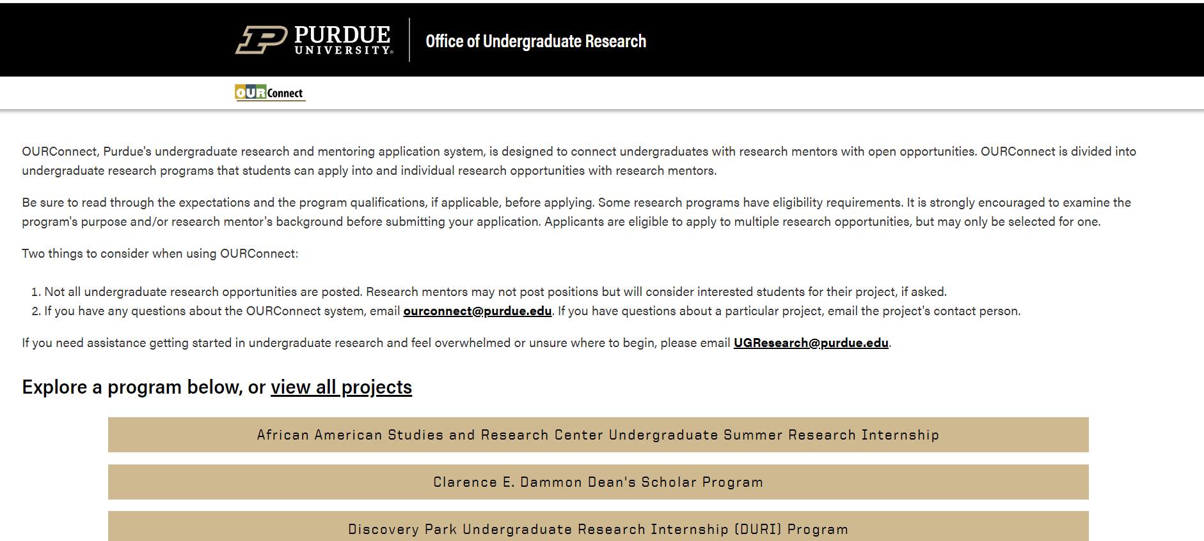

Select the Program tile that best fits your project. Here we’ve selected the “Margo Katherine Wilke Undergraduate Research Internship Program”: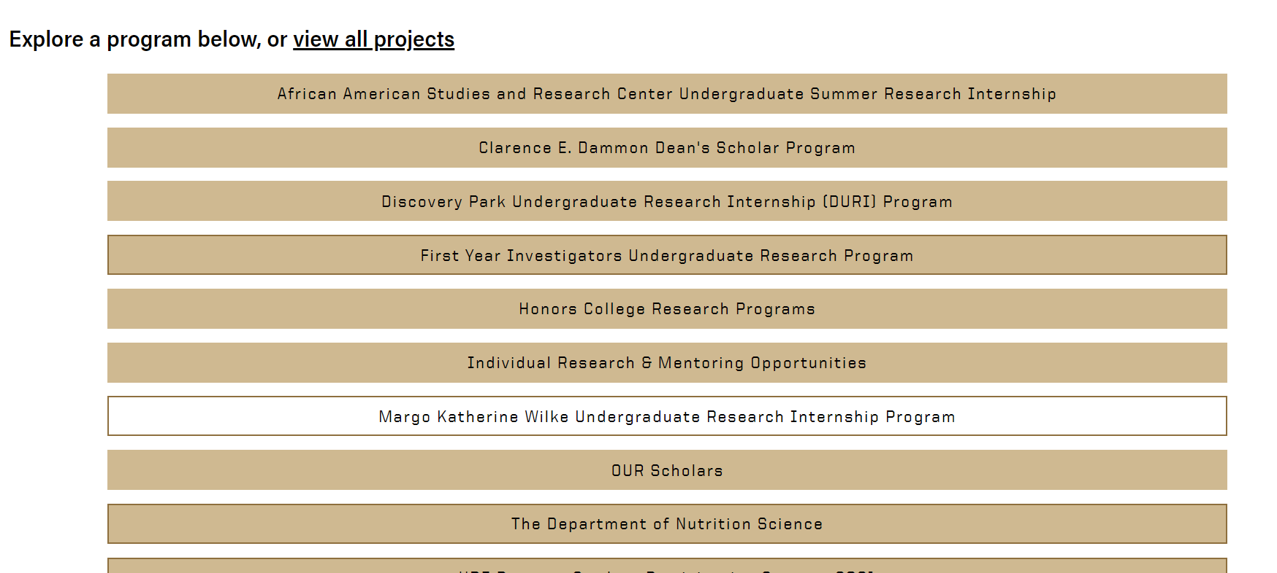
You’ll see this screen: 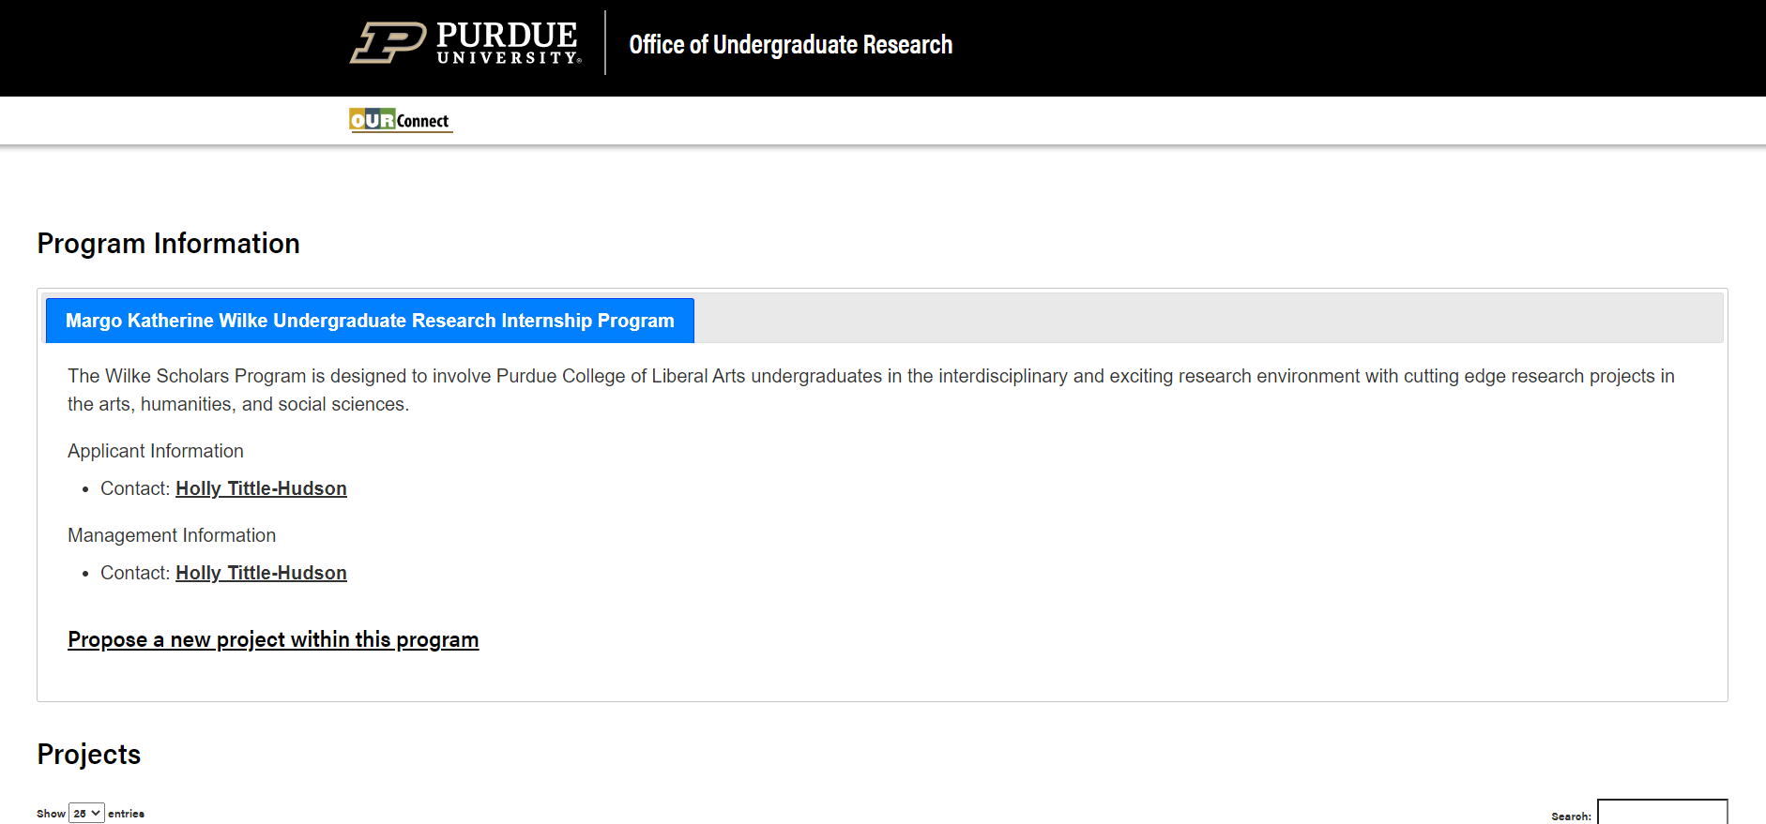

Select “Propose a new project within this program”:

The BoilerKey login screen will appear:
Enter your information:
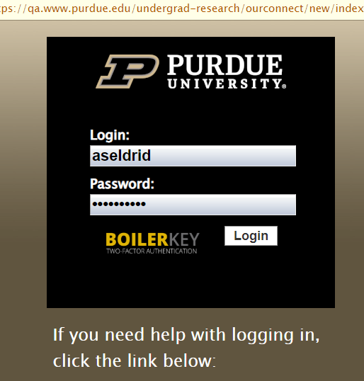

This screen will appear, and you’ll be prompted to fill in the information for your project. 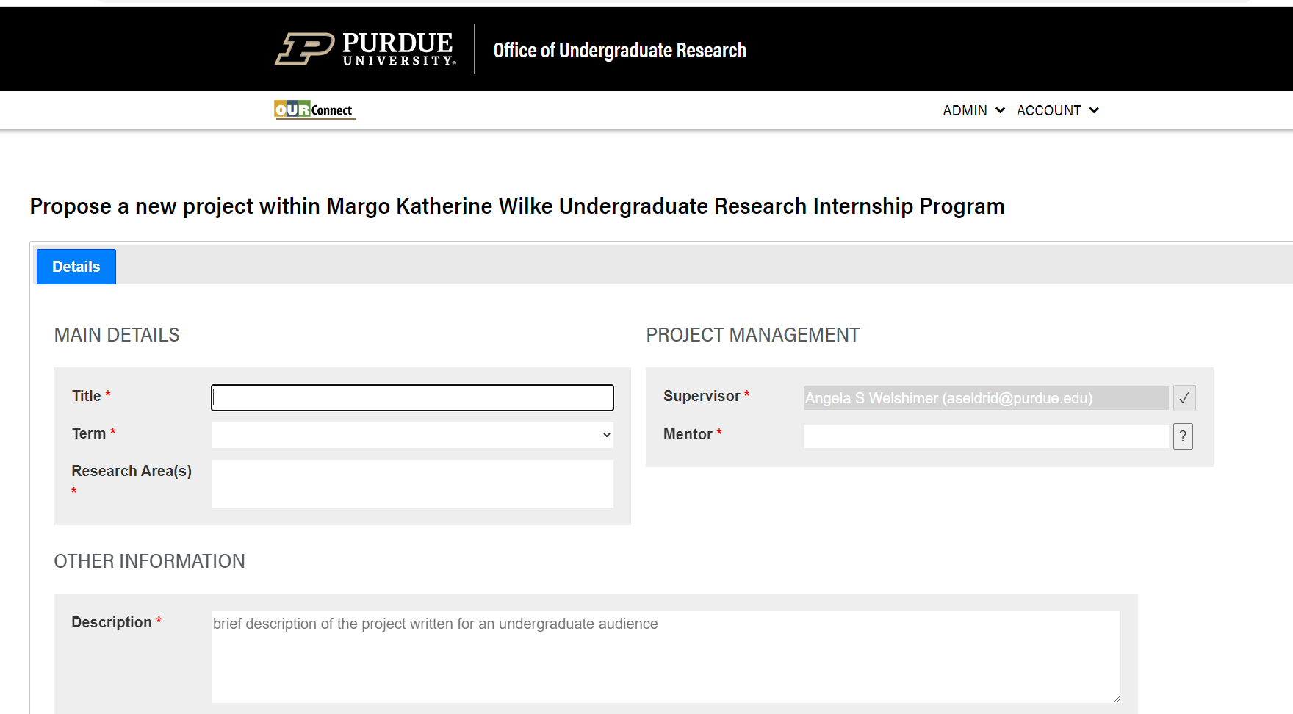

Example of what you see upon entering information:
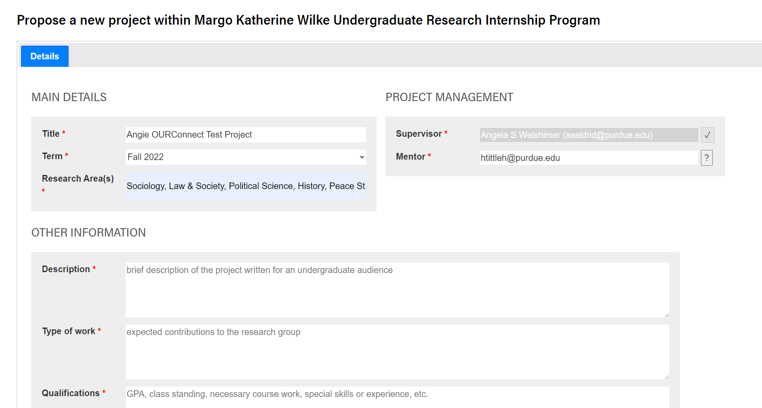

At the bottom of the screen, you will see the option to “Save project for later” or “Submit new project.” Make your selection: 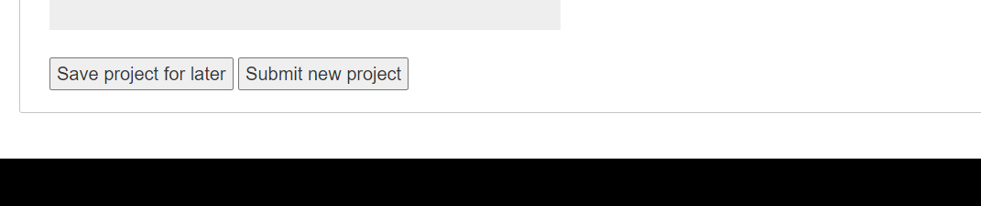
Upon submitting your new project, you will see this screen: 